**Sky Claw Assembly Manual**

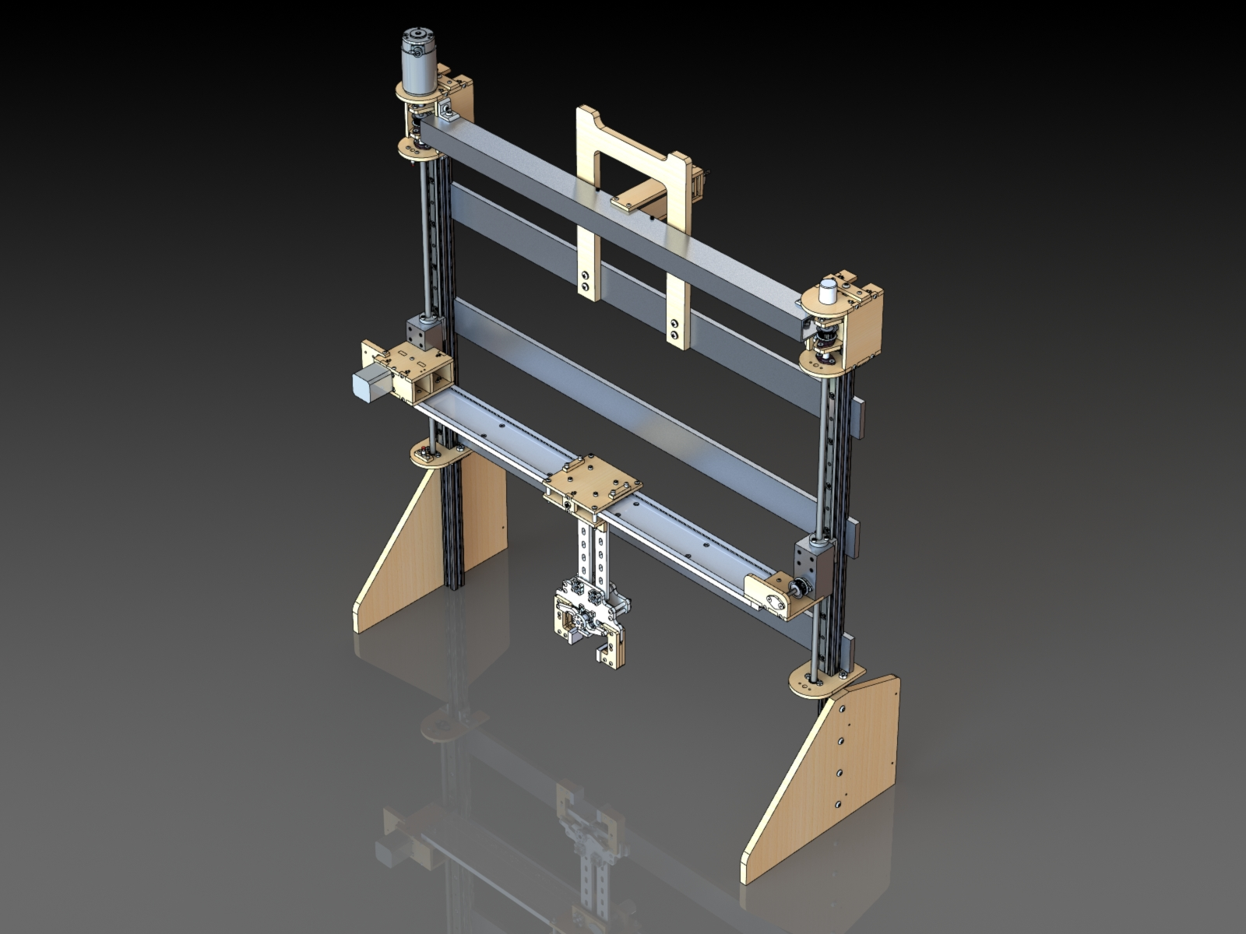

**[Please read the entire manual before proceeding with assembly]**

**Required Skills:**

* Basic electrical knowledge
* Circuit diagram comprehension
* Soldering abilities
* Basic programming is strongly recommended (specifically Arduino based C)
* Machine milling experience
  + Alternatively, parts may be sent to a machine shop for fabrication

**Required Software:**

* Microsoft Office – required for viewing various word and excel documents
* SolidWorks – all parts, assemblies, and drawings are modeled in SolidWorks
* Arduino IDE – used to upload code to Arduino; Arduino IDE can be downloaded for free at <https://www.arduino.cc/en/software>
* TinyCAD (optional) – used to view circuit diagrams included in Sky Claw package

**Required Tools:**

* Milling Machine/Drill Press
* Soldering Iron
* Laser Cutter
* Band Saw
* Wire Stripper/Cutter
* Screw Drivers
* Wood Glue
* Allen Wrench
* Vise Grips
* Clamps
* Needle Nose Pliers
* Magnet
* Heat Gun

**[Everything in this section is to be completed before continuing to the assembly]**

**Parts List:**

A complete bill of materials (BOM) is included in the excel sheet “MASTER BOM.xls.” Review the parts list to ensure all required components for assembly are acquired. Using the BOM in conjunction with the CAD model.

A folder named “Schematics and Datasheets” containing specification sheets for available parts is included. These files will need to be used later in the assembly and will help serve as a reference.

**Fabricated Parts:**

All files in the “CAD Files🡪SkyClaw🡪FAB” folder will need to be fabricated/modified through one of three methods:

1. Sending parts to a manufacturer
2. 3D Printing the parts
3. Laser cutting the parts

* The HORIZONTAL SPINDLE CARRIAGE will need to be machined (QTY: 2).

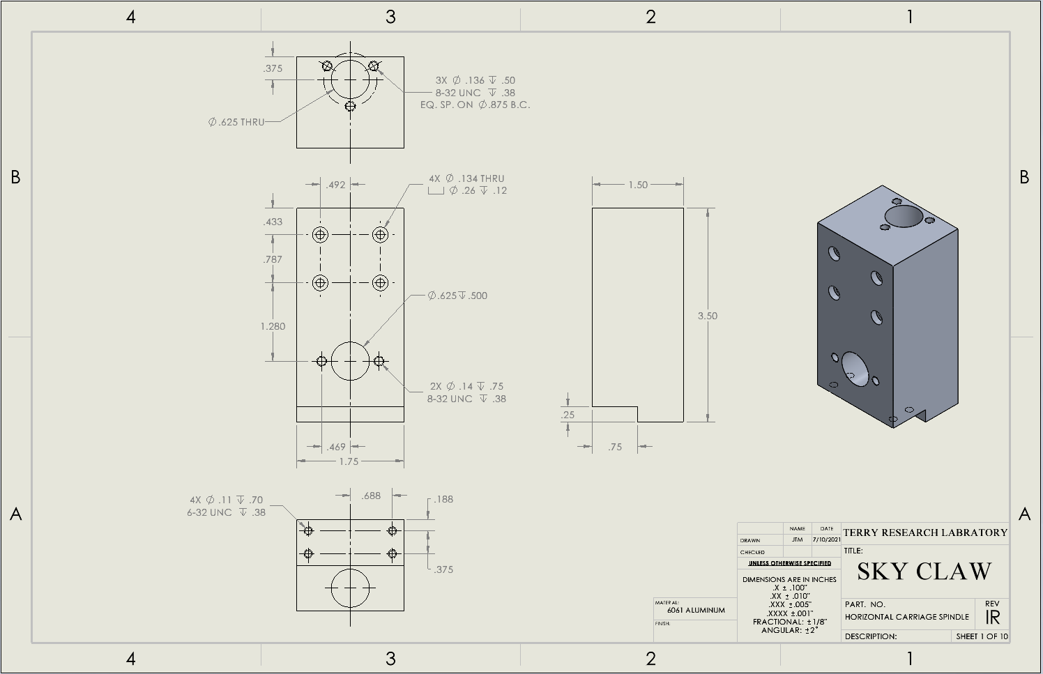

**Modified Parts:**

* Drill 1/8” holes and ¼” clearance holes in the MDF (PN: FOOT)

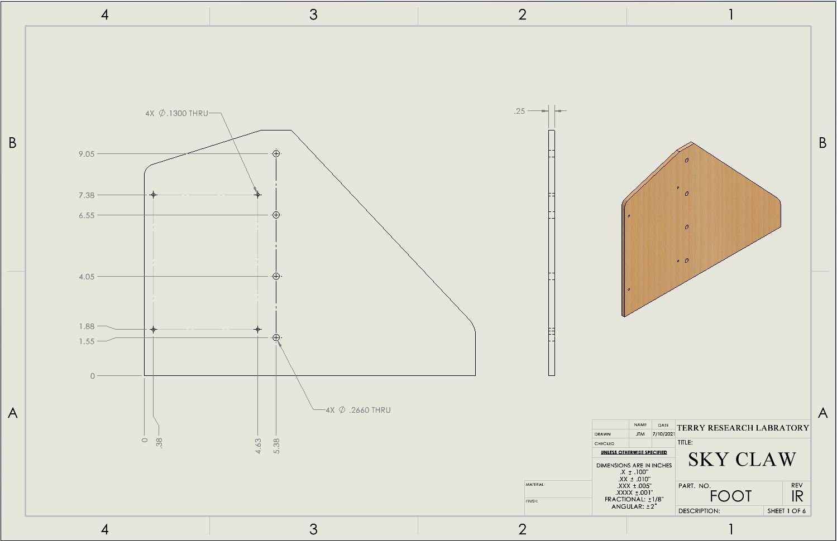

* Cut the guide rails (QTY: 2 / PN: 9880K13) to a length of 22 inches.

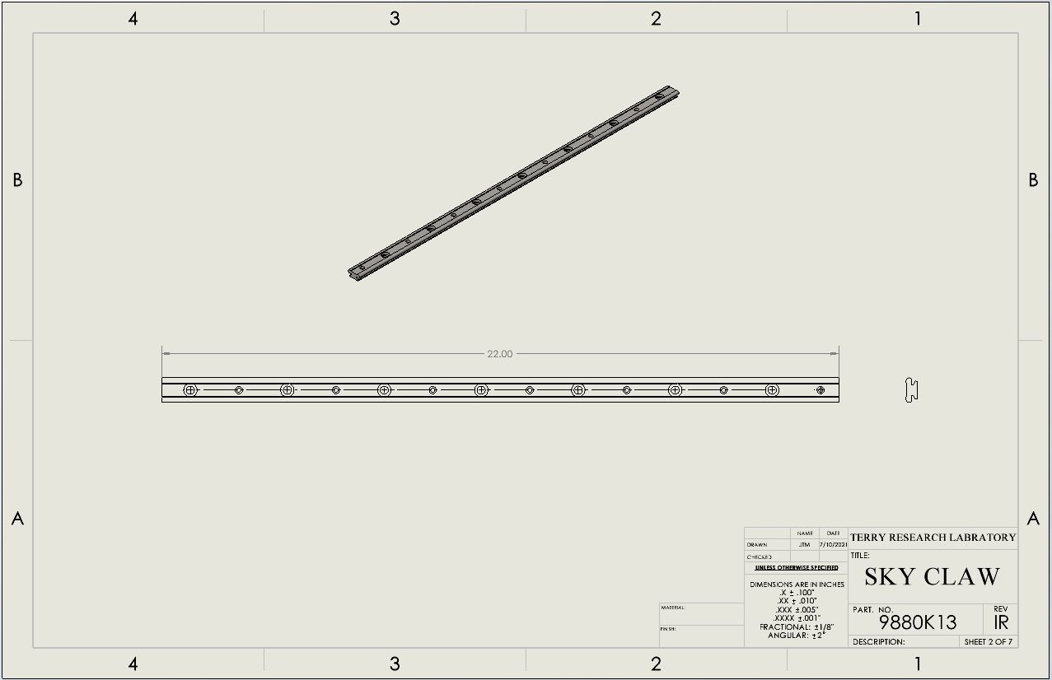

* Mill out all holes to Ø7/16” X 5/32” deep using current holes in the guide rails for location.

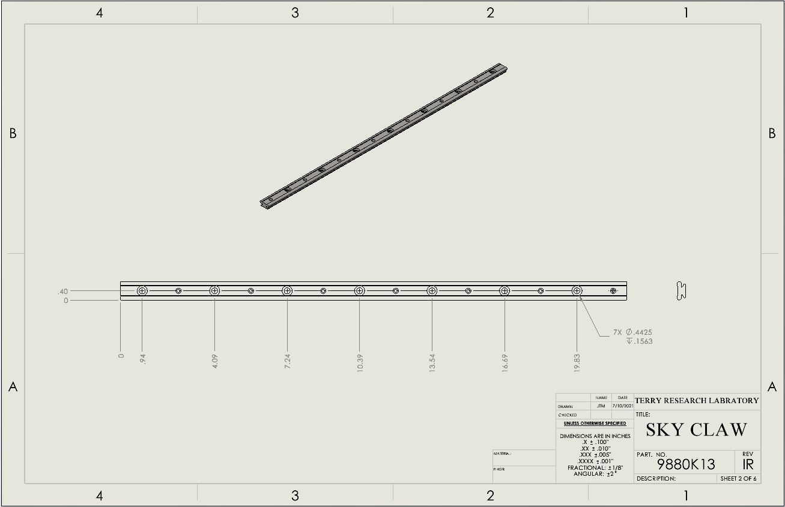

* Cut aluminum extrusion profiles (QTY:2 / PN: 47065T101) to a length of 38.5 inches.

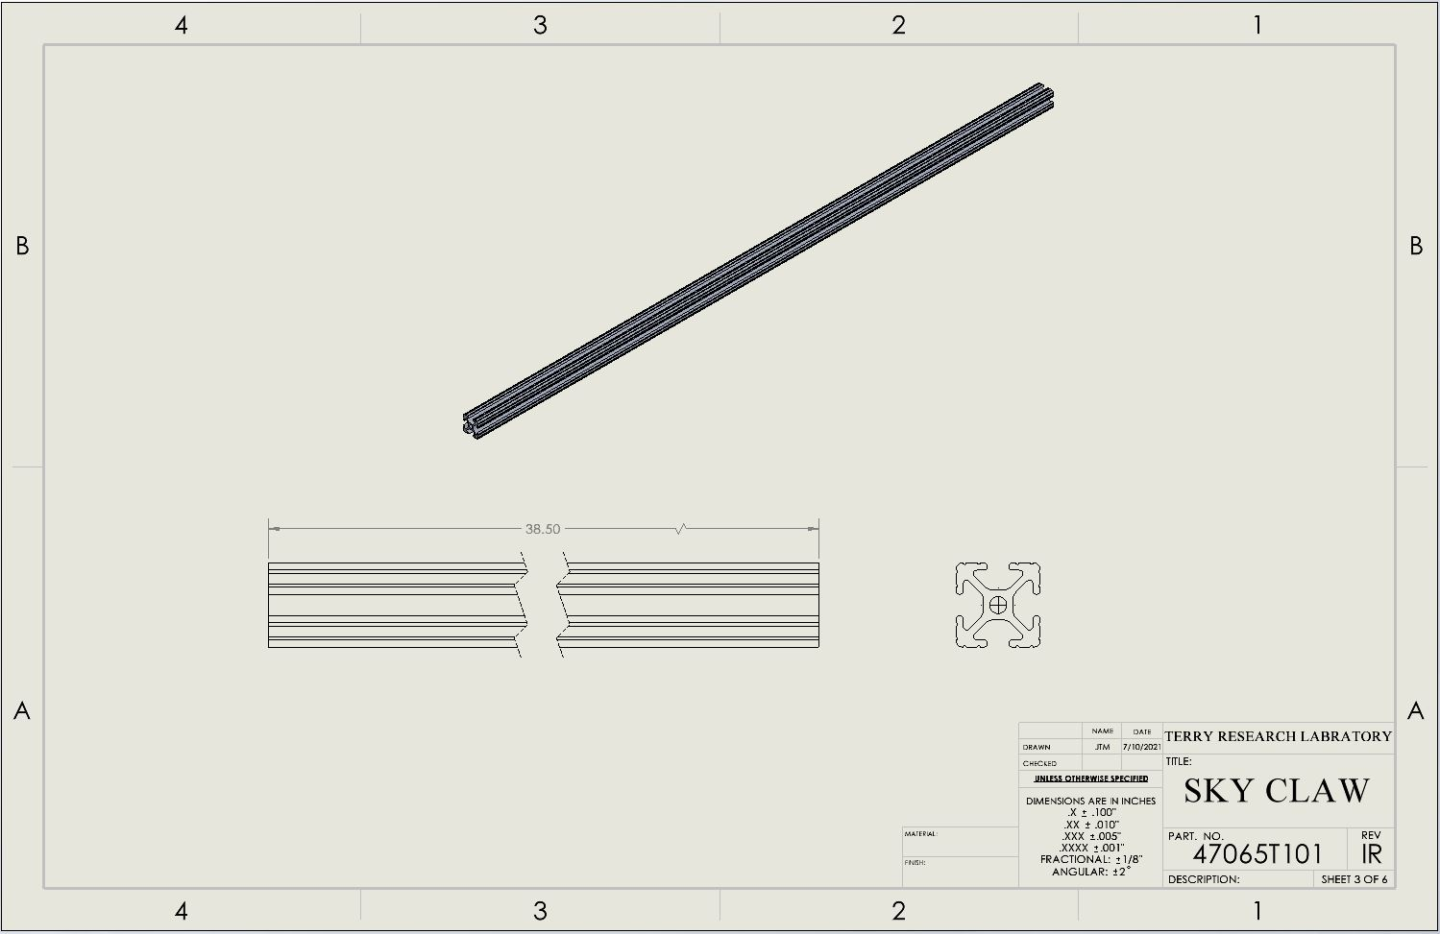

* Mill two slots in the 6061 Aluminum 3/8” thick bar (QTY: 3 / PN: 8975K468). These slots are for the aluminum extrusion profiles. Ensure that the aluminum profiles fit into the groove of the slots.

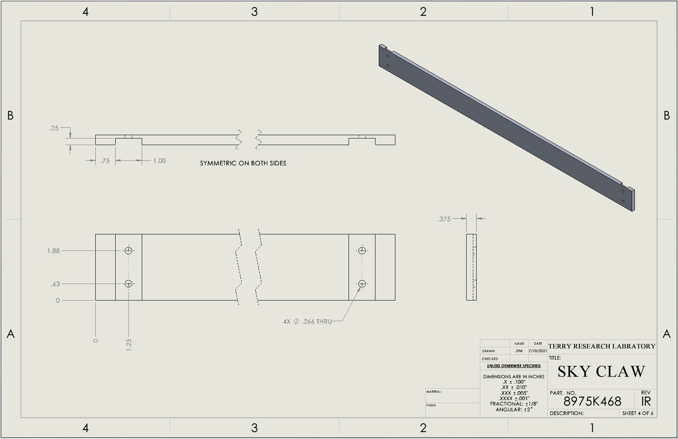

* Take one of the aluminum bars in previous step to drill 4 X ¼” clearance holes (Ø.266”) as shown.

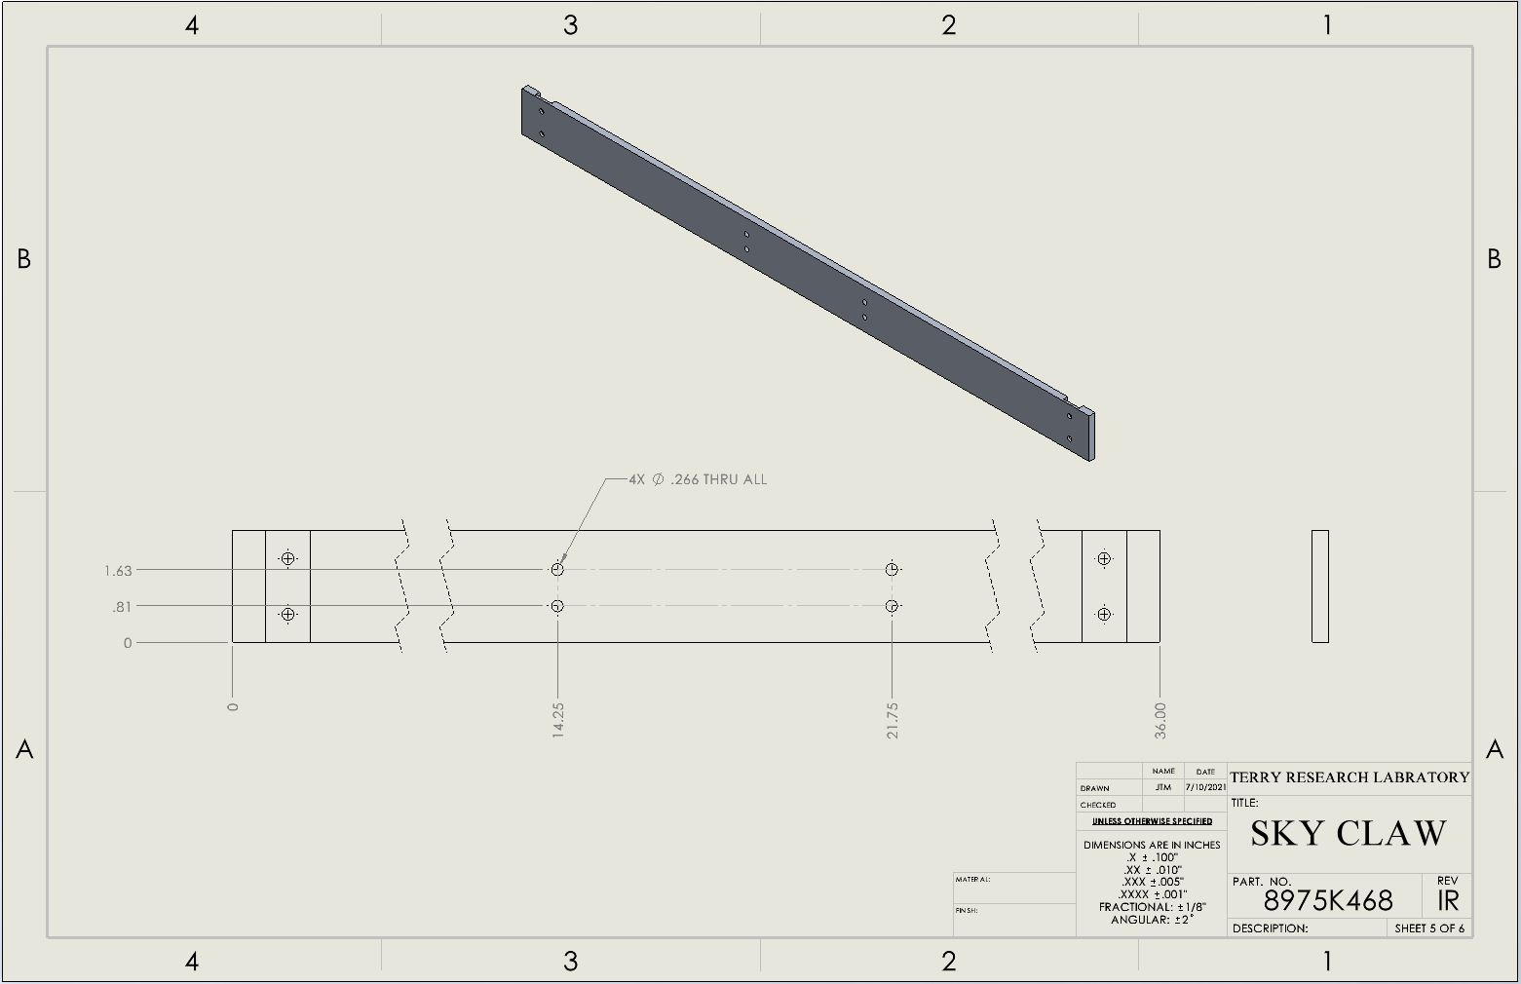

* Drill 4 X ¼” clearance holes, 4 X #6 clearance holes, and tap 4 X #6-32 clearance holes into the 6063 Aluminum U-Channel (QTY: 1 / PN: 9001K62)

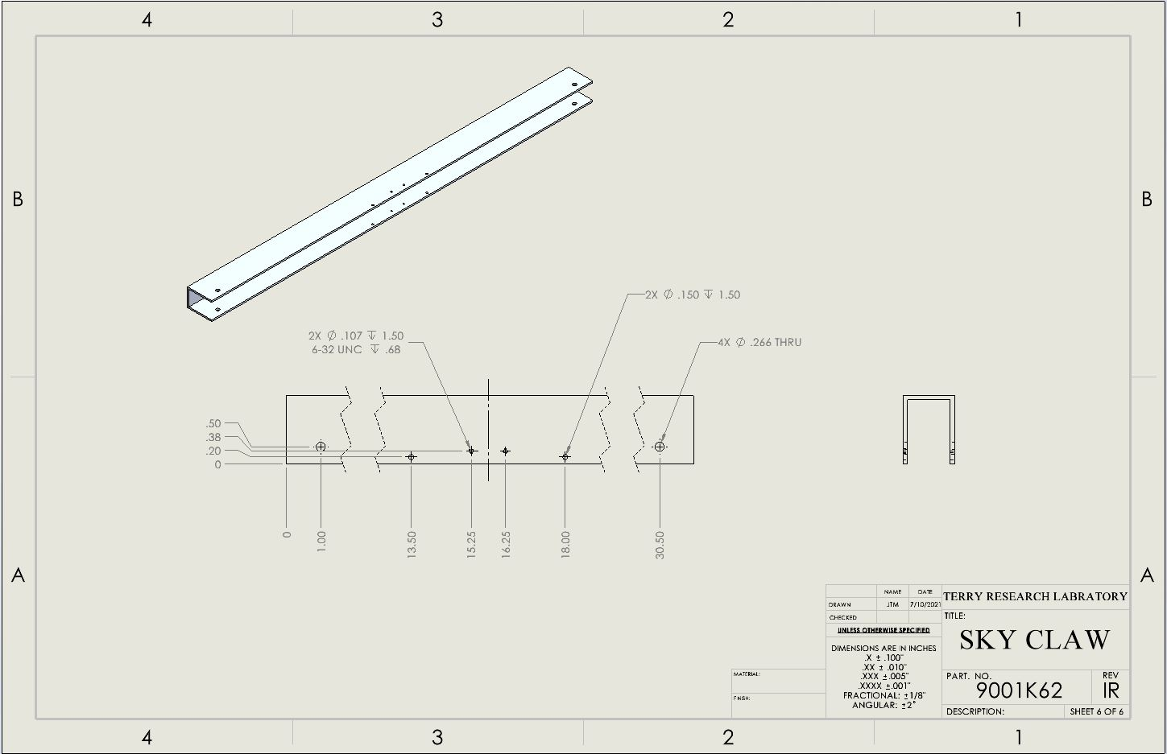

* Drill a Ø.25” hole through the center of the black mounted ball bearing (QTY: 11 / PN: 4575N23). This is for the Ø1/4” D-Profile shafts to fit.

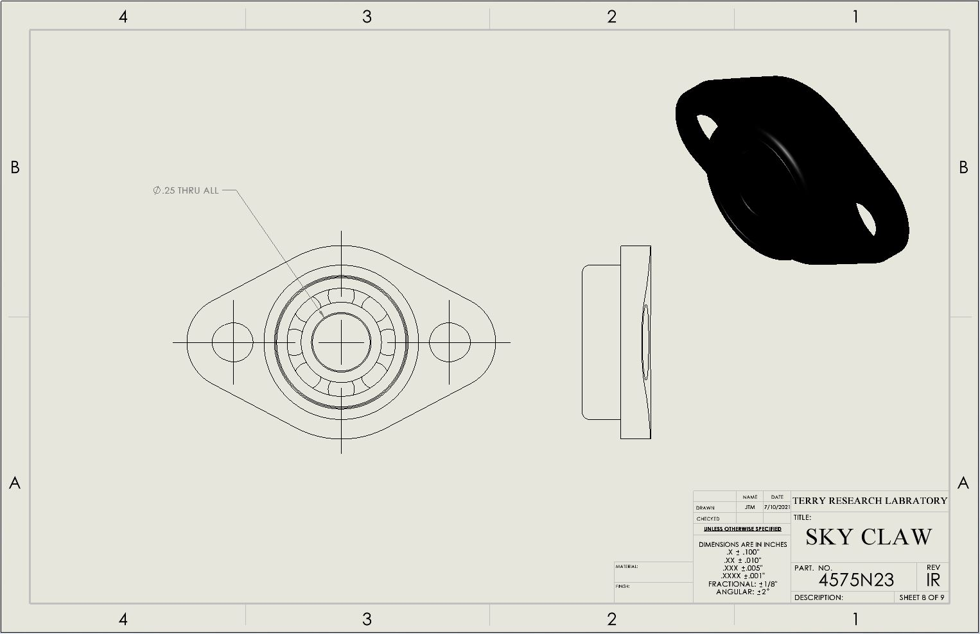

* Cut Ø¼” D-profile rotary shafts (PN: 8632T141) to various lengths

|  |  |
| --- | --- |
| LENGTH | QTY |
| 1.75 | 3 |
| 2.25” | 1 |
| 2.5” | 1 |
| 2.625” | 2 |
| 2.875” | 1 |

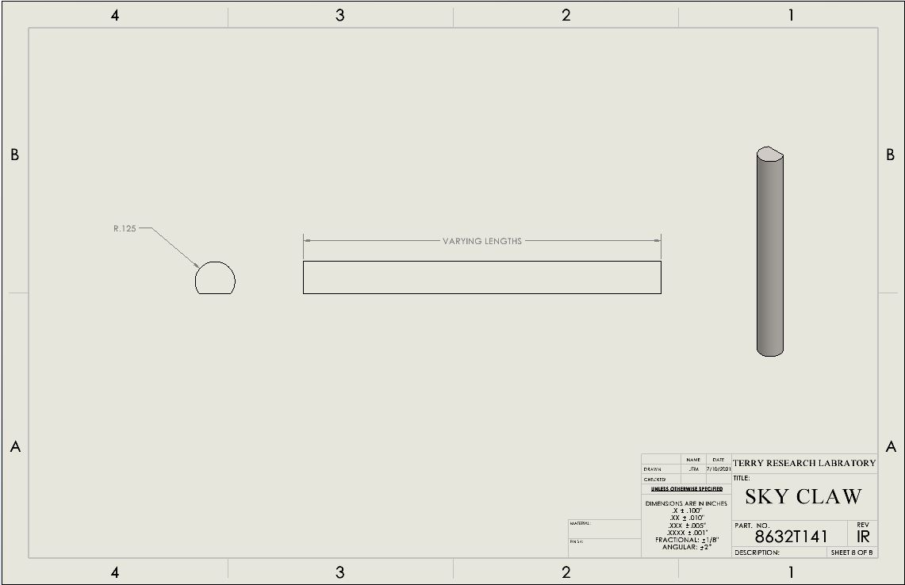

**Frame**

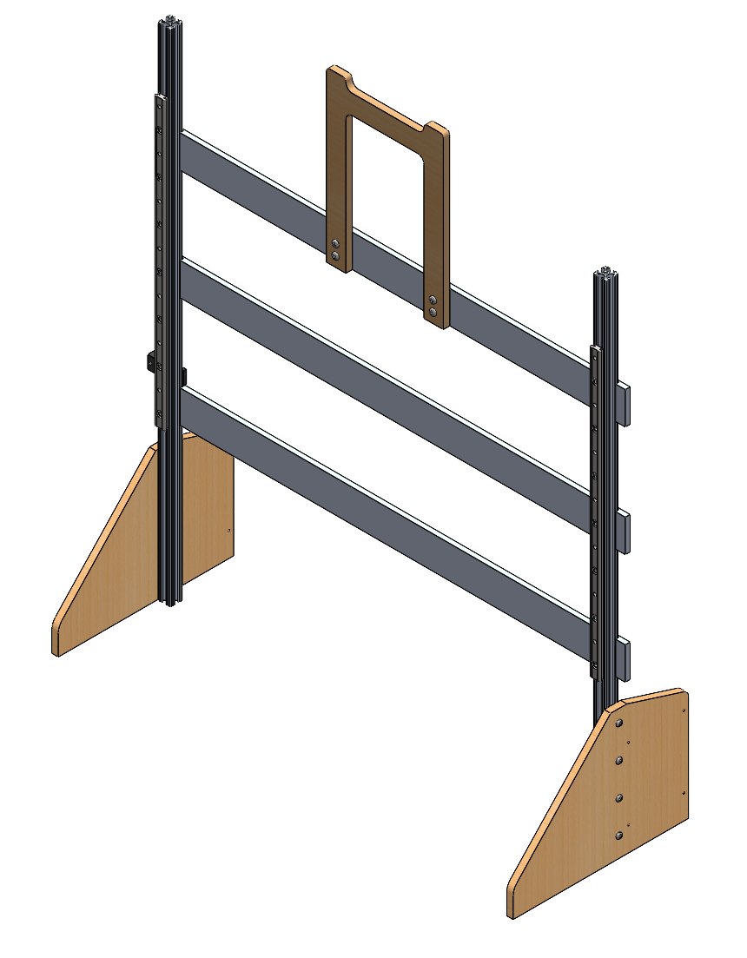

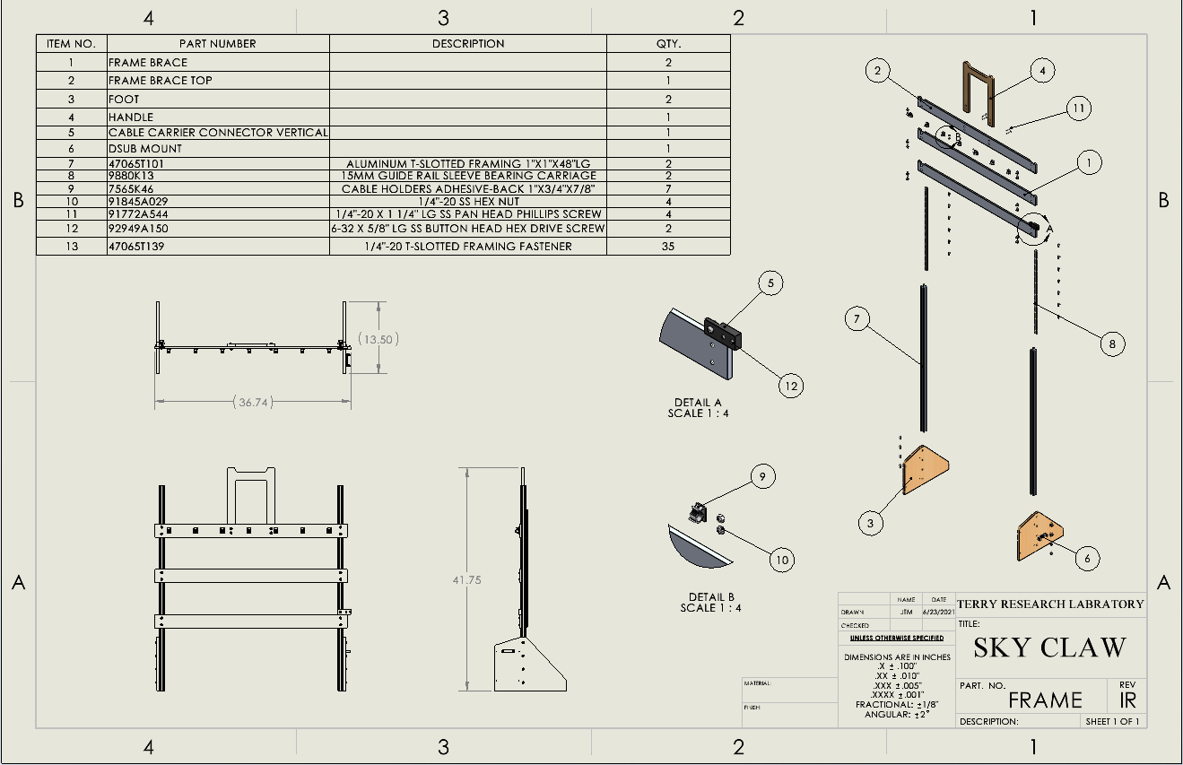

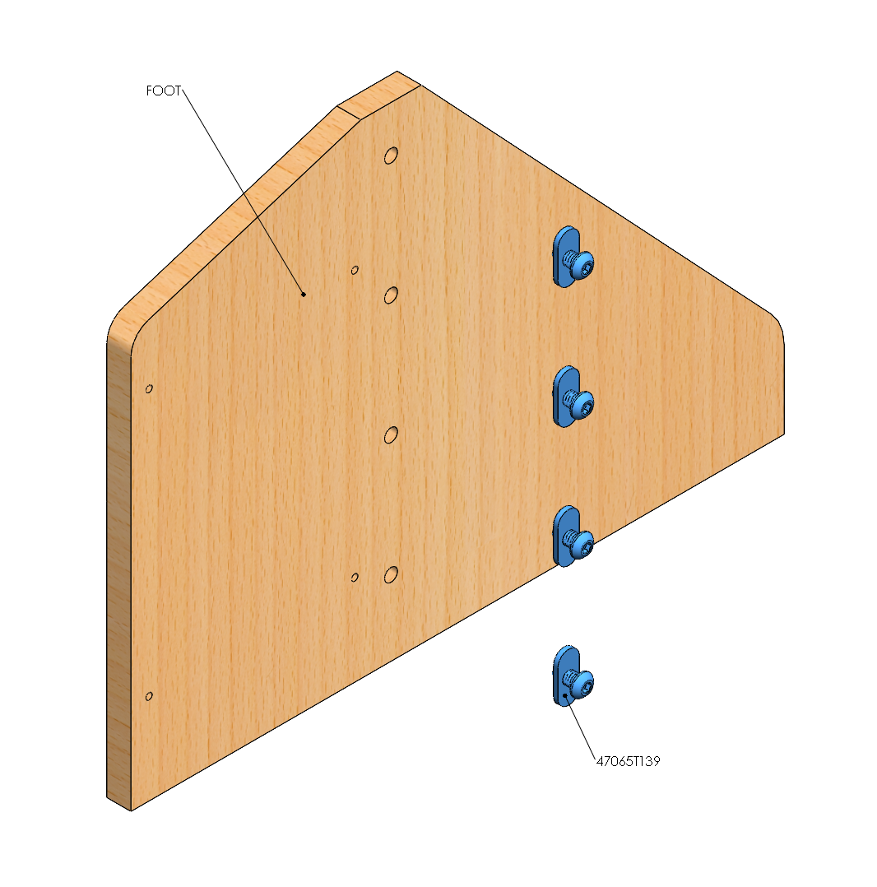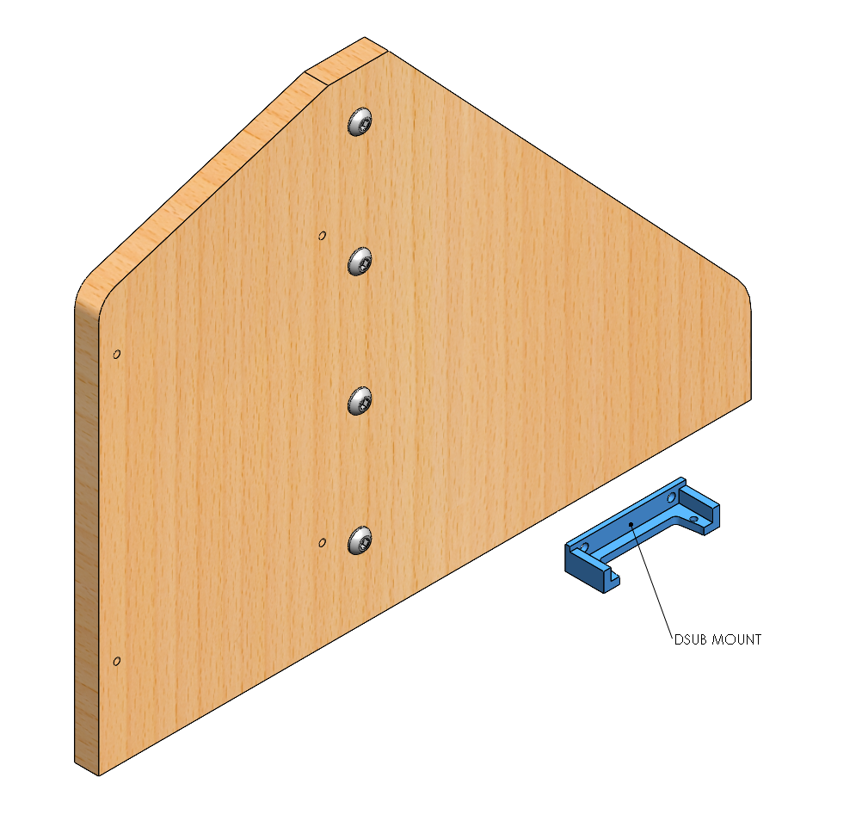

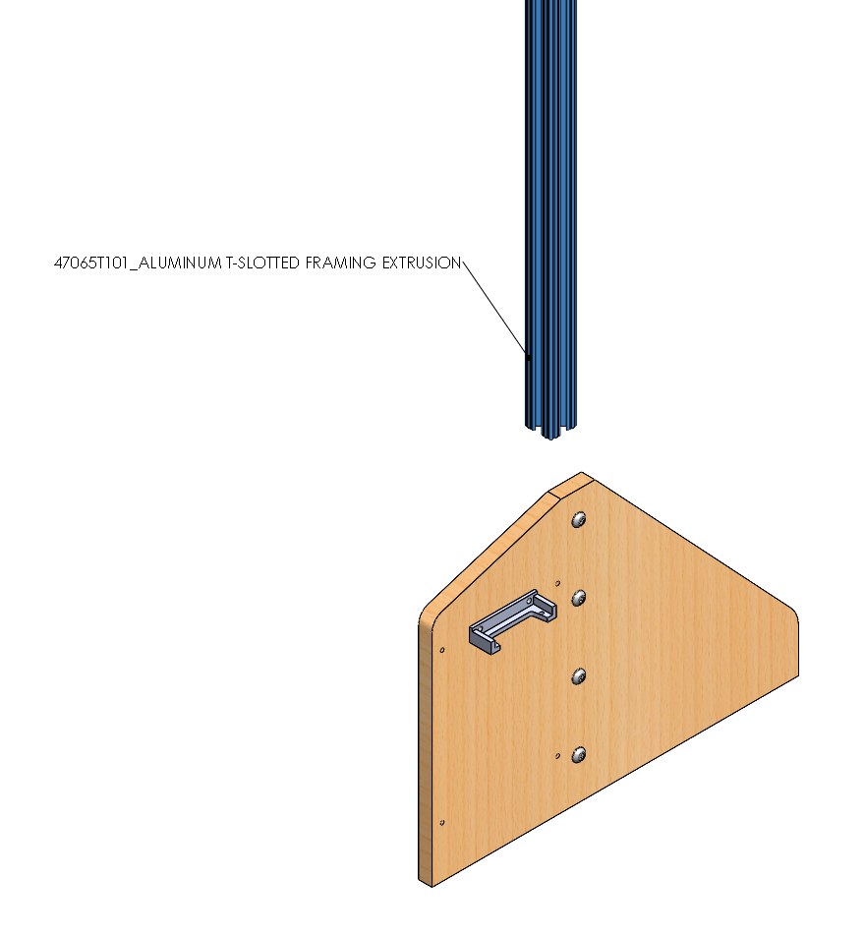 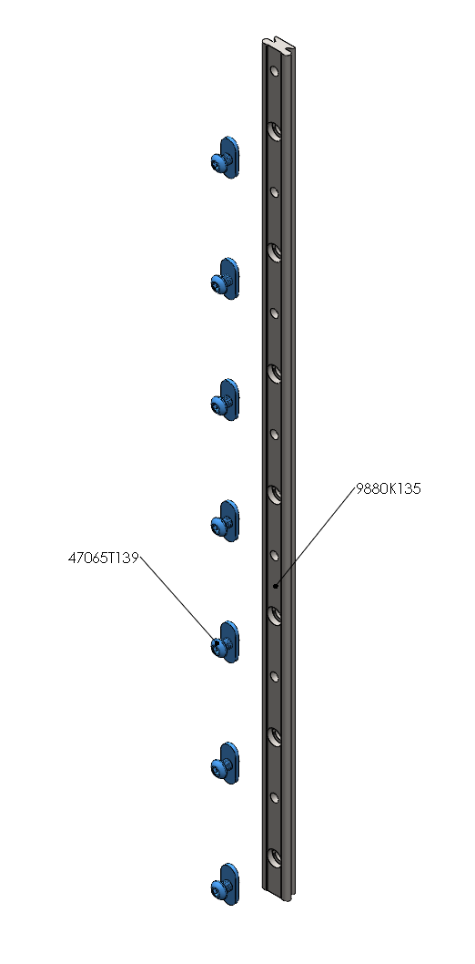

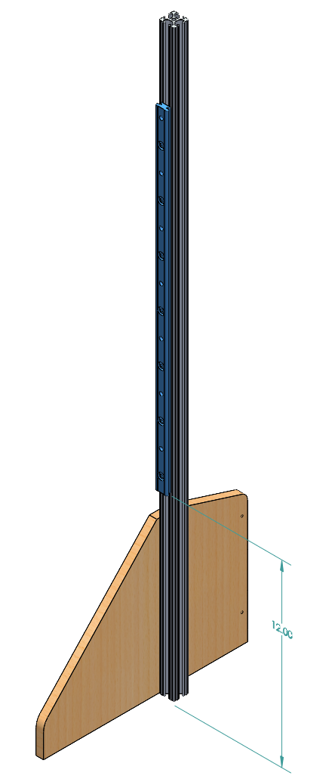 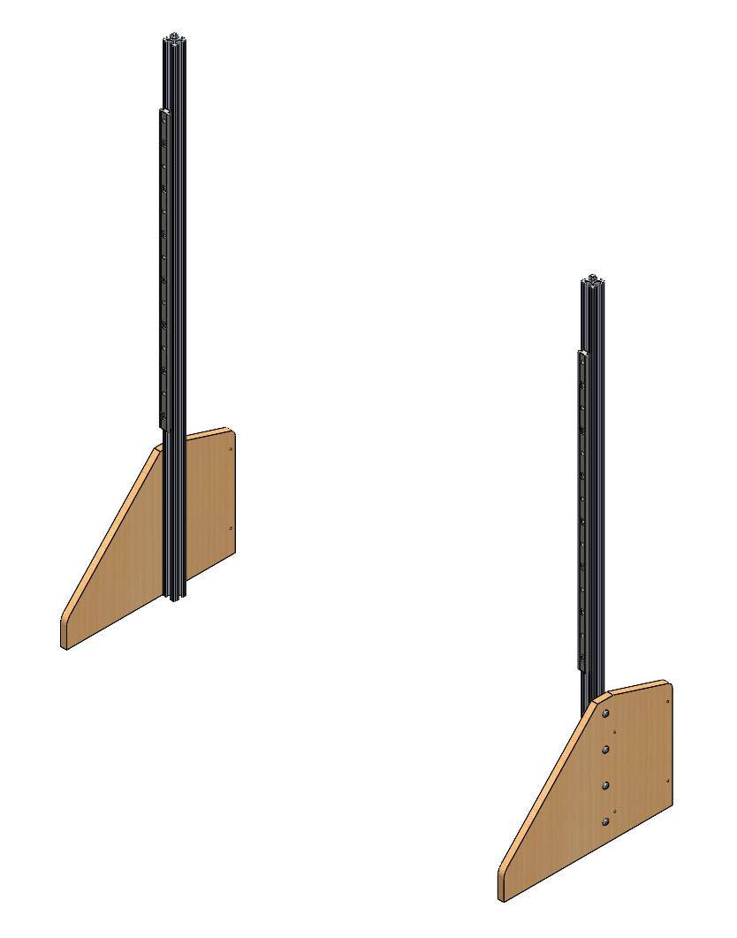

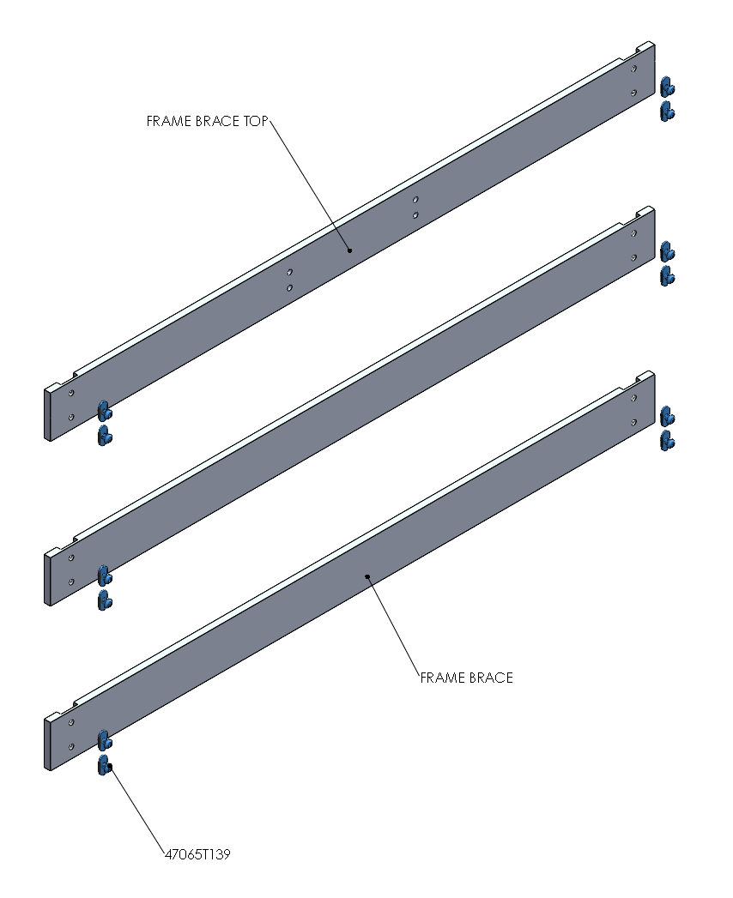 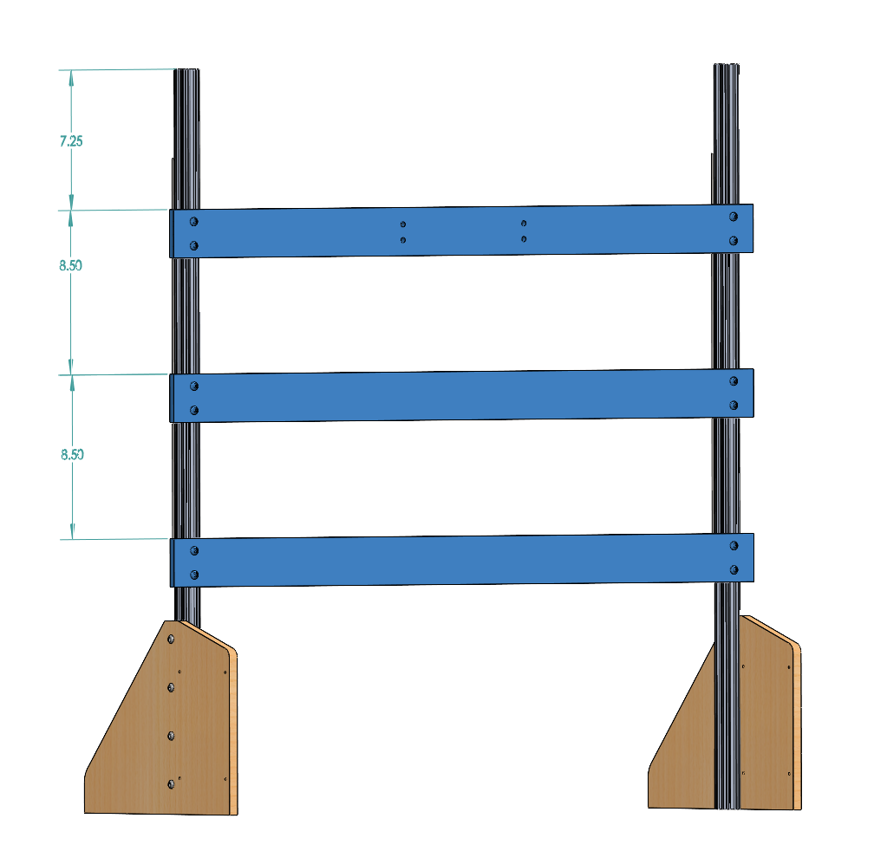

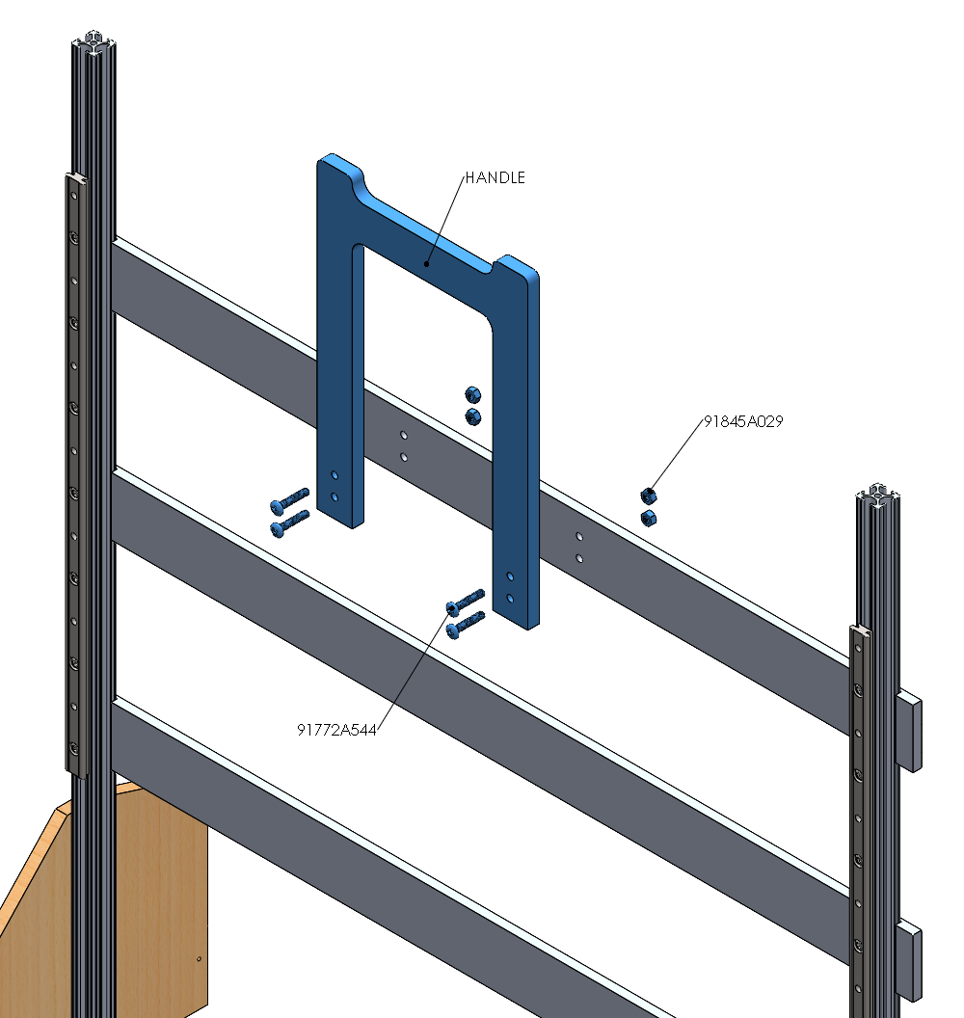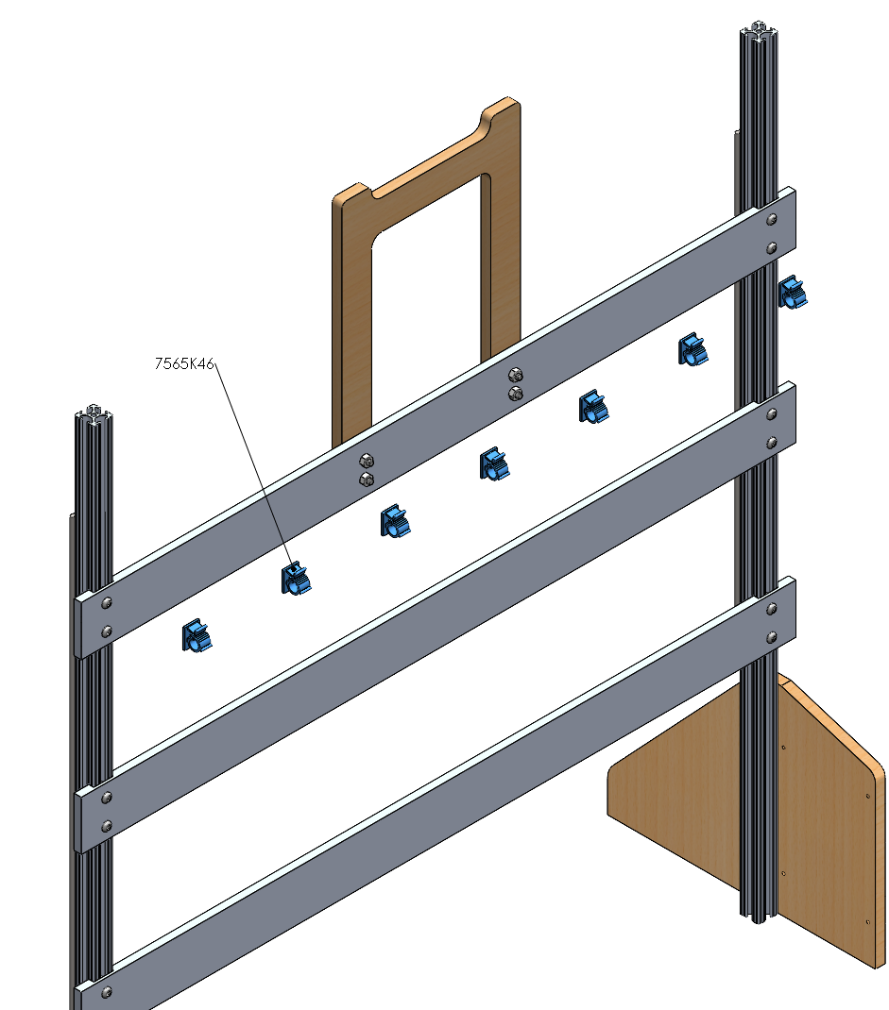

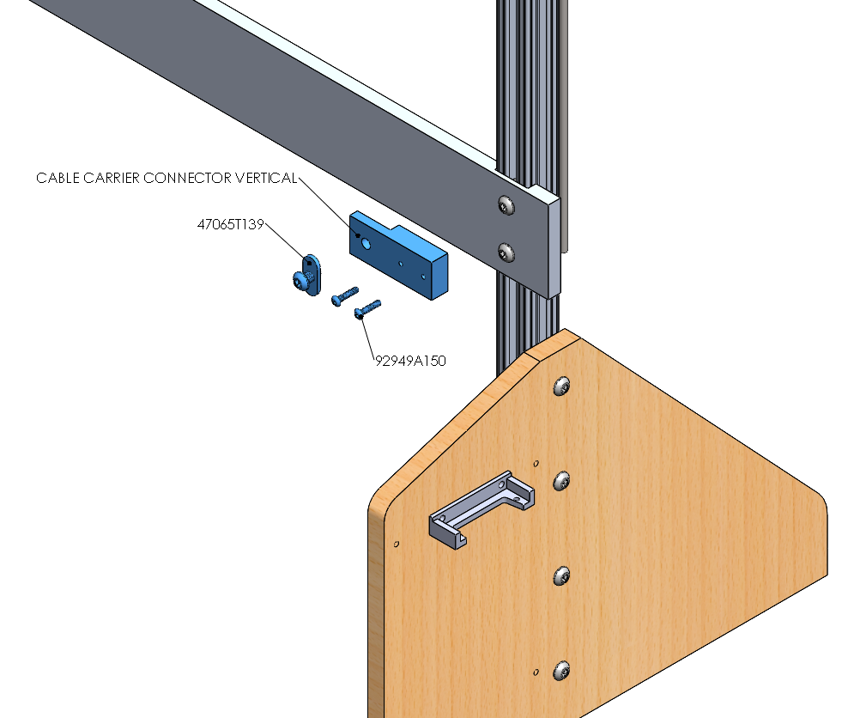

**Horizontal Housing Spindle**

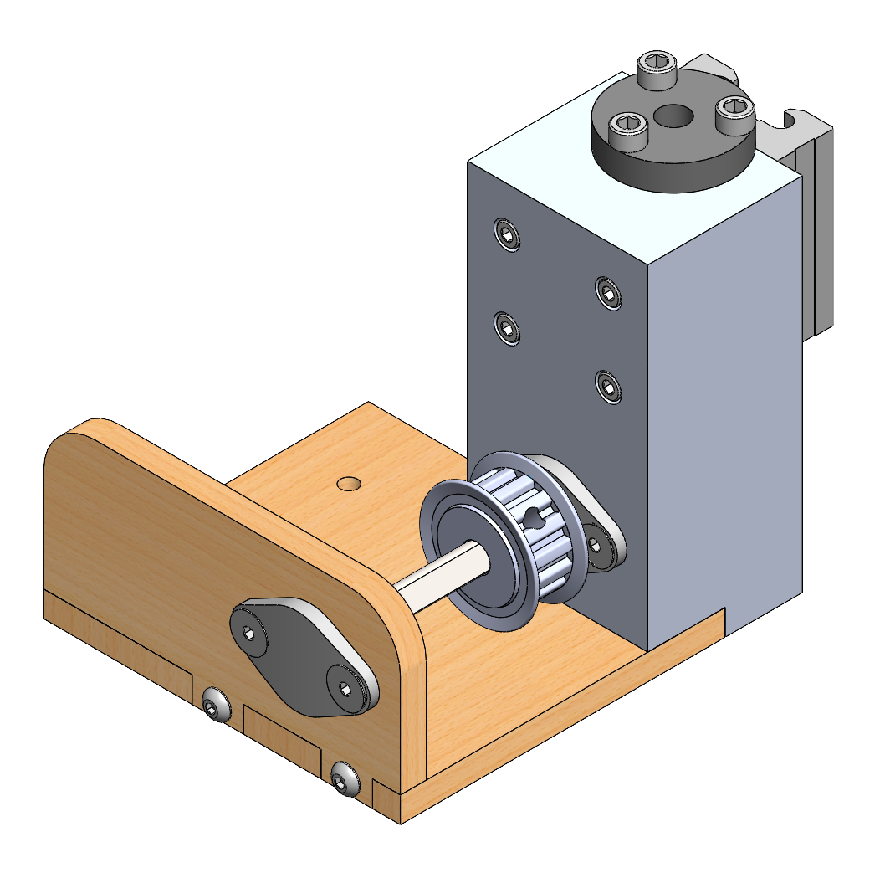

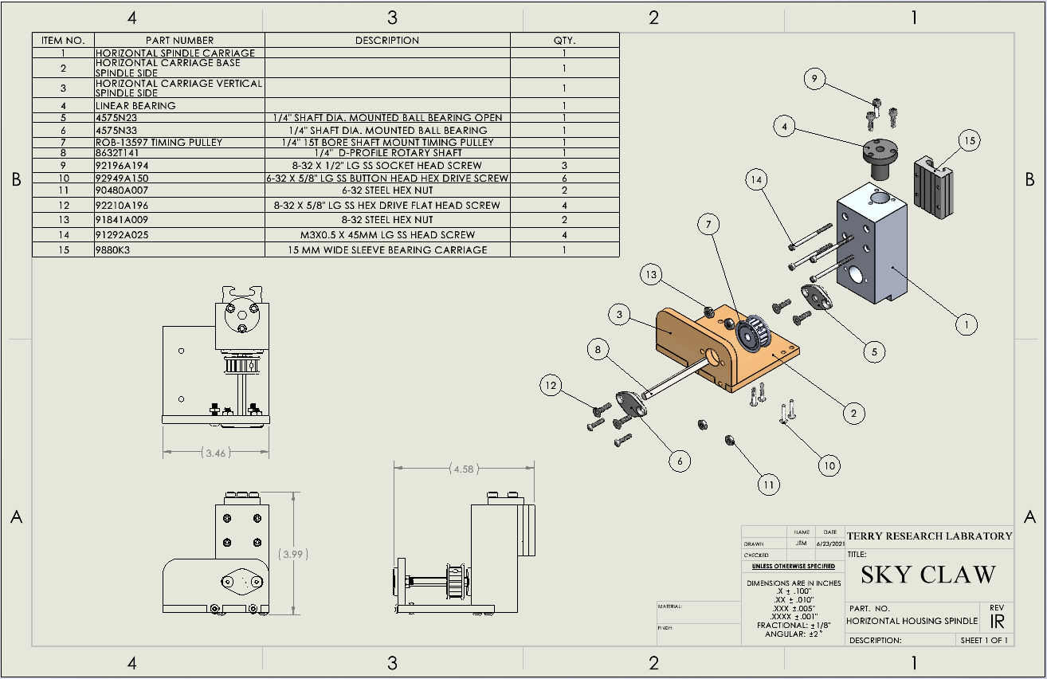

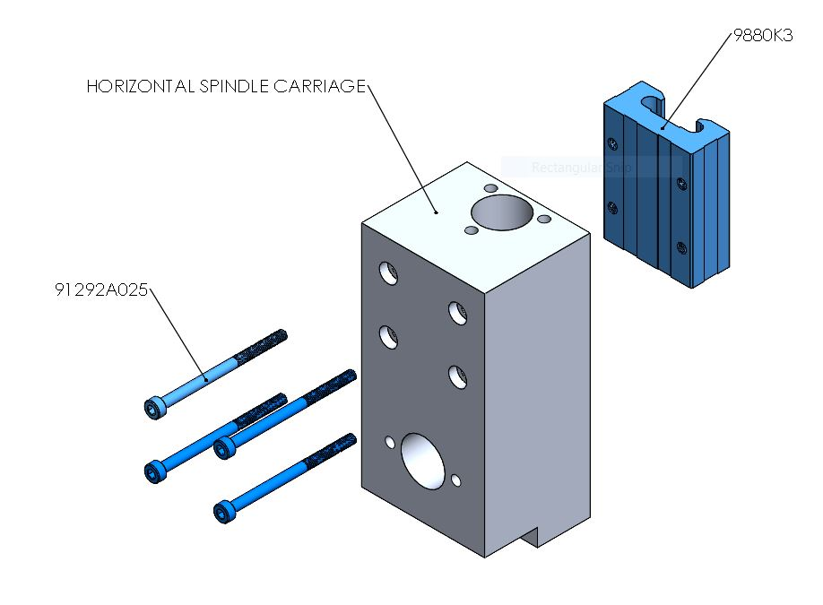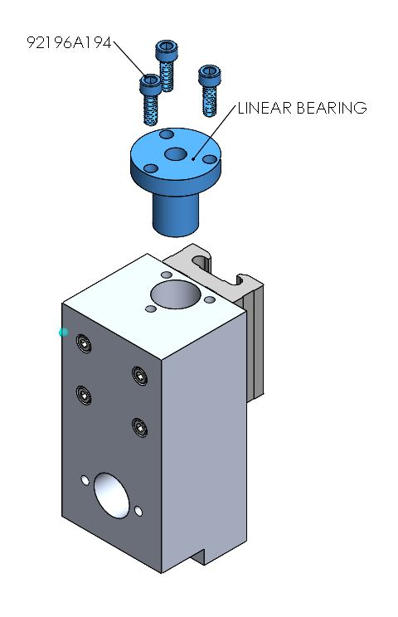

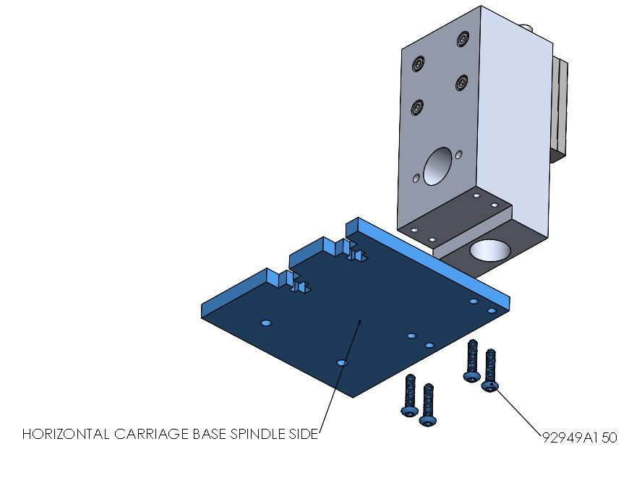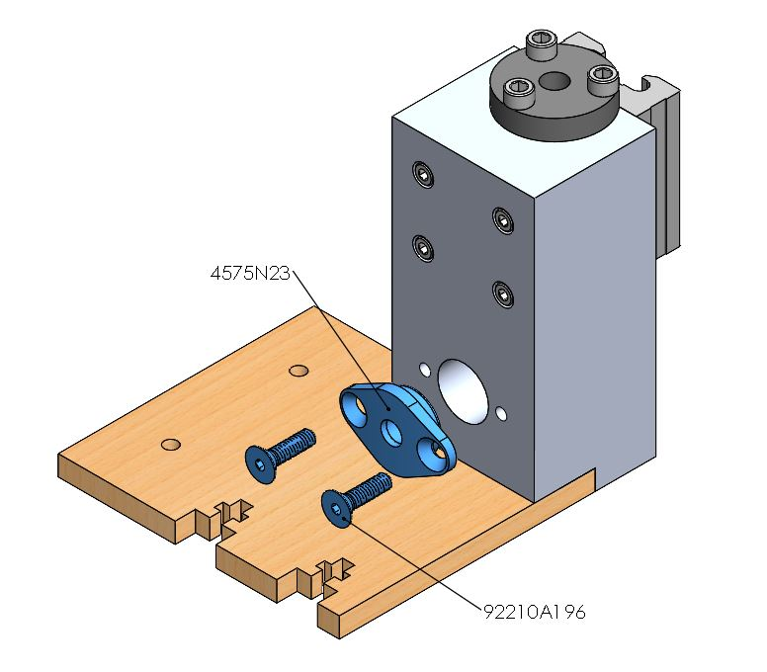

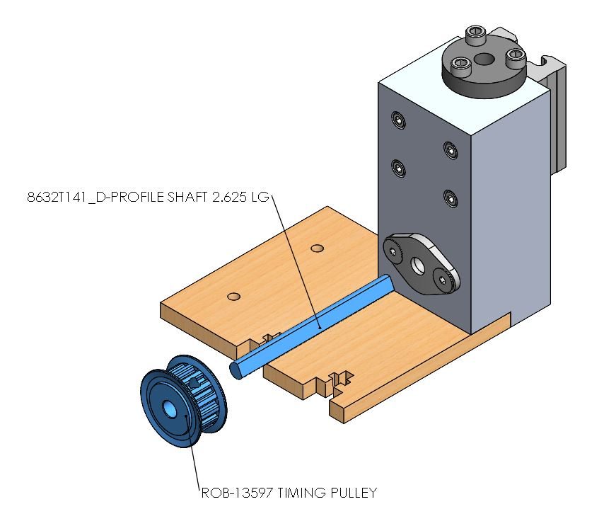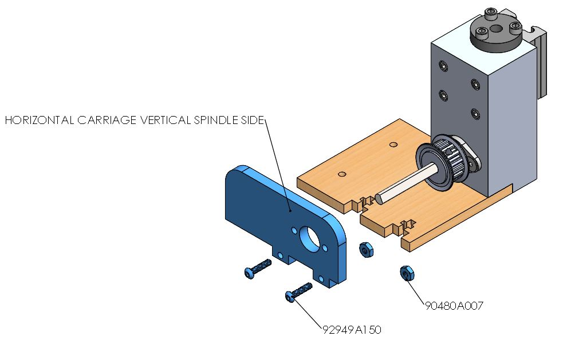

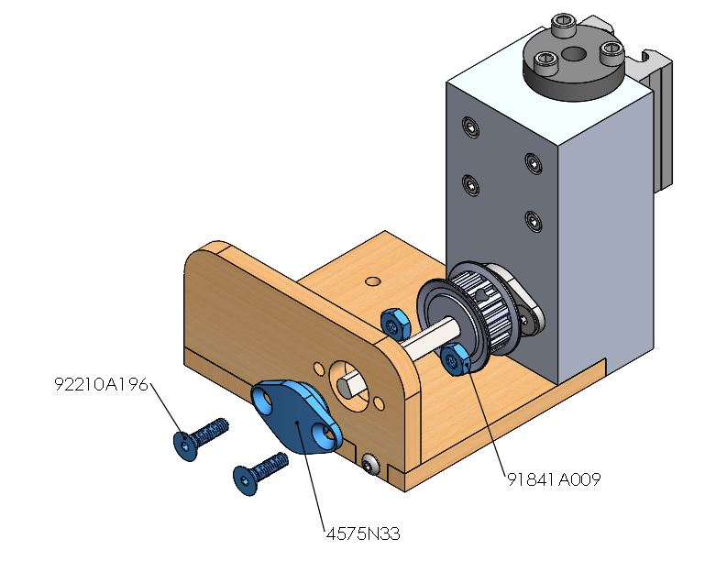

**Horizontal Housing Motor**

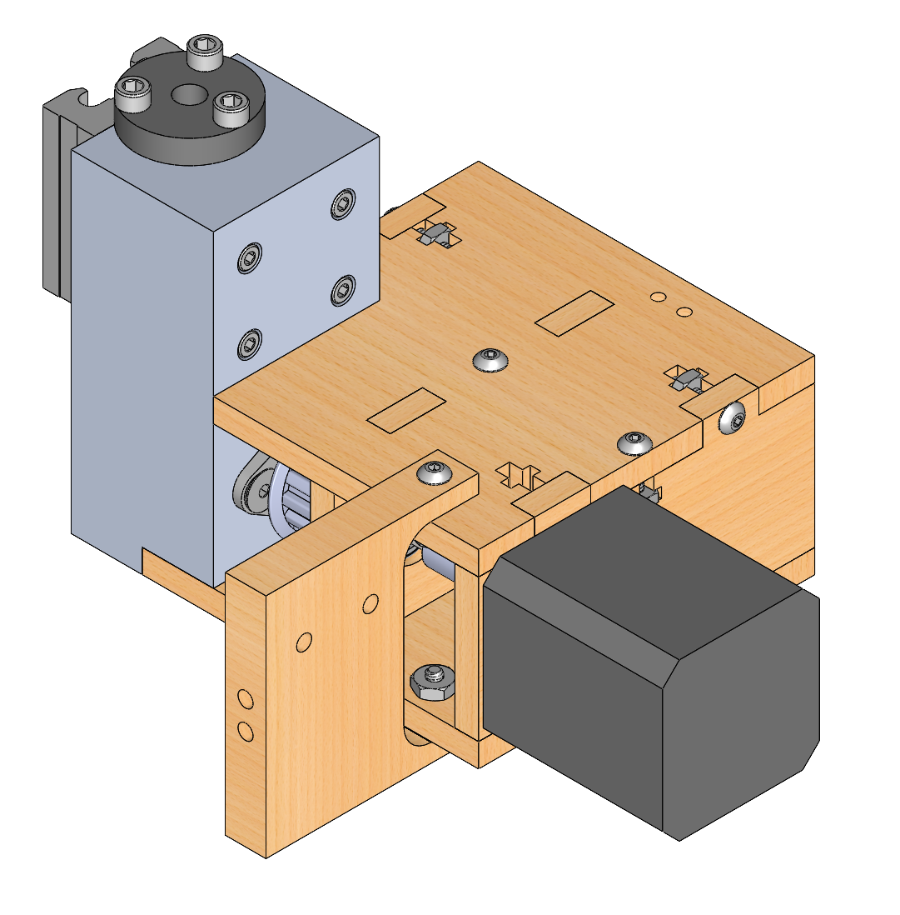

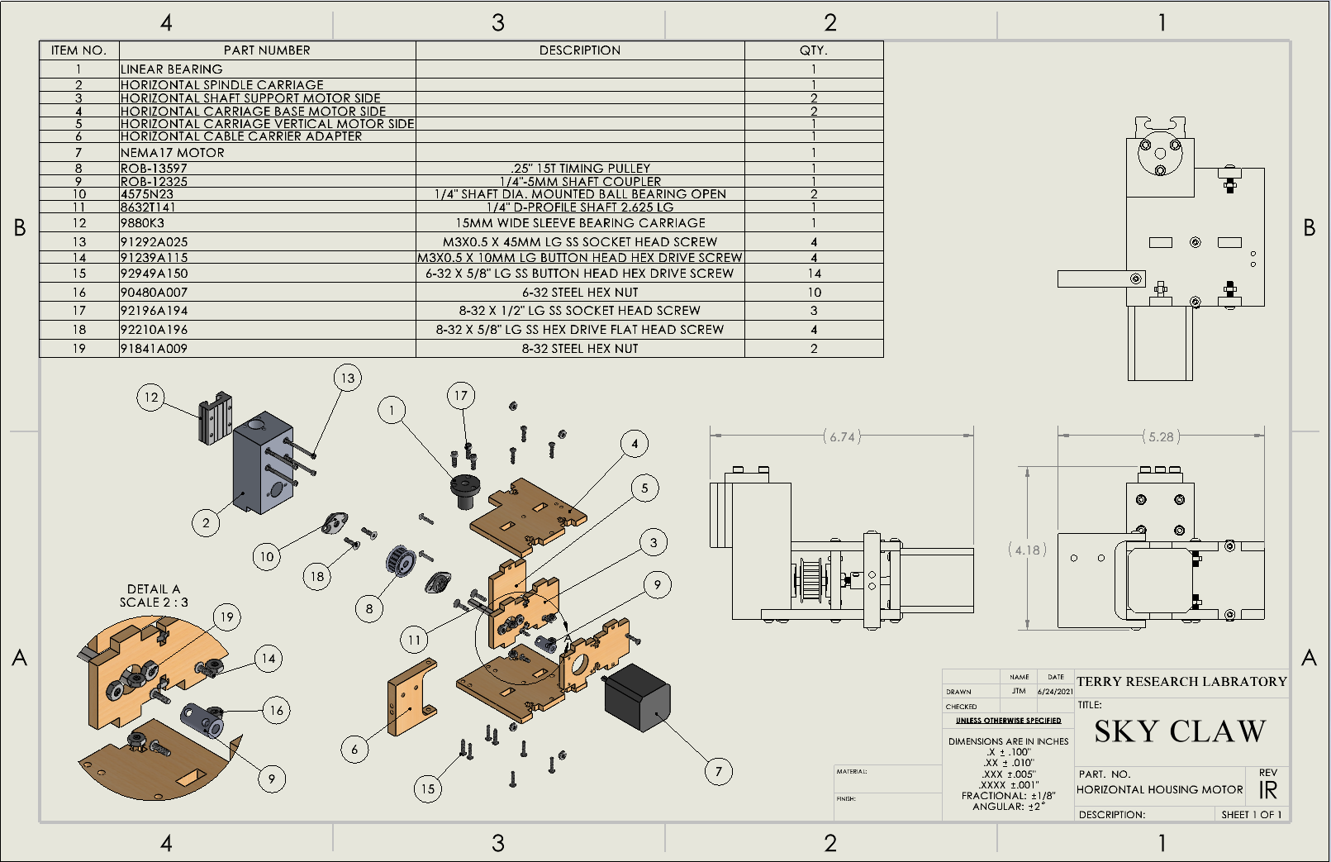

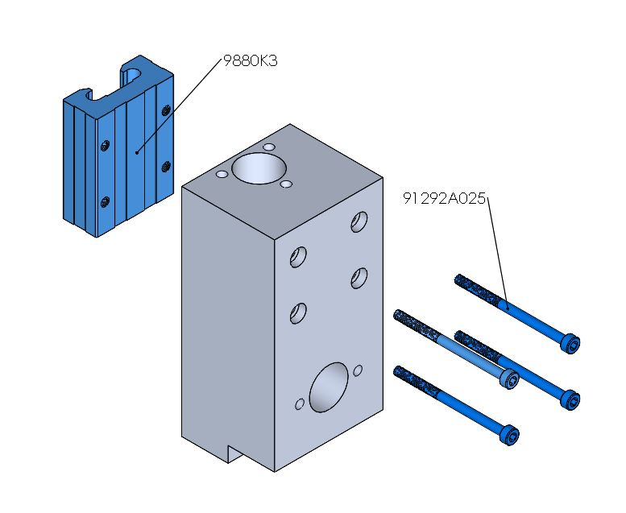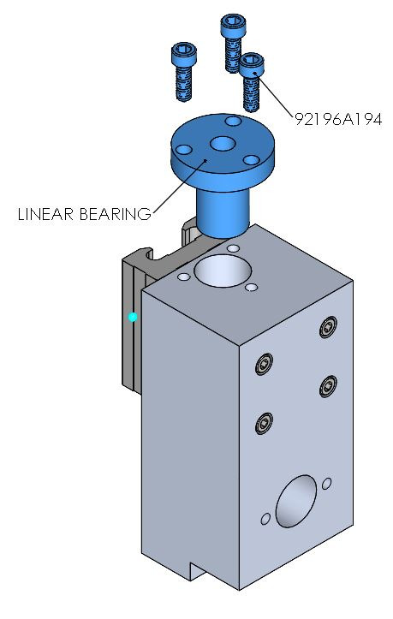

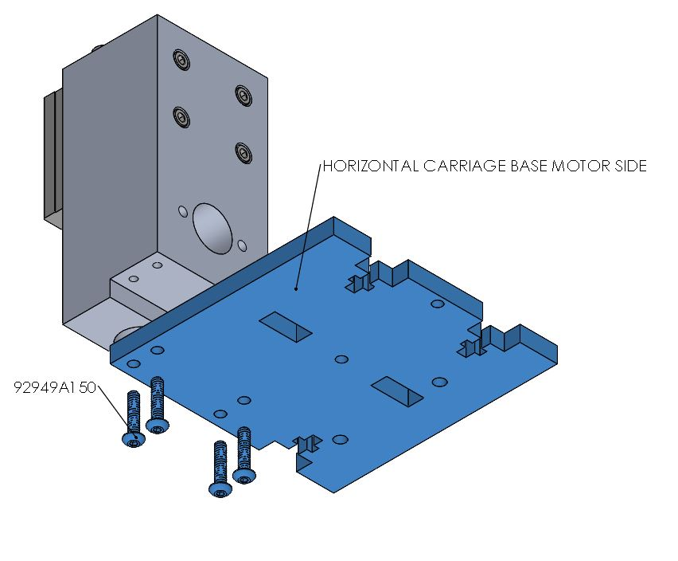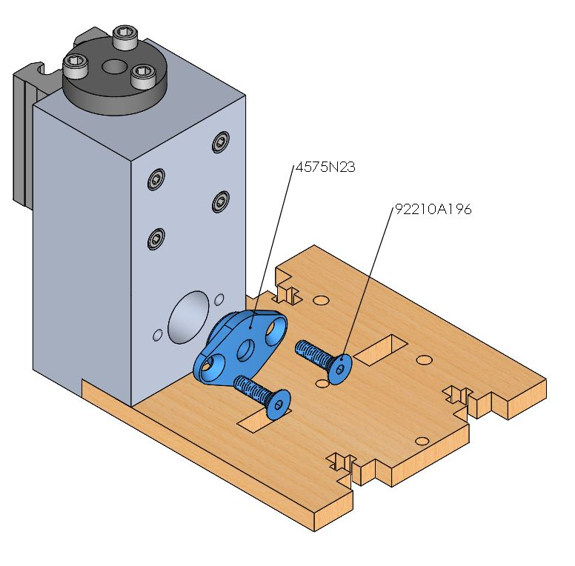

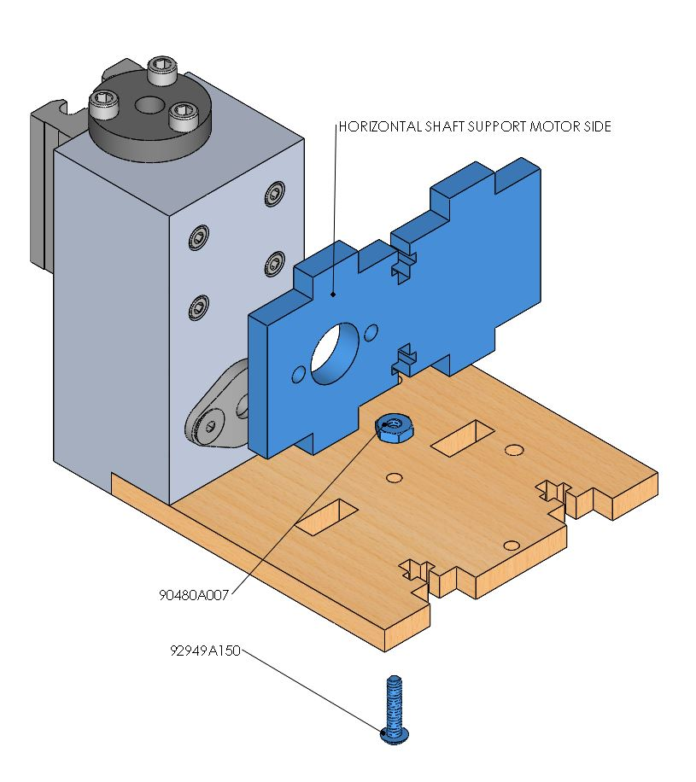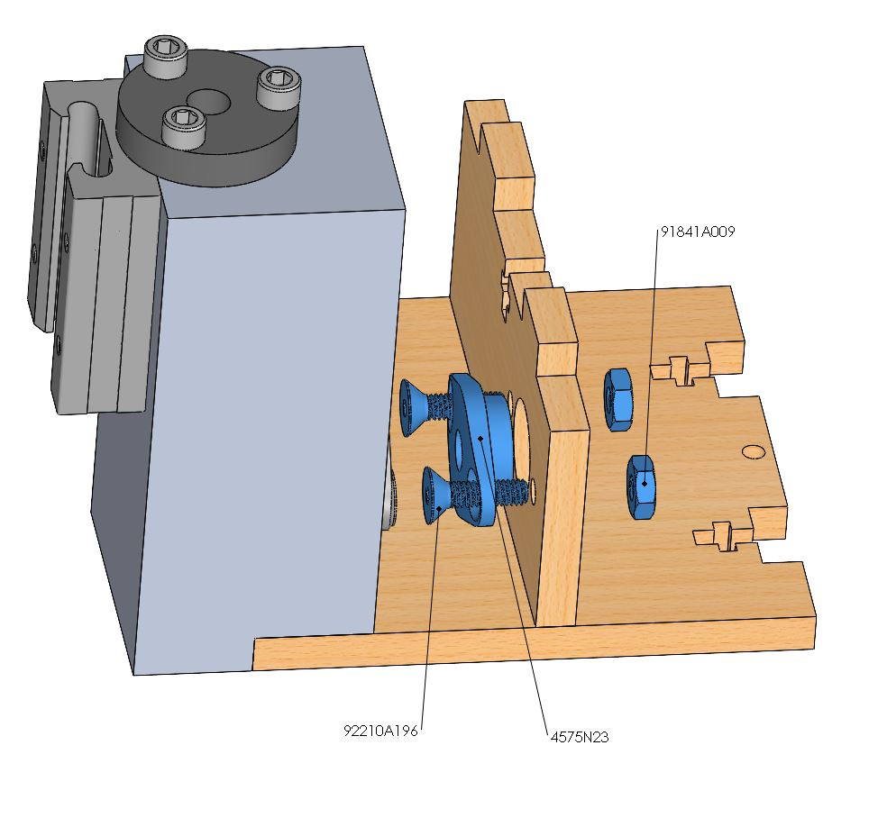

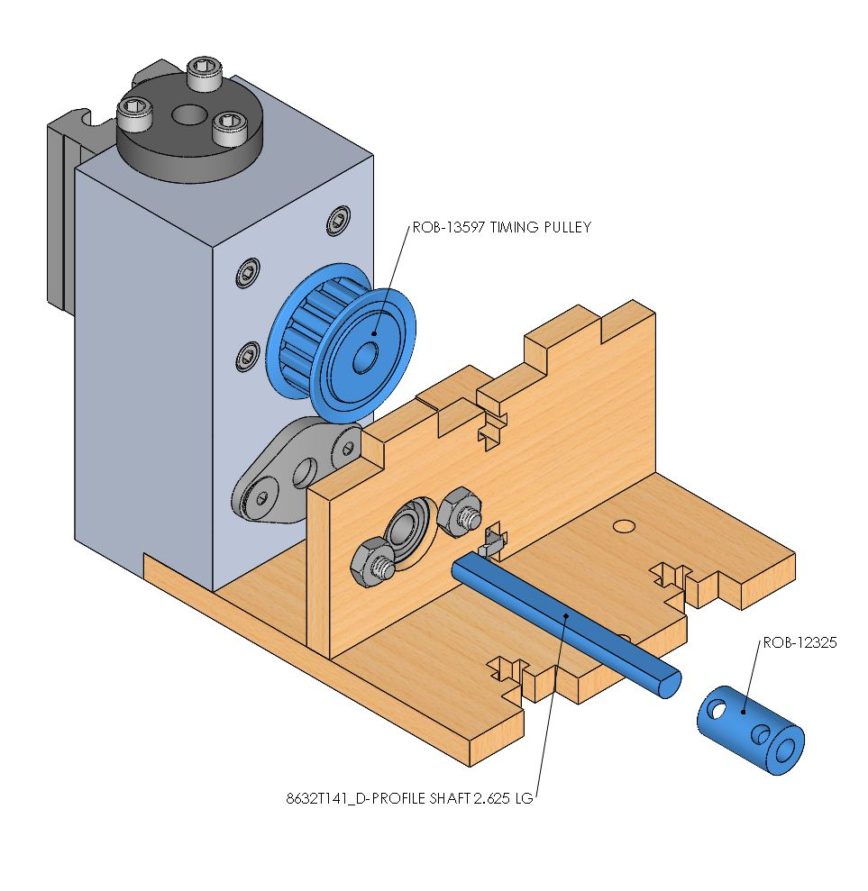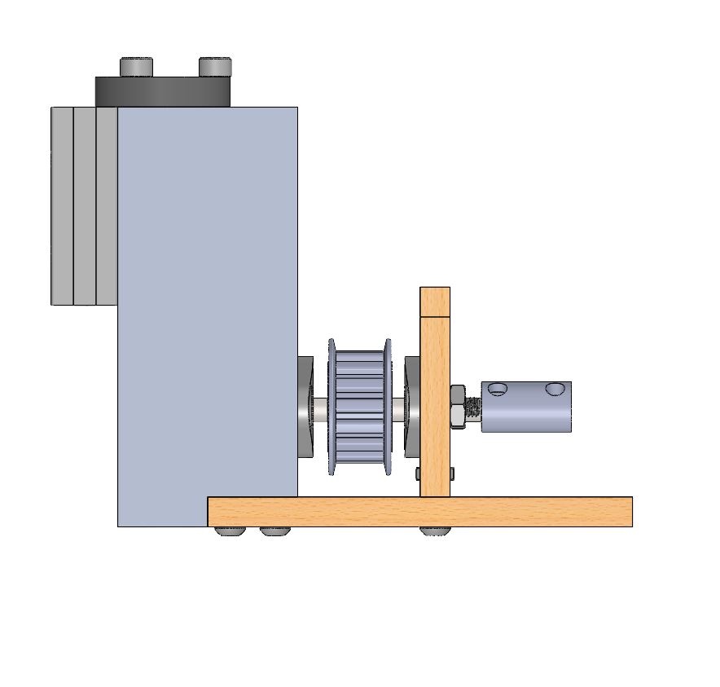

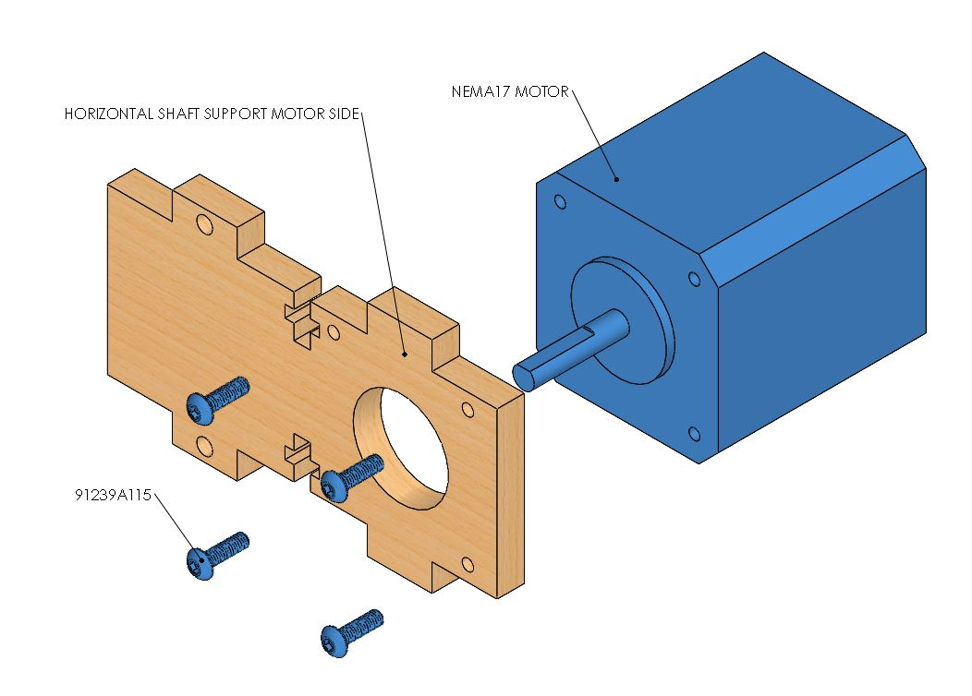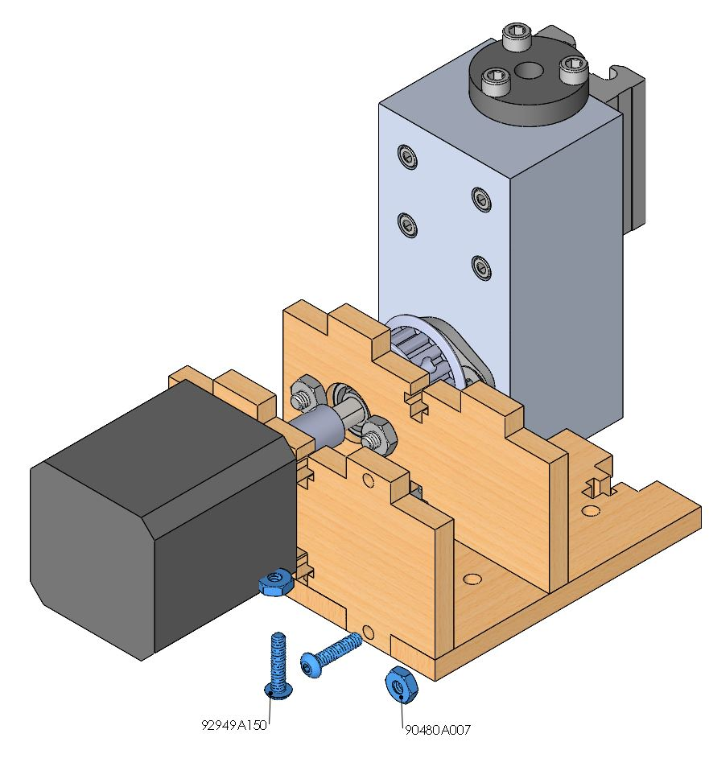

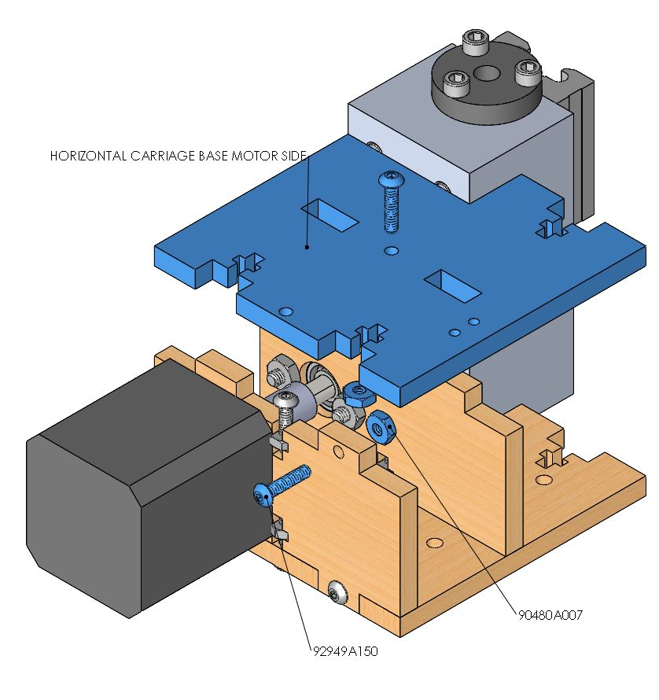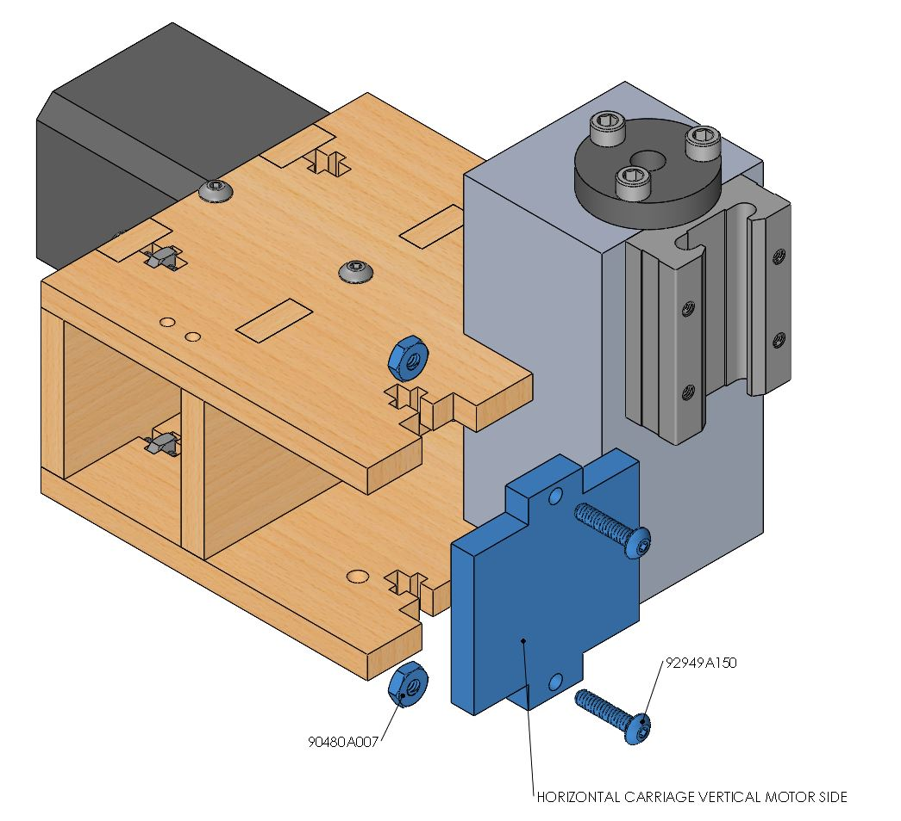

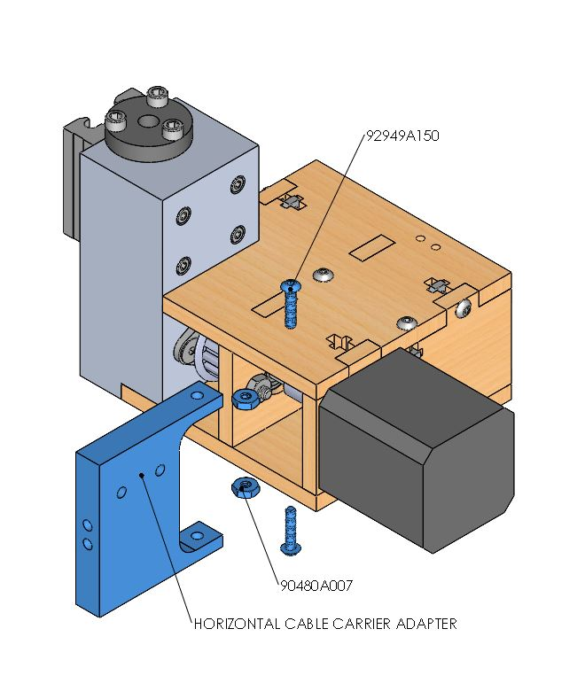

**Gripper**

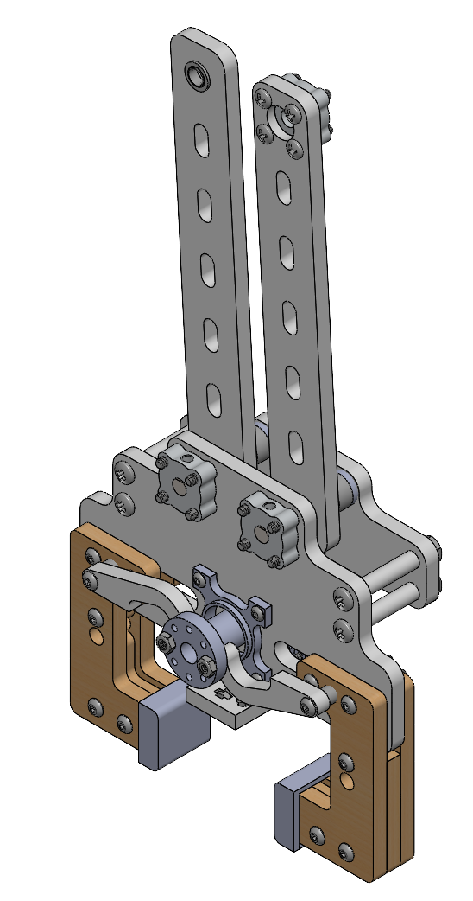

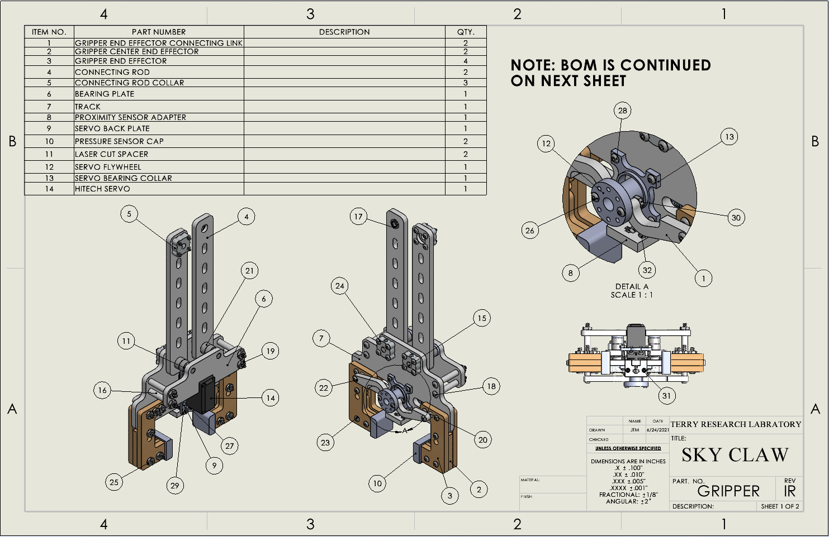

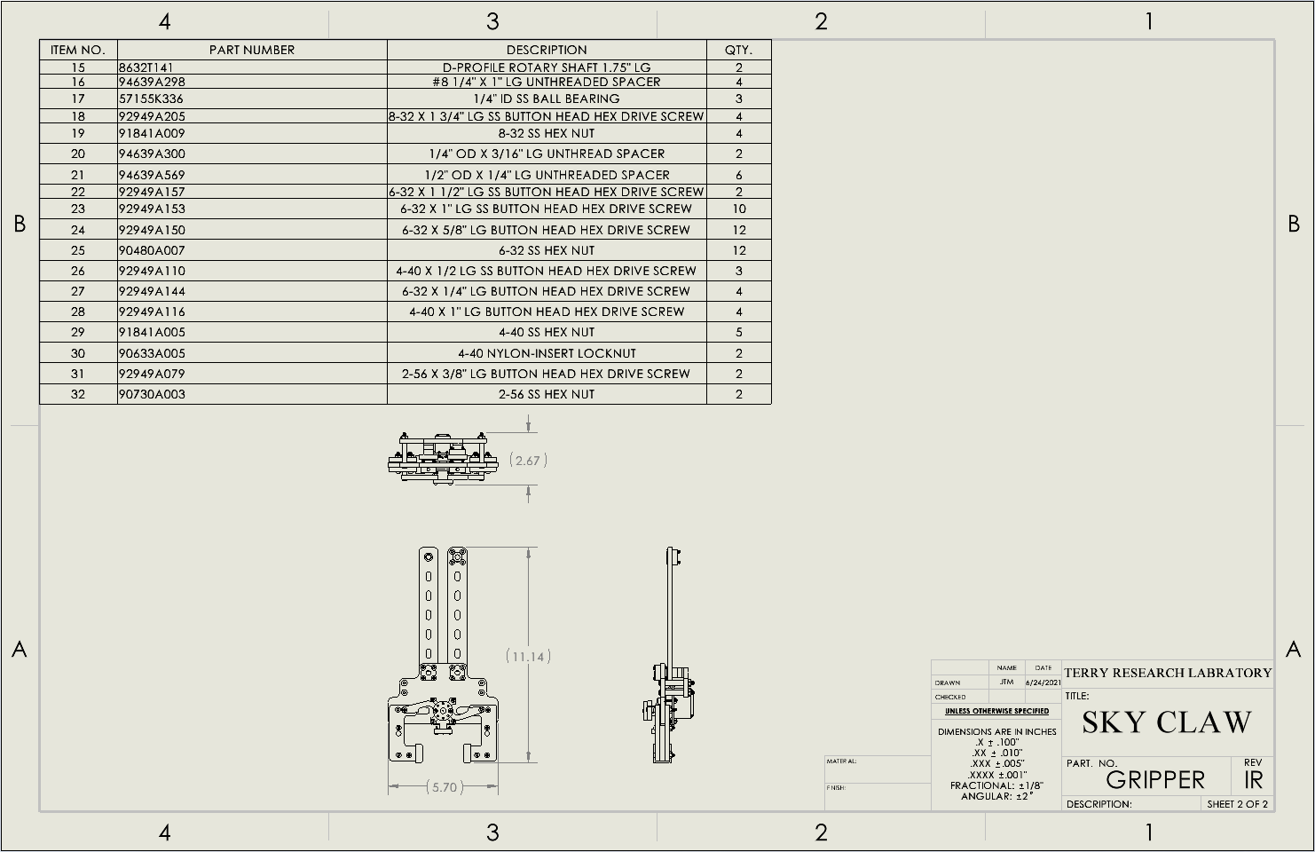

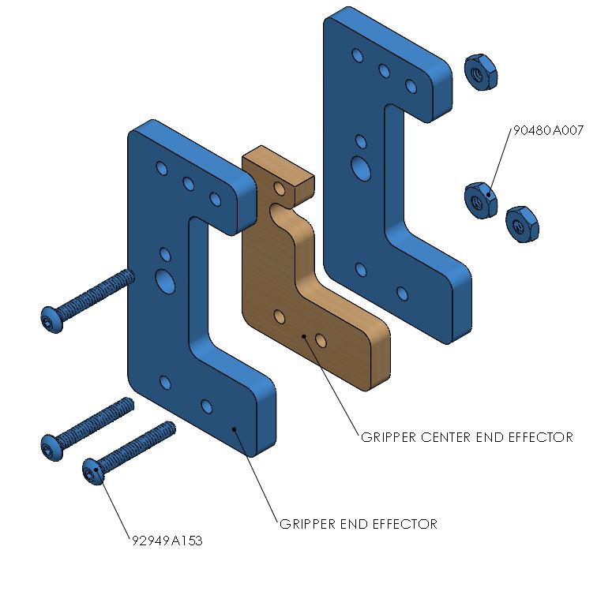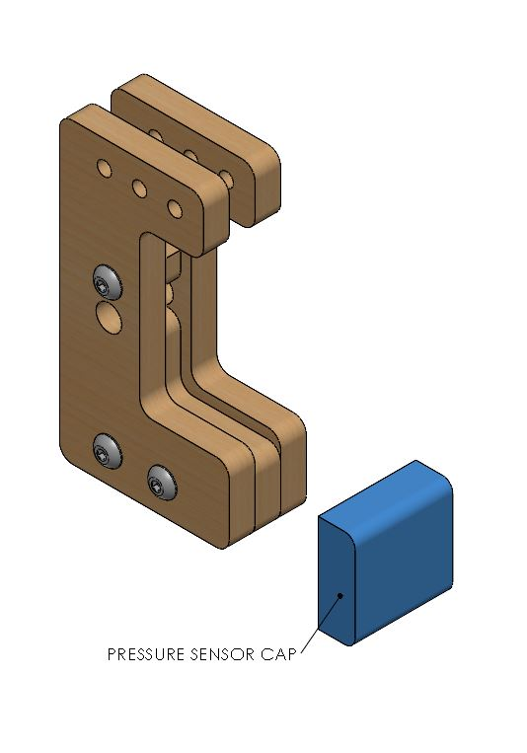

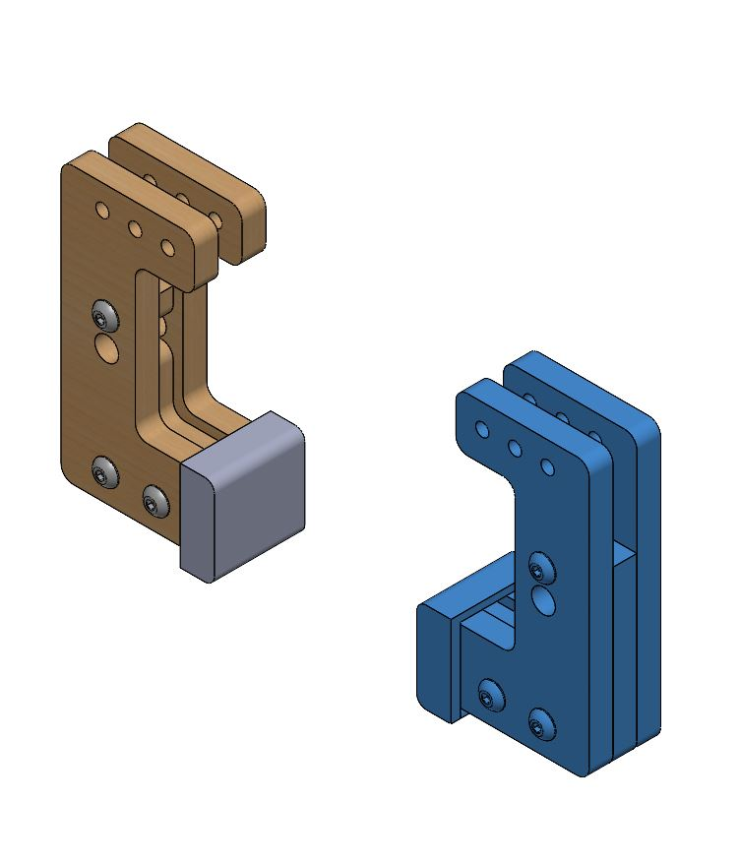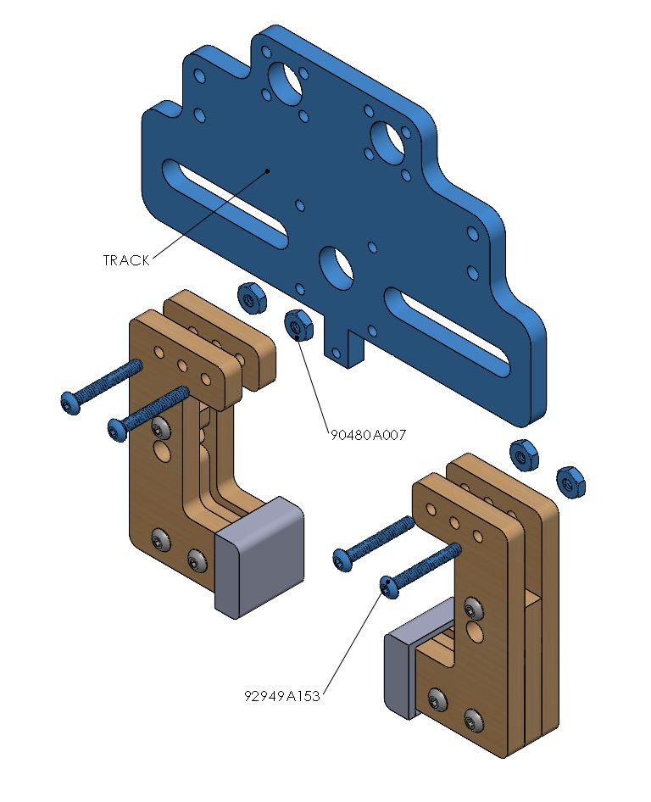

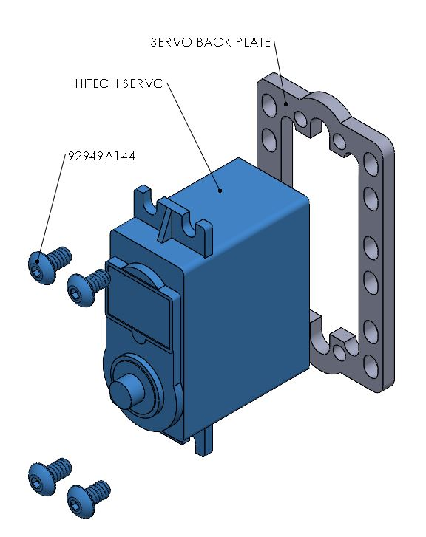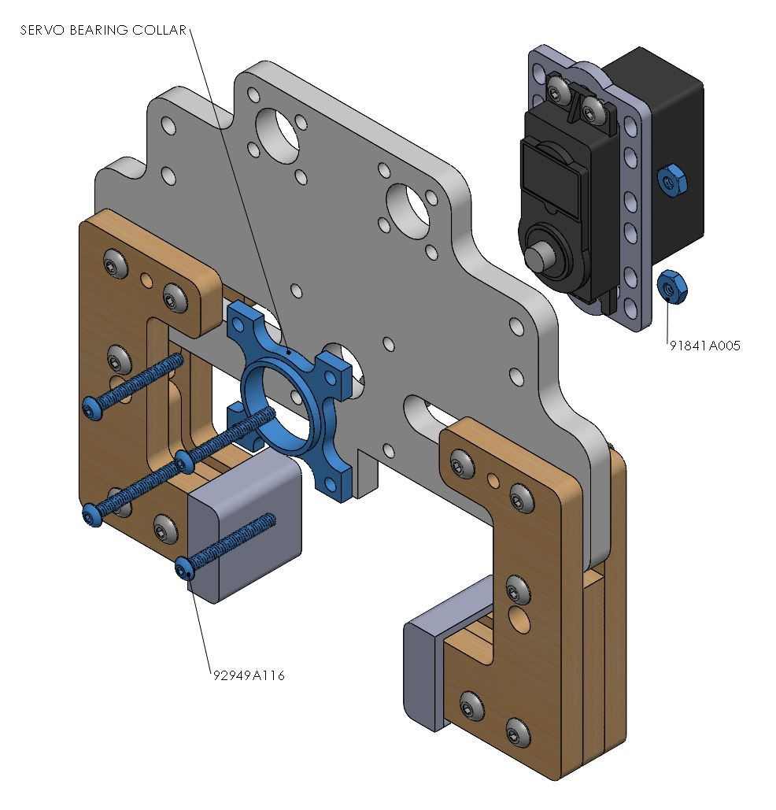

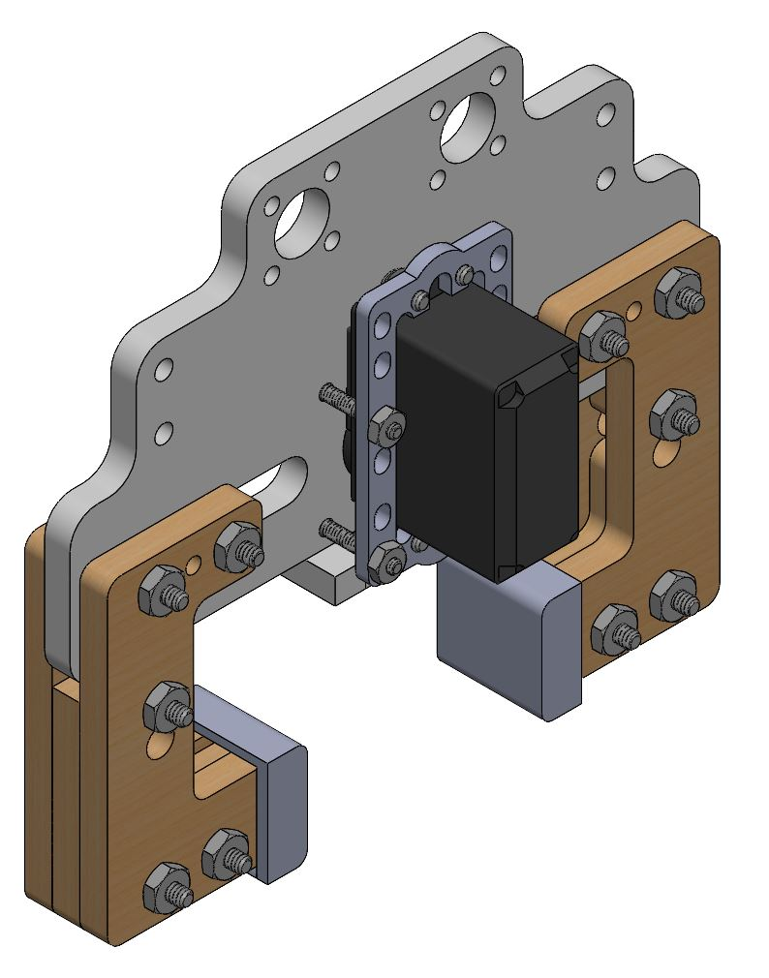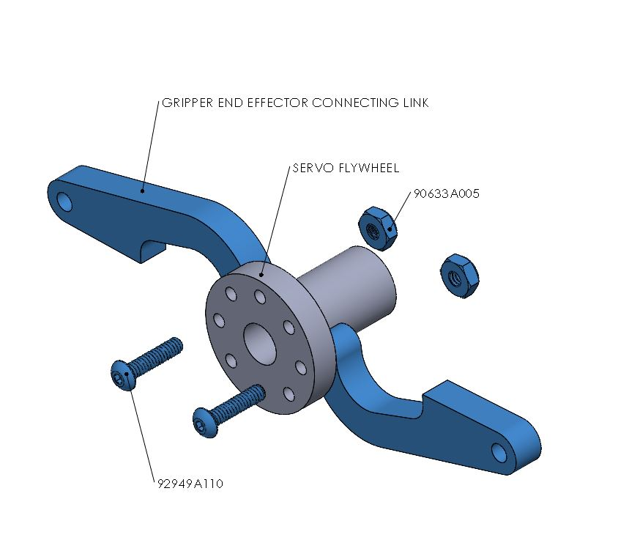

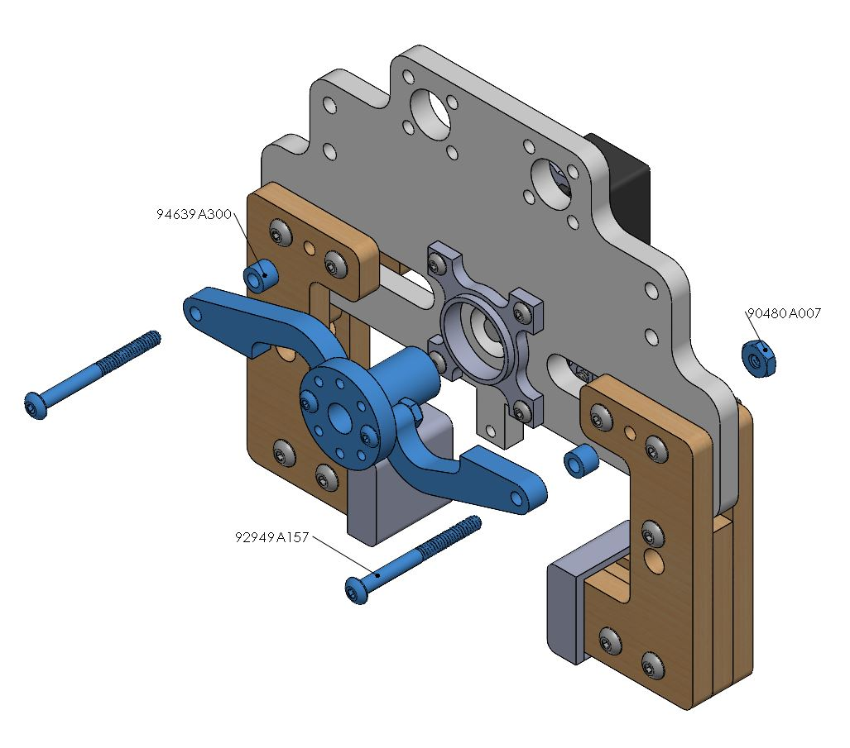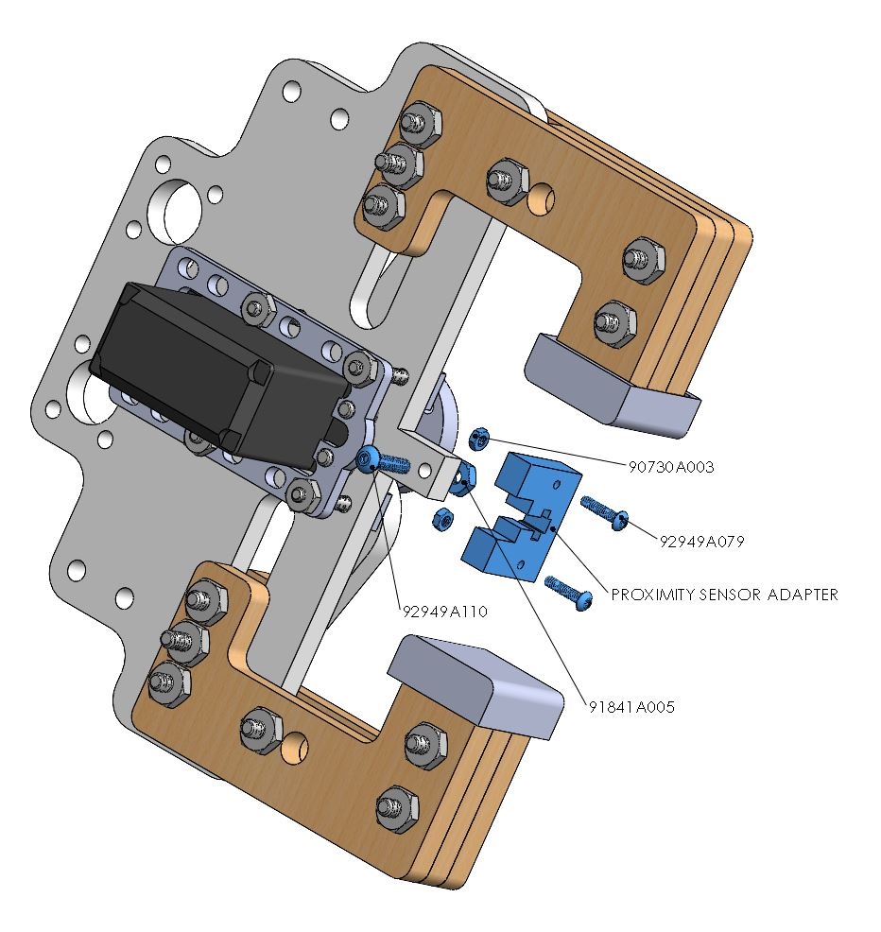

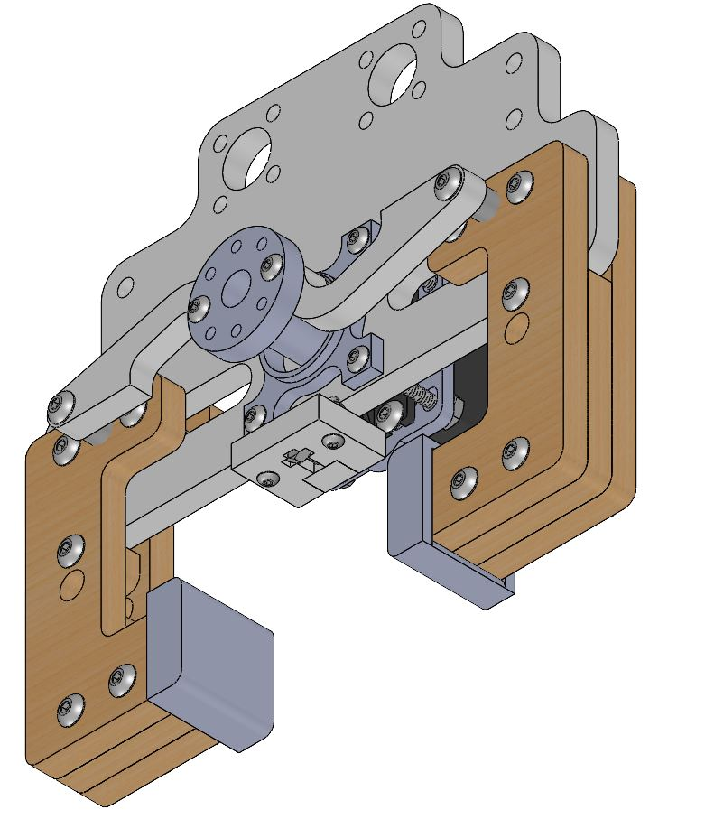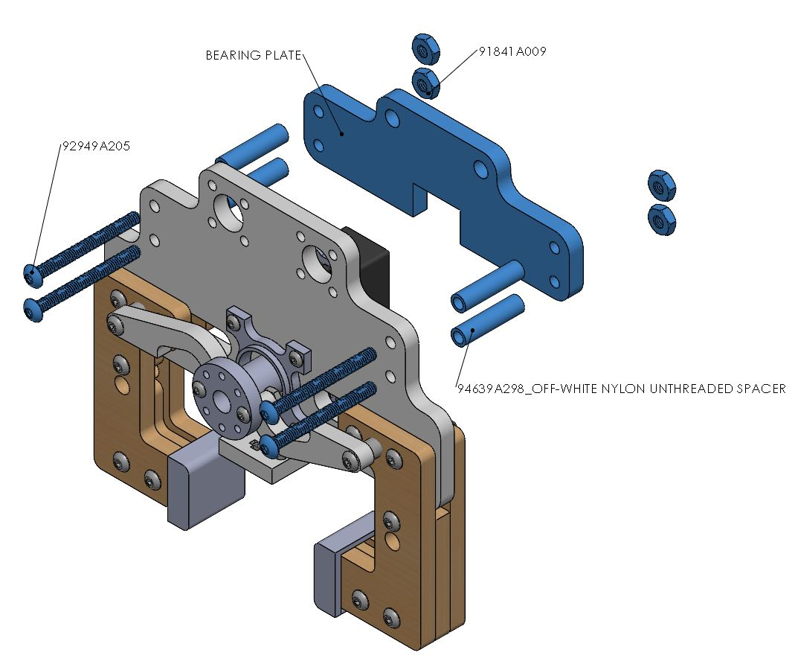

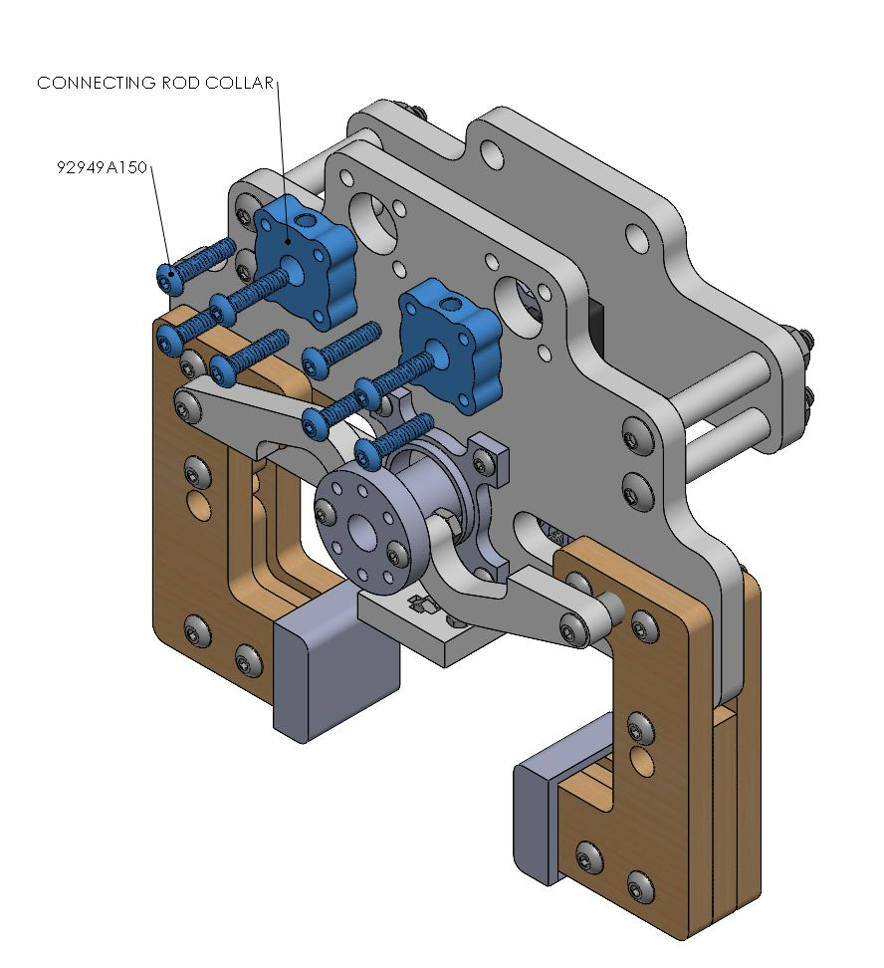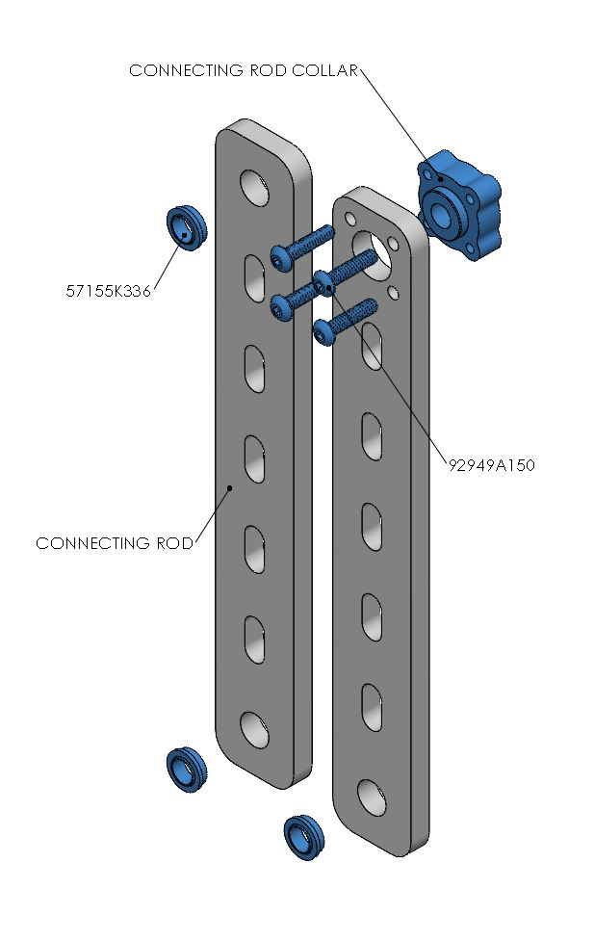

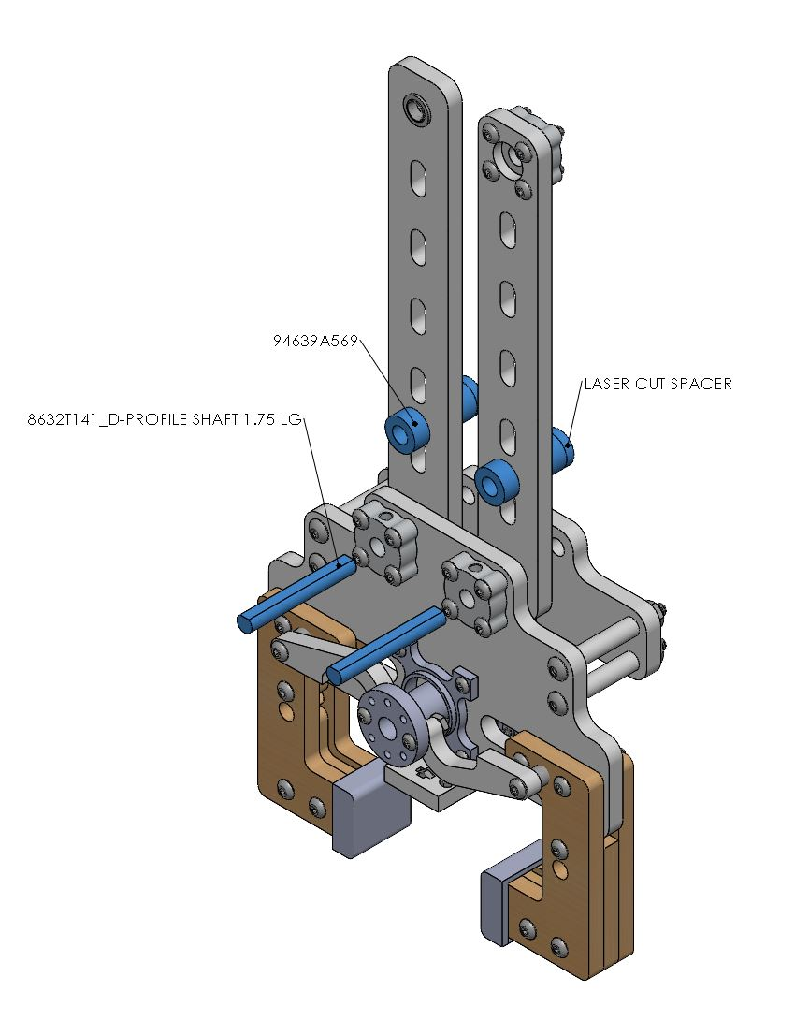 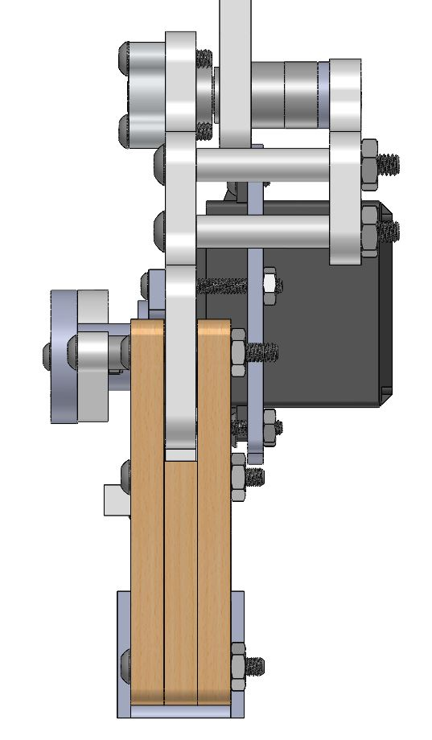

**Gripper Mount**

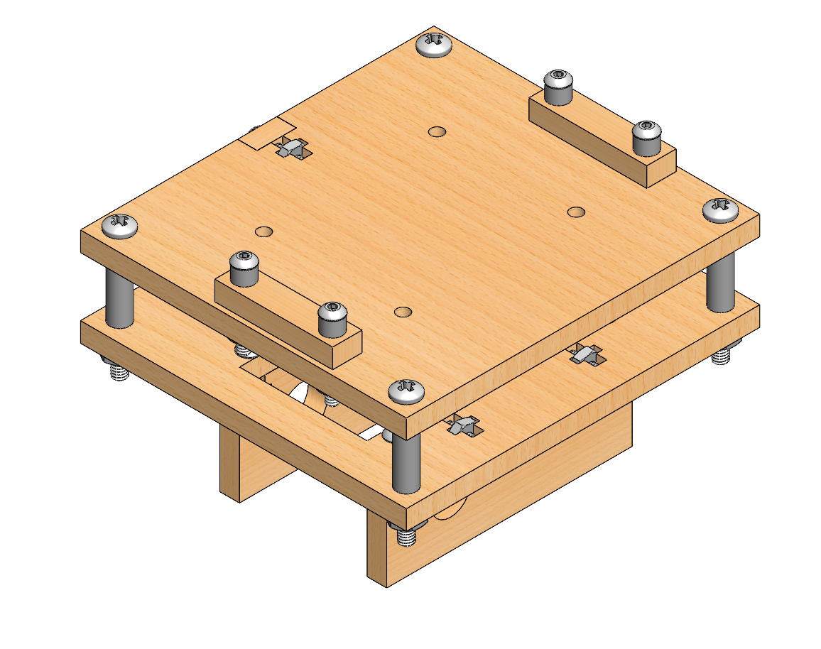

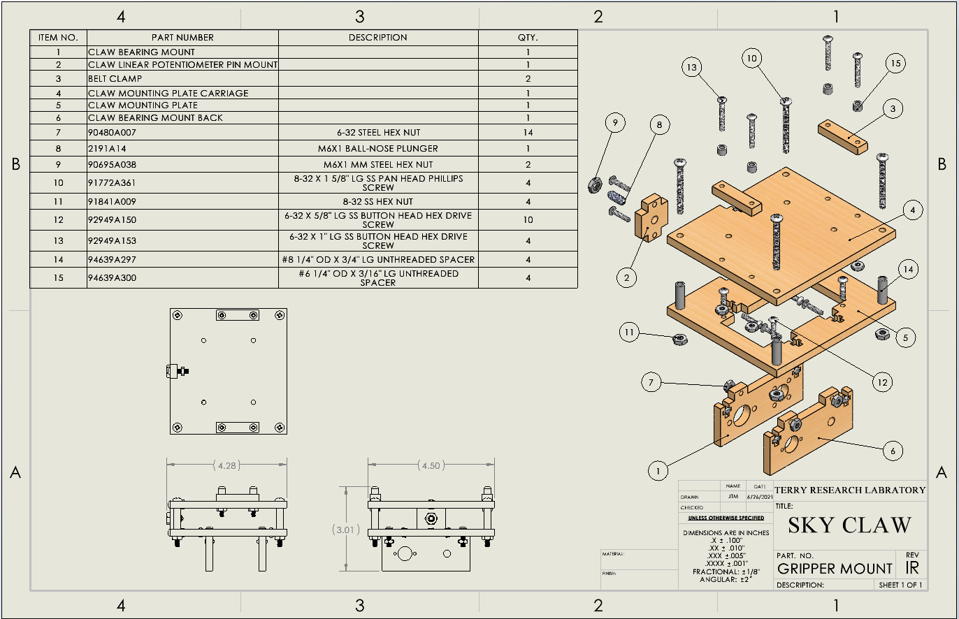

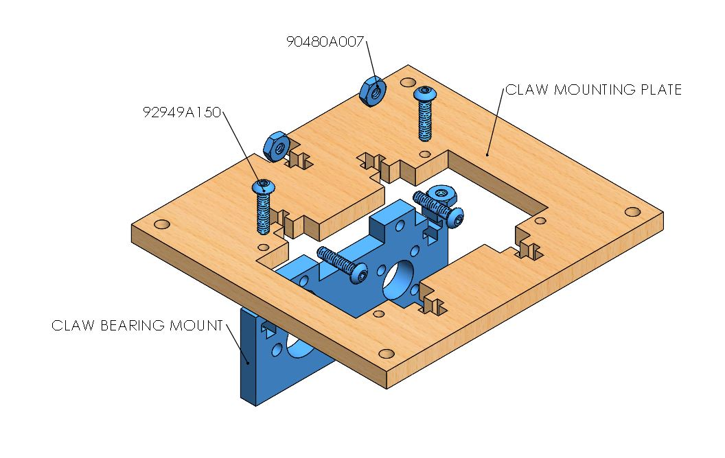

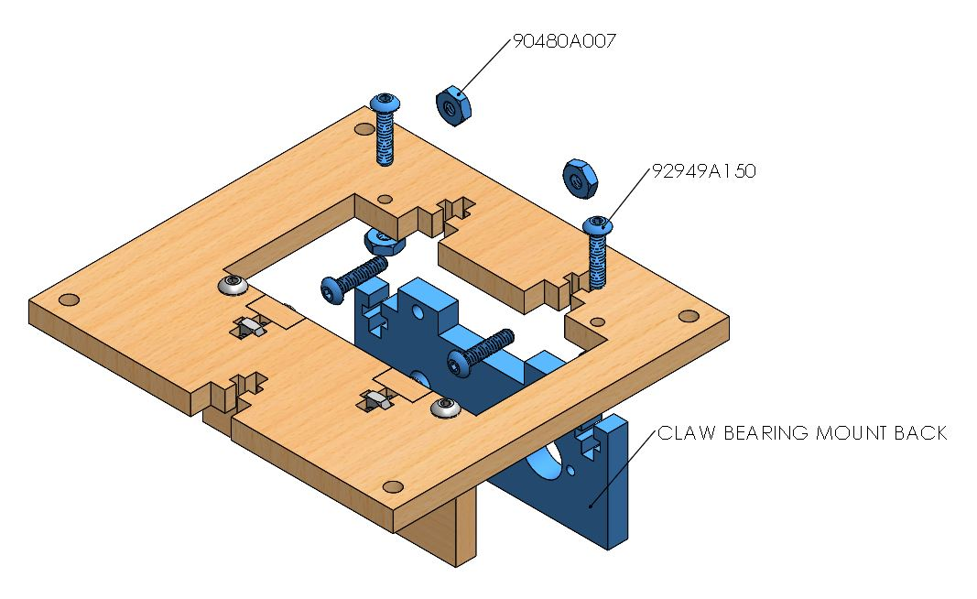

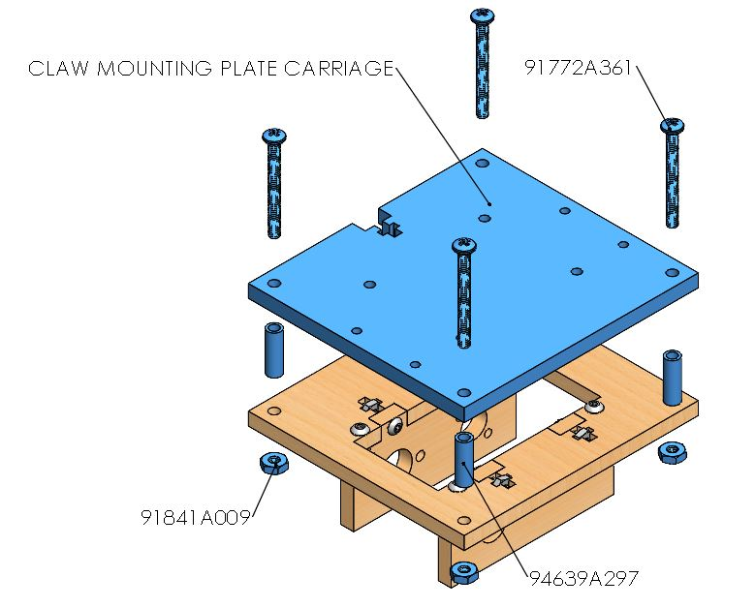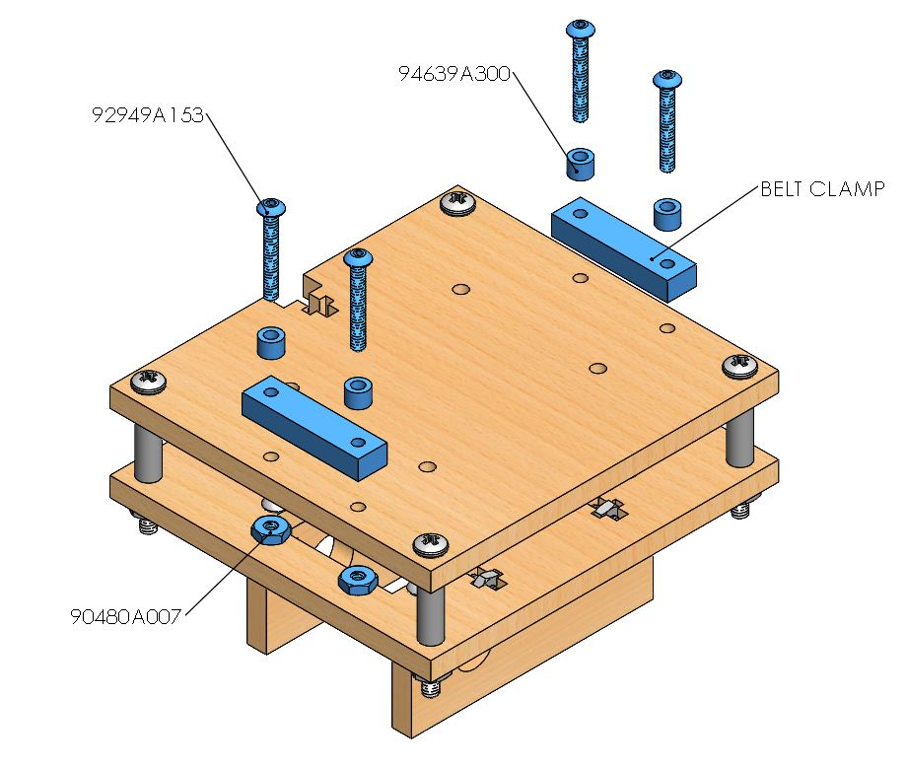

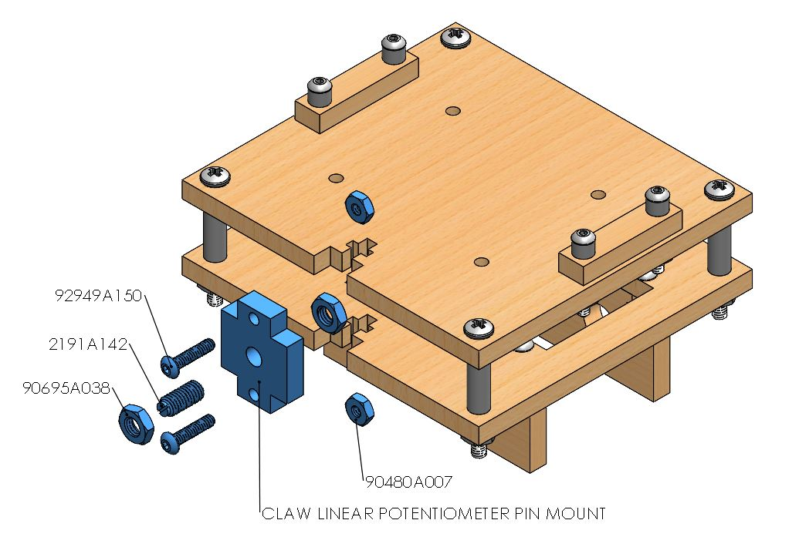

**Claw**

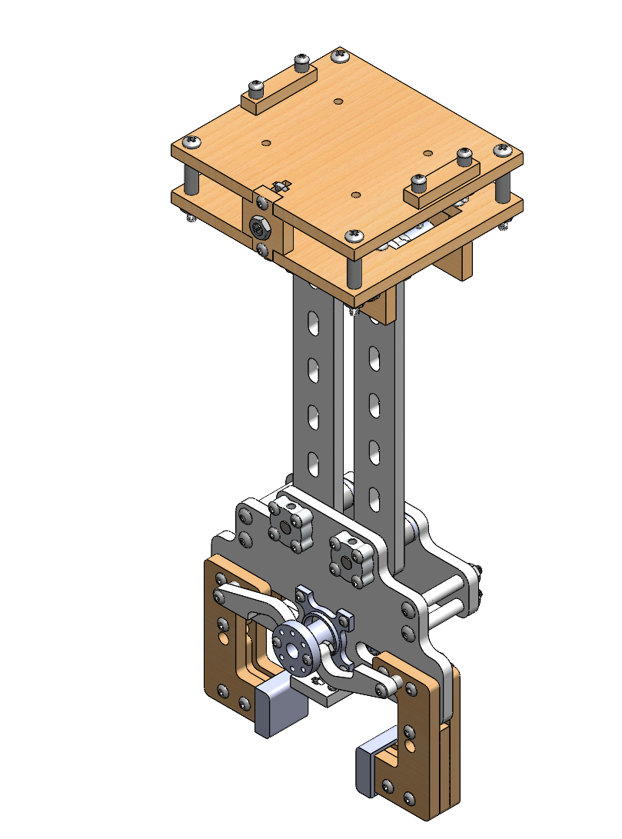

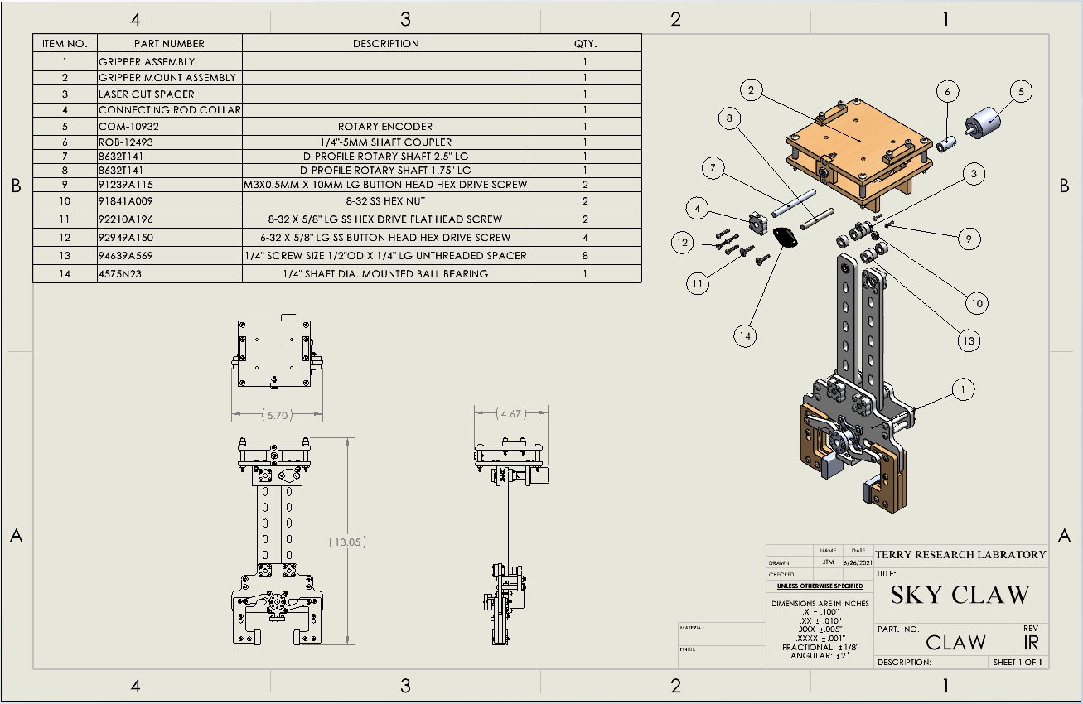

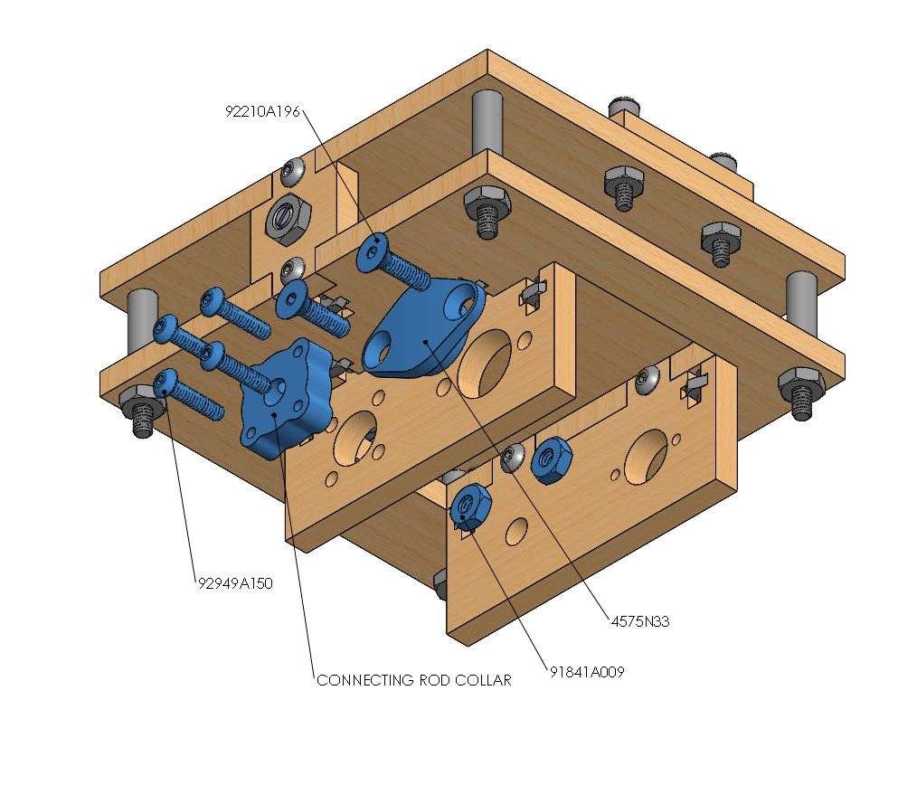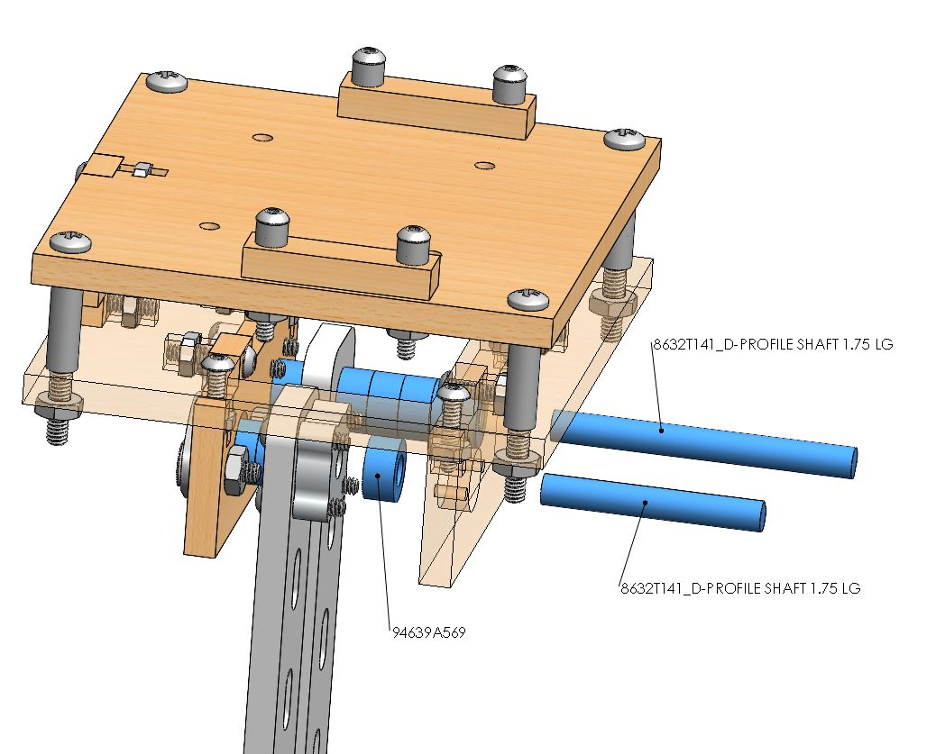

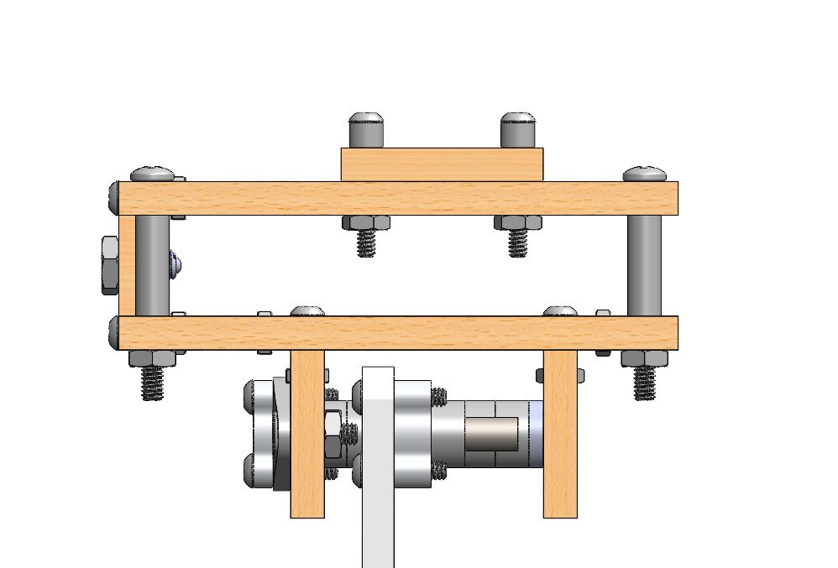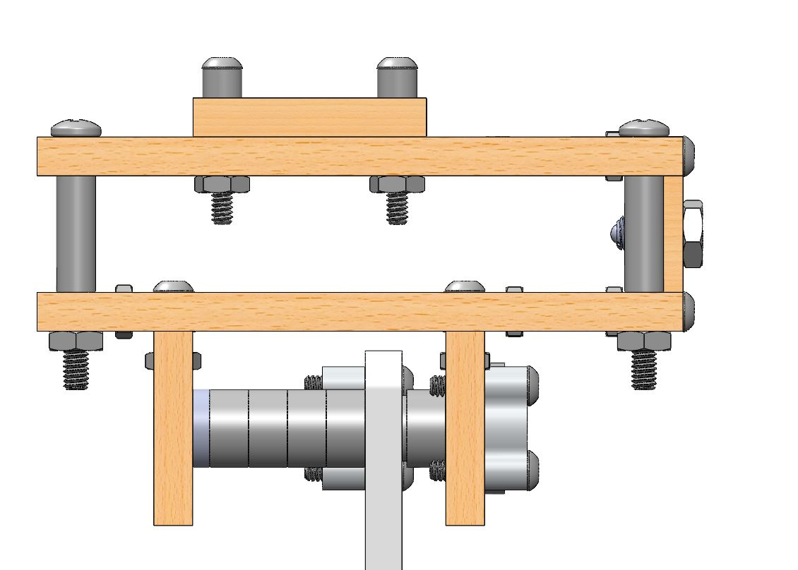

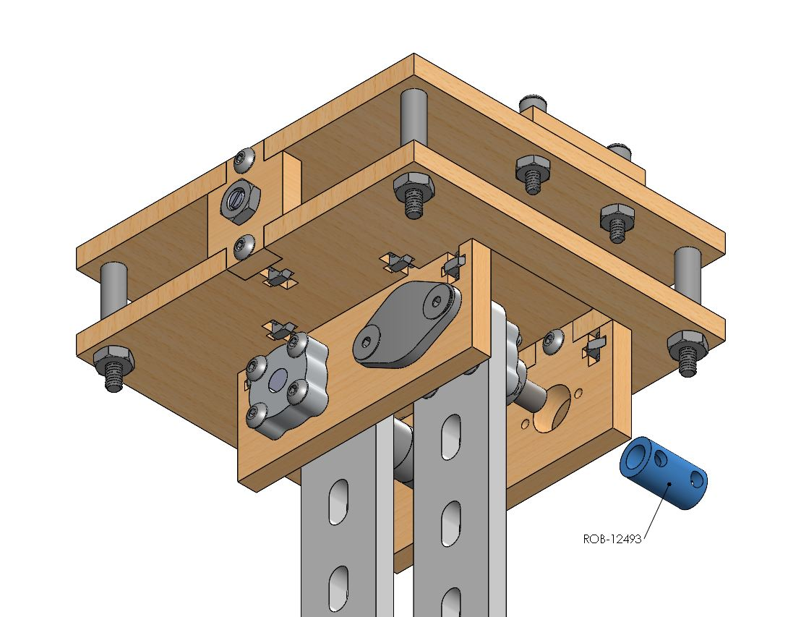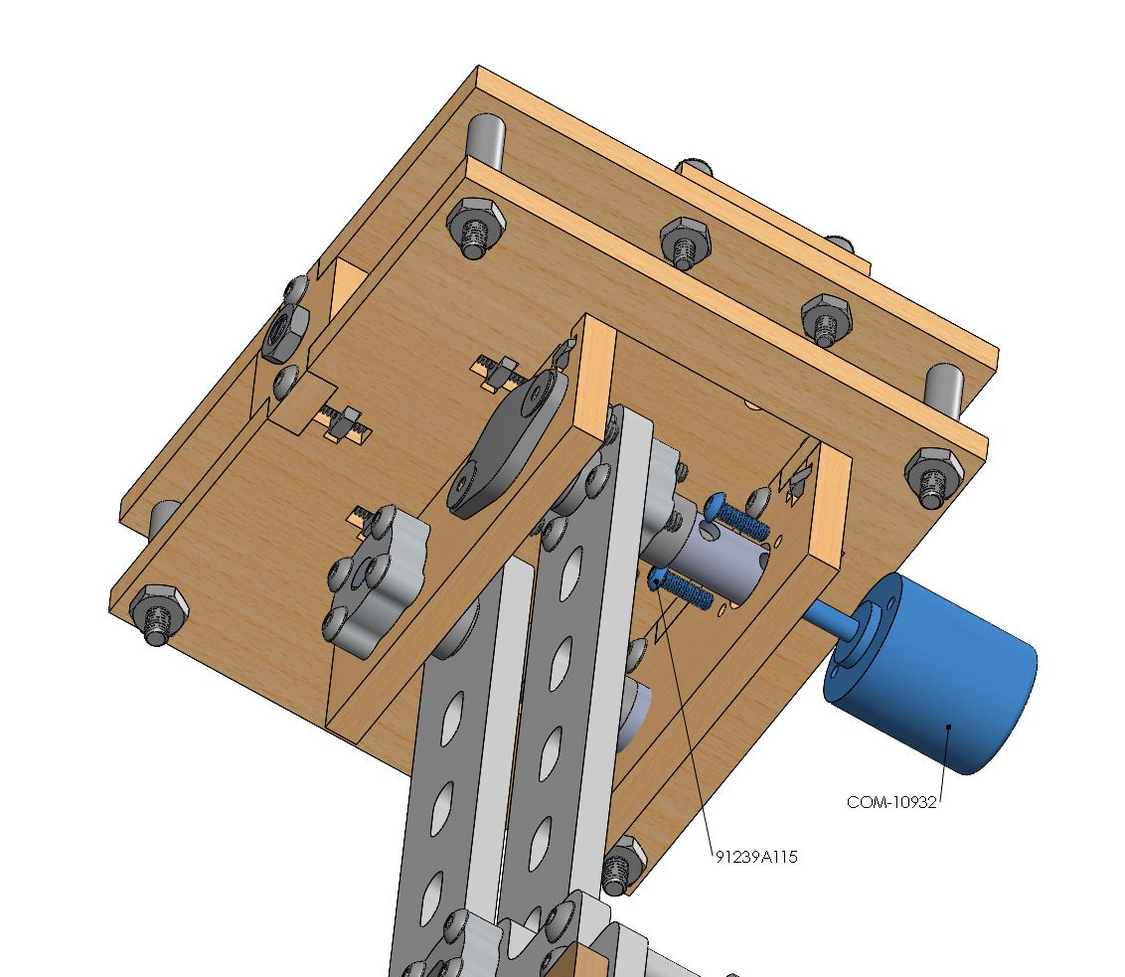

**Horizontal Translation**

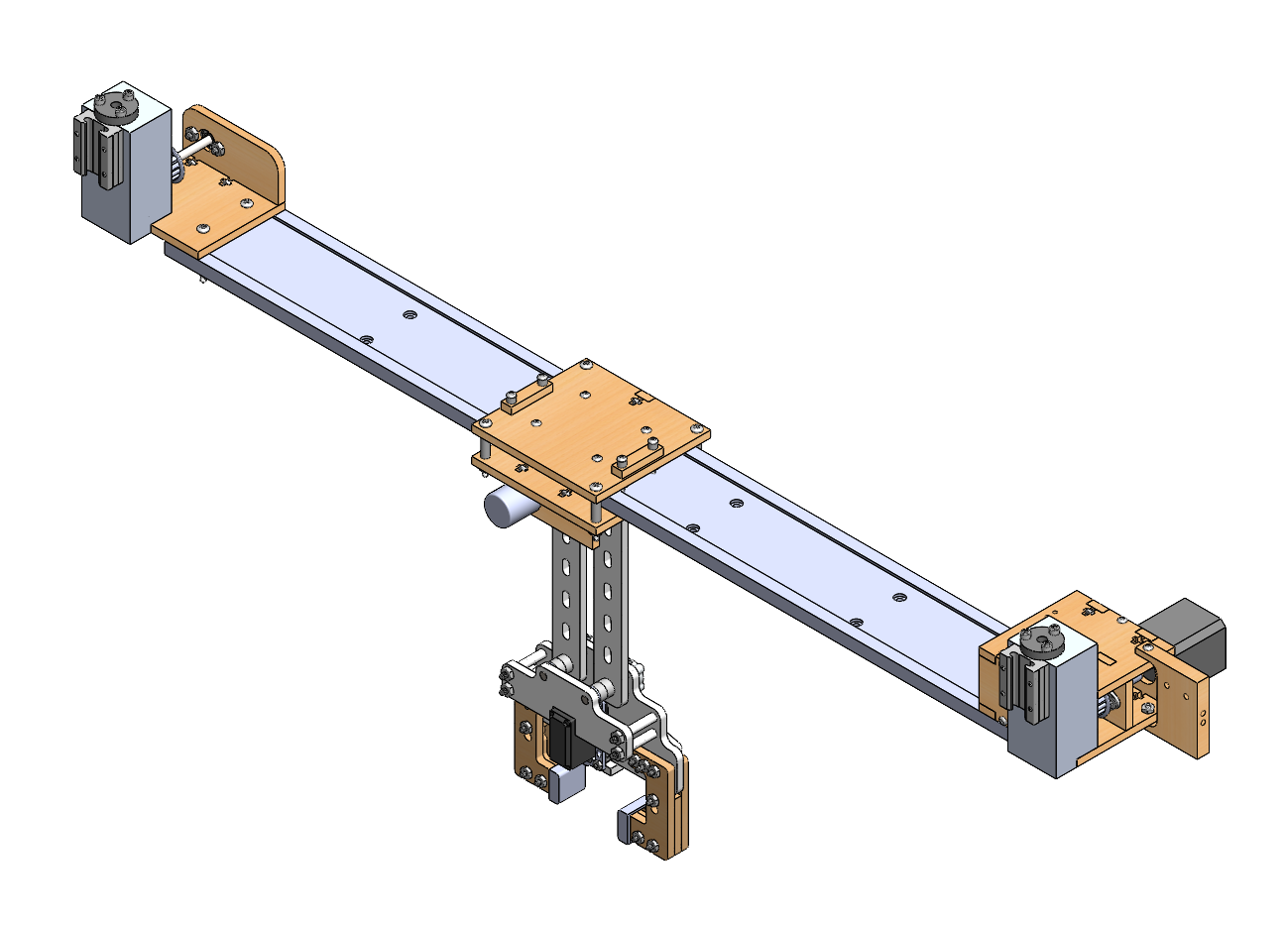

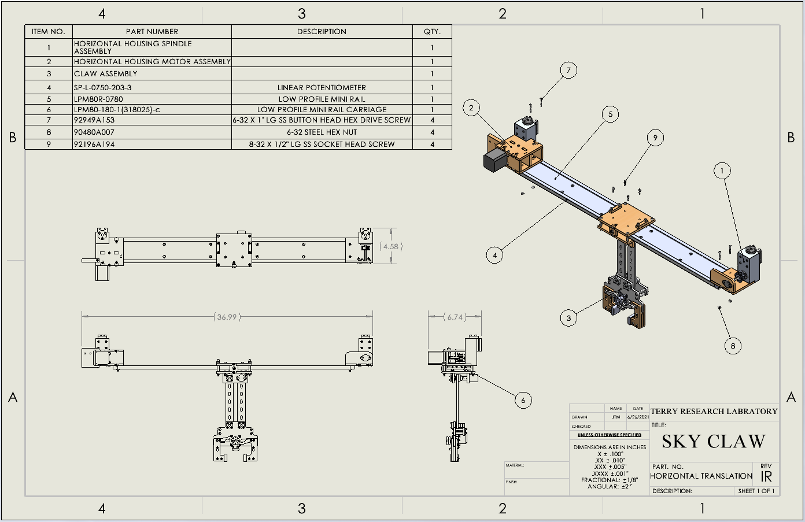

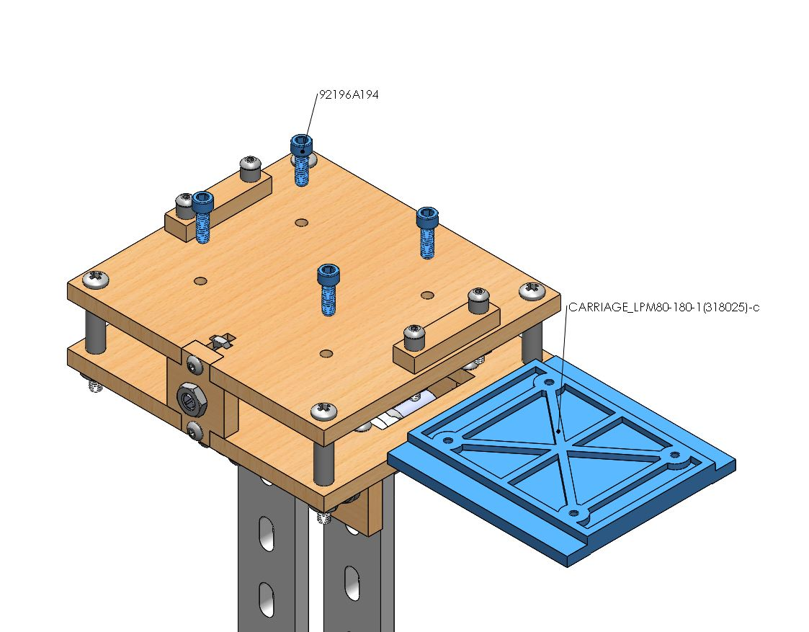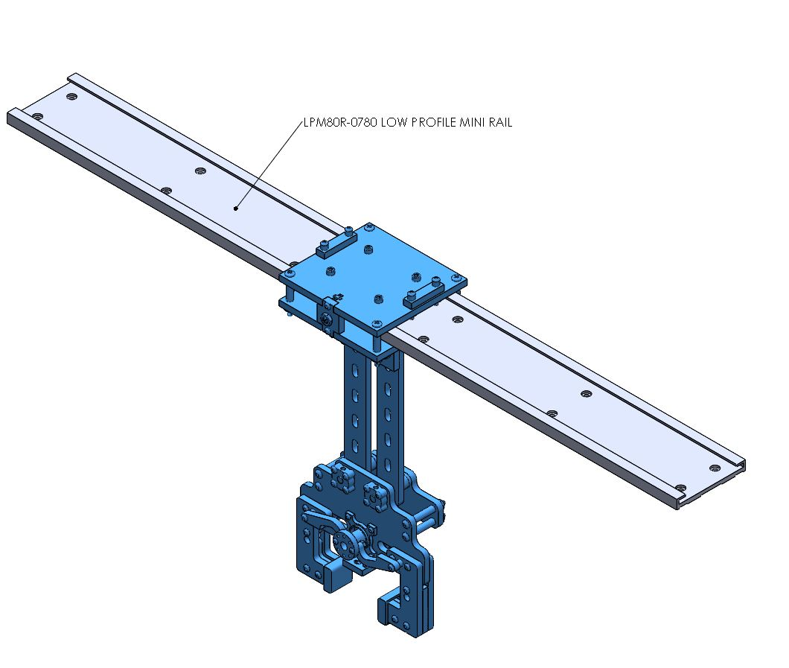

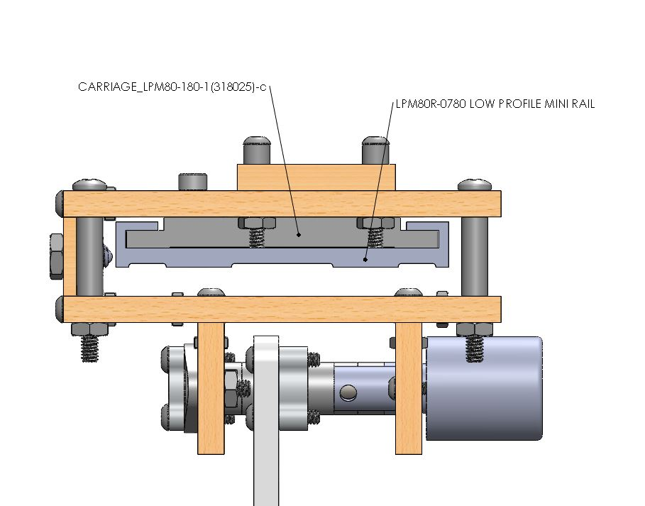

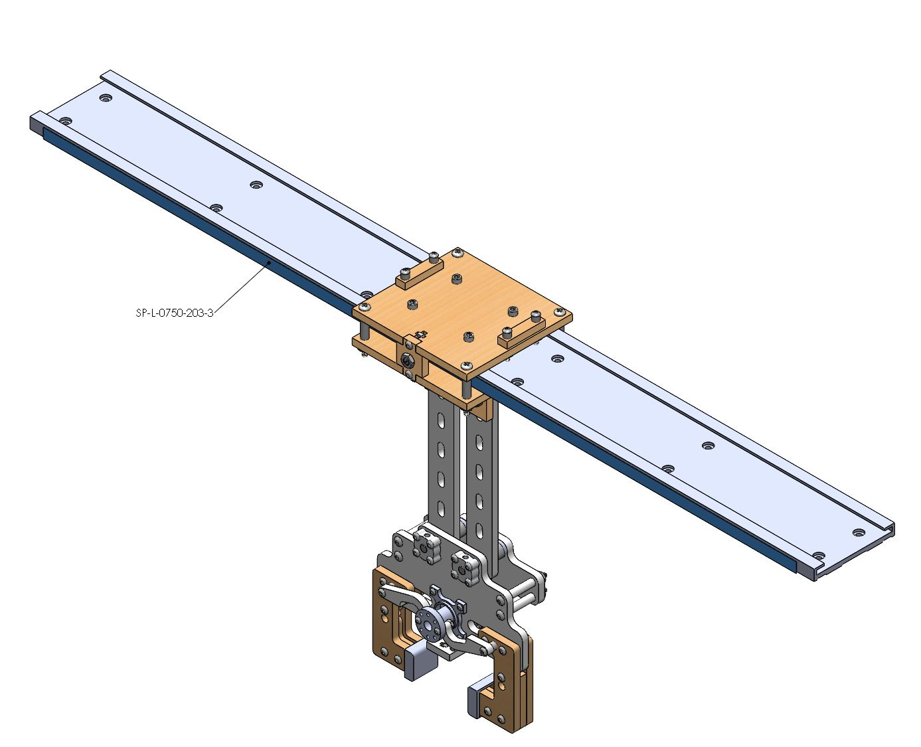

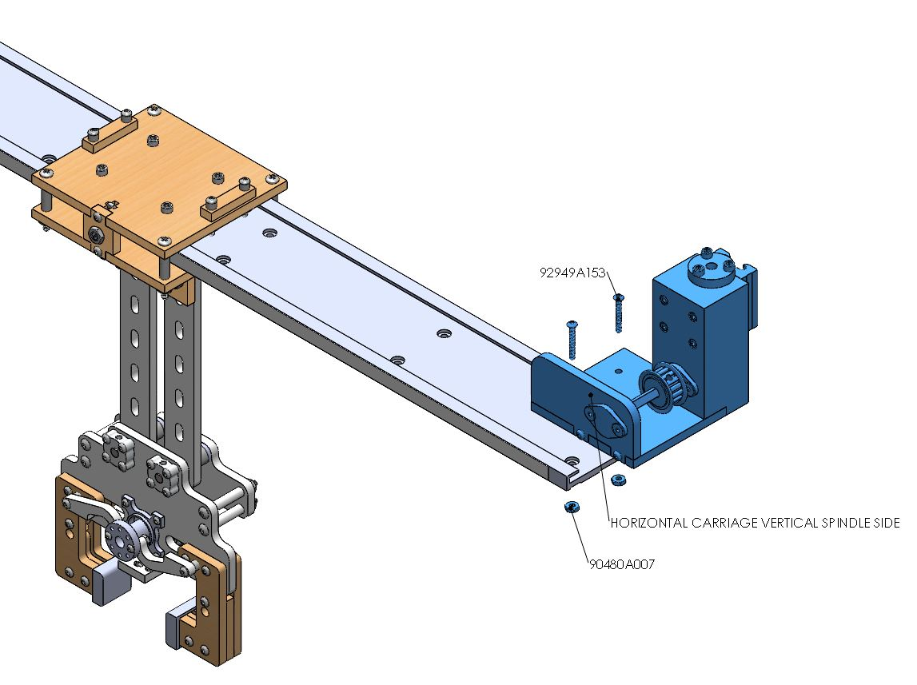

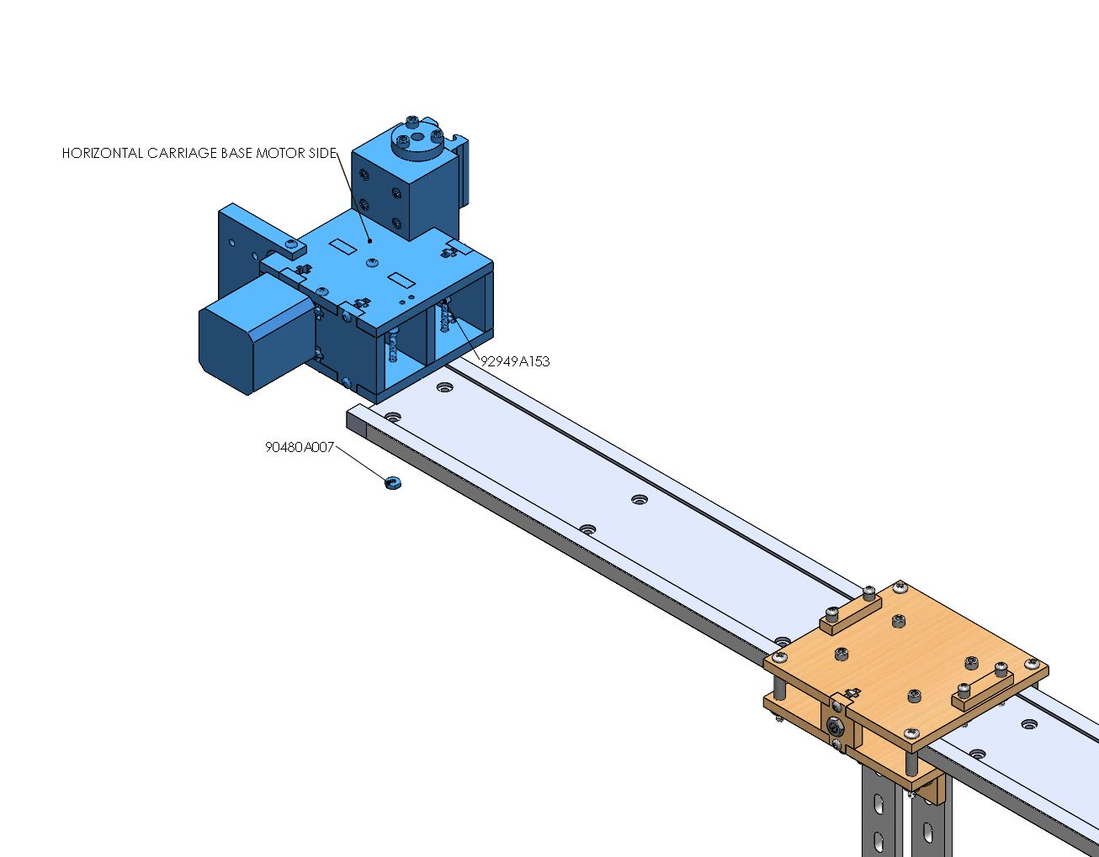

**Tensioner**

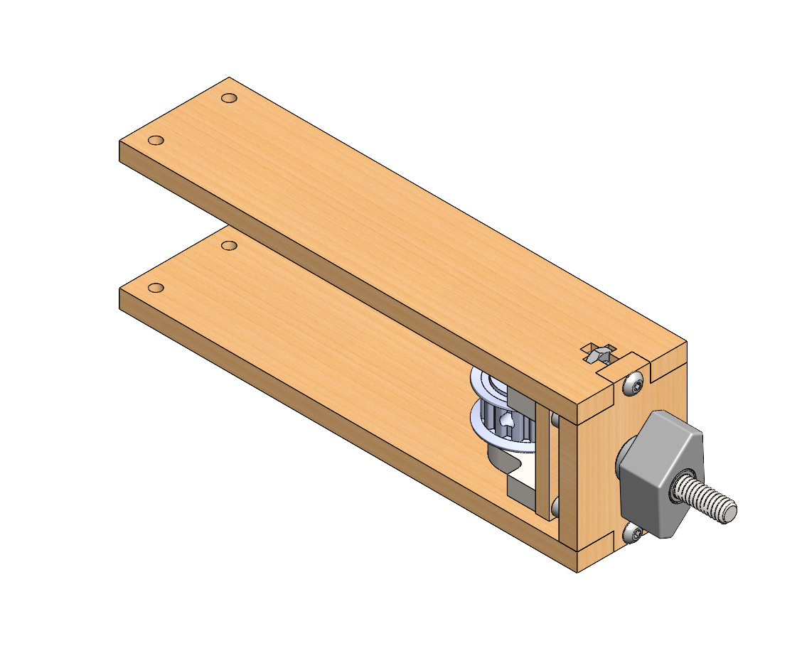

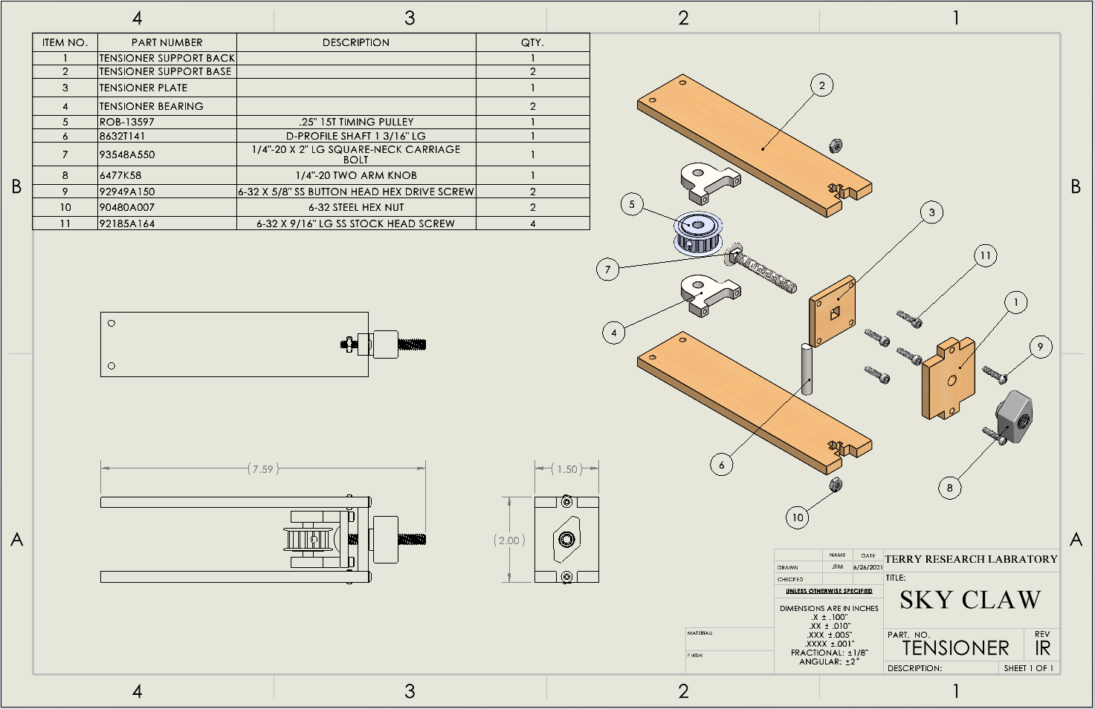

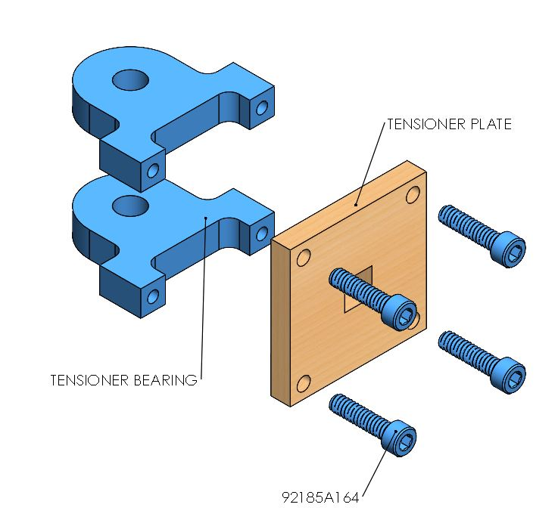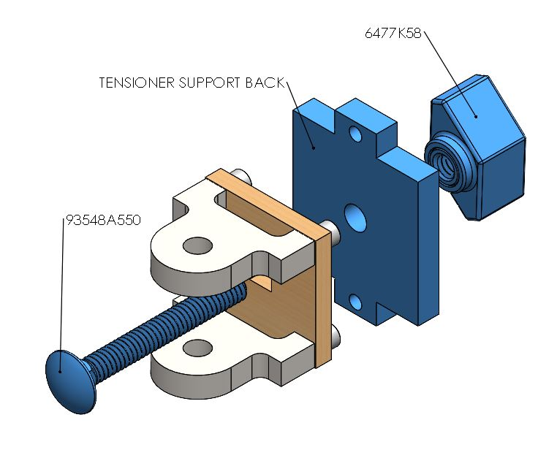

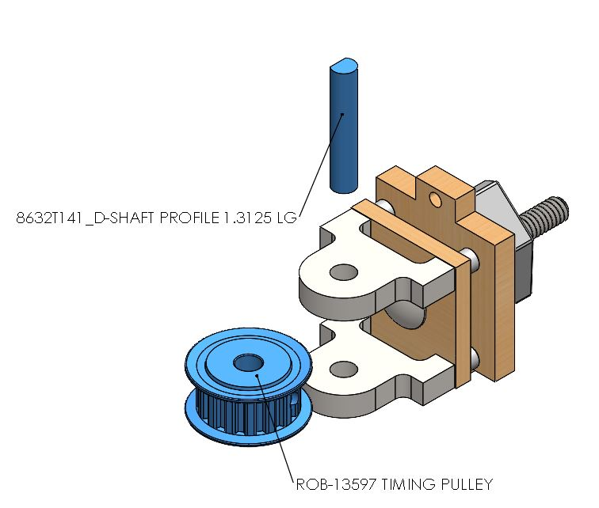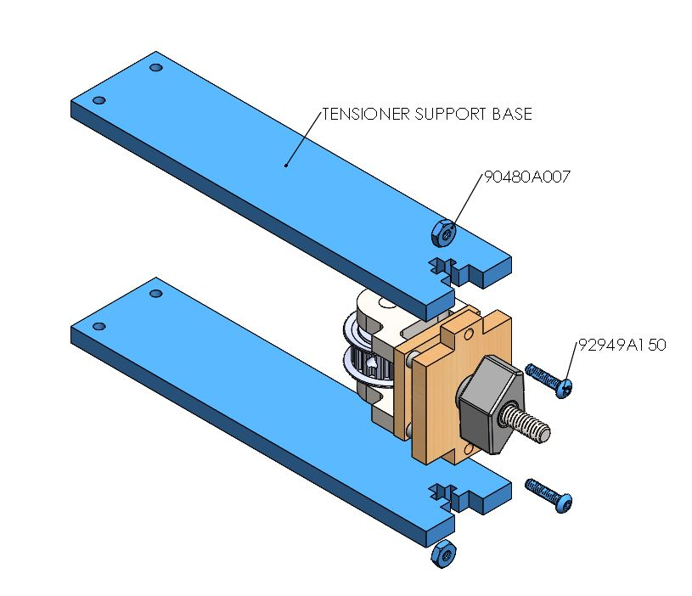

**U-Channel**

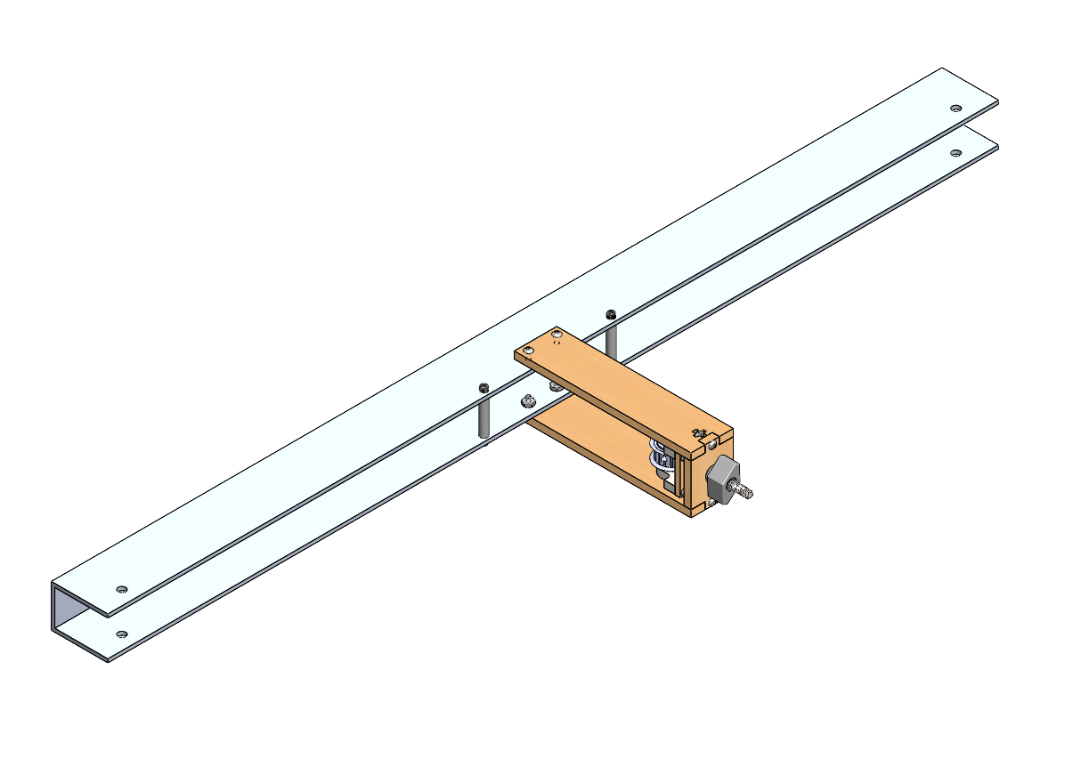

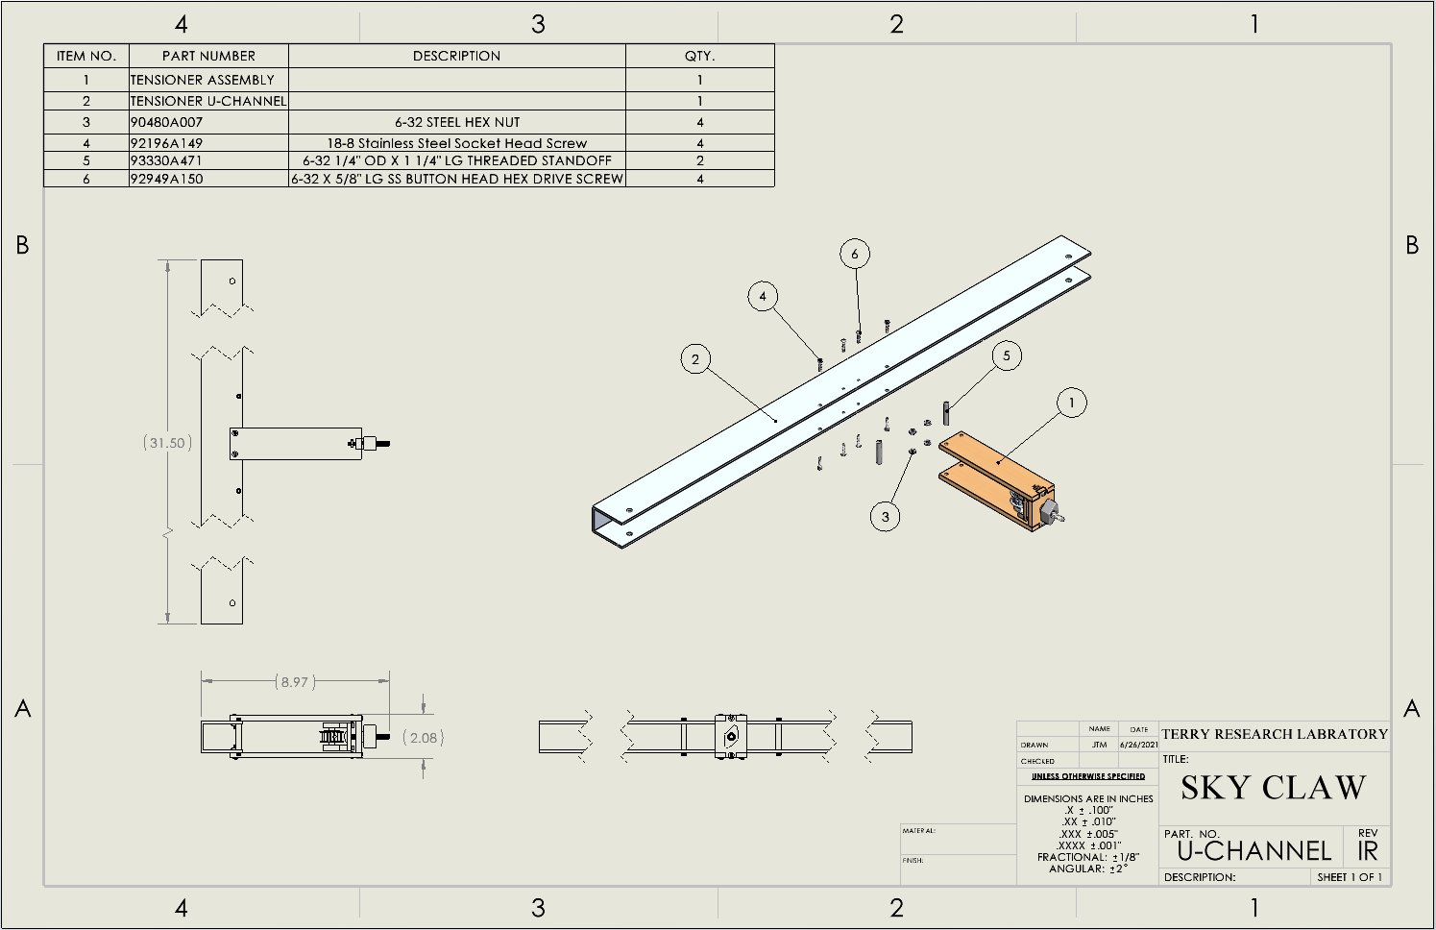

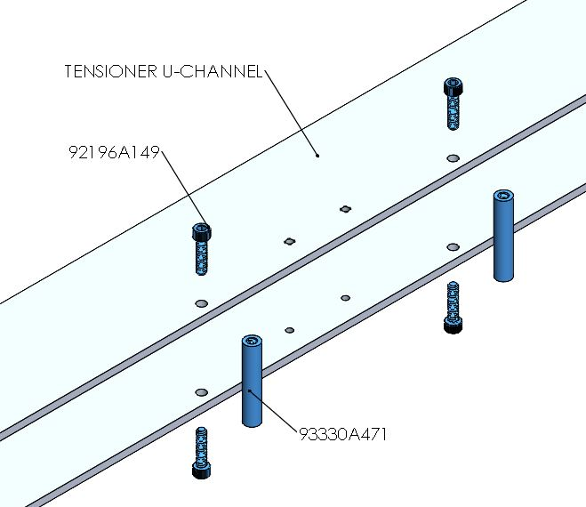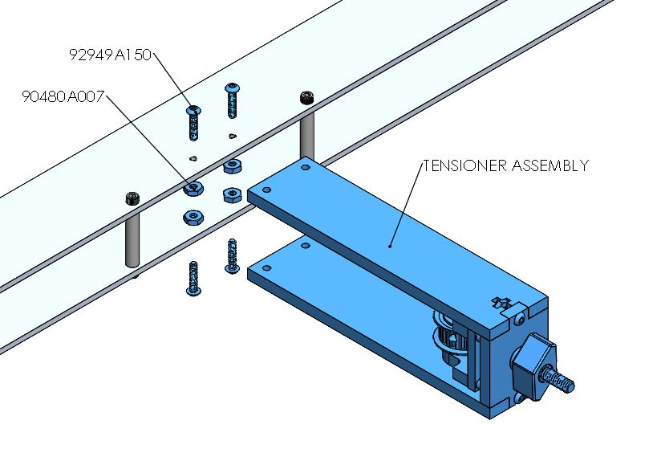

**Vertical Translation Housing Encoder**

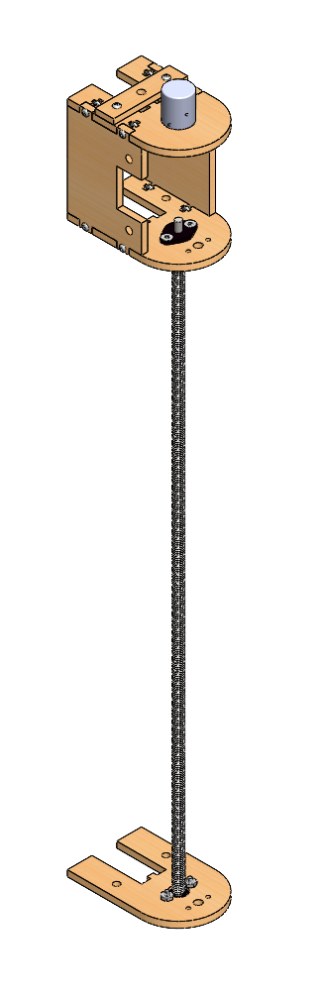

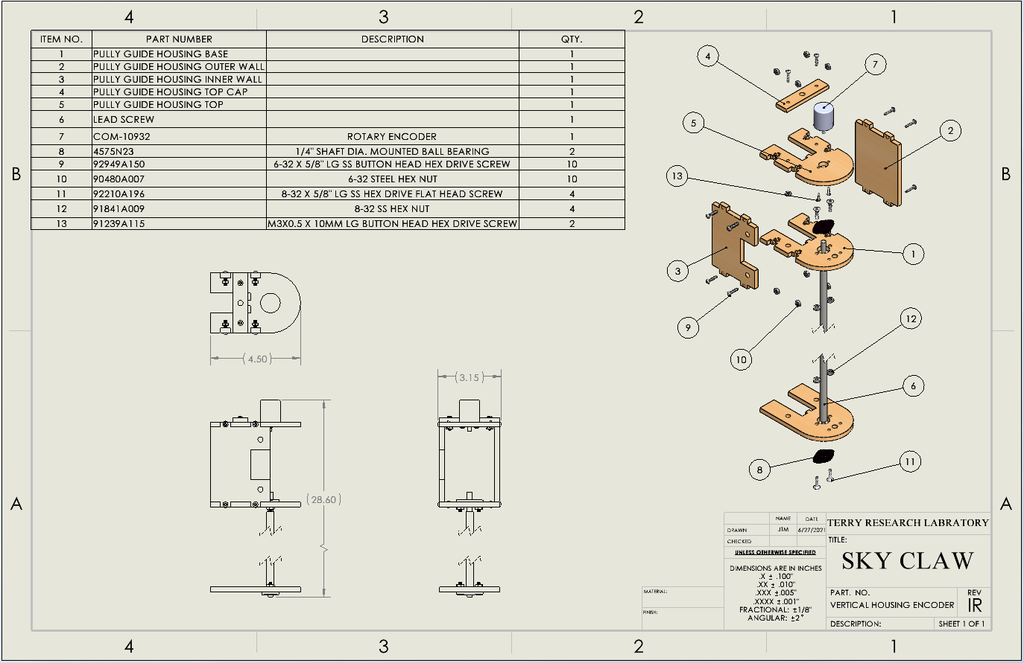

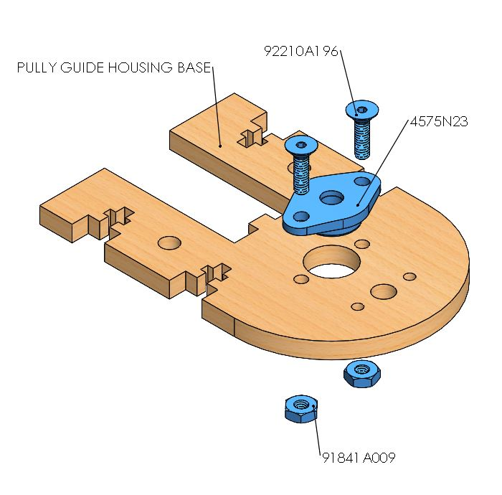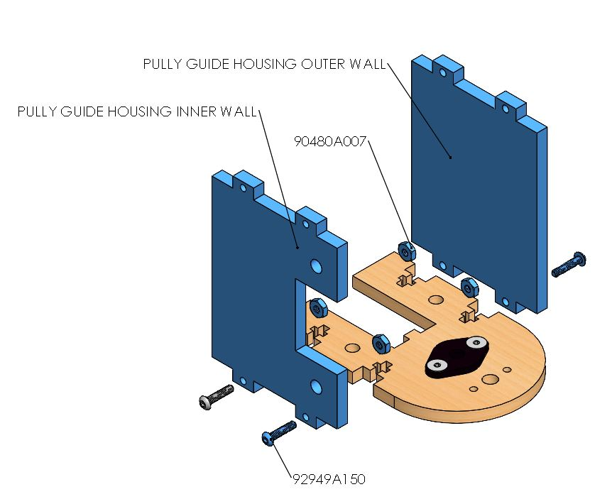

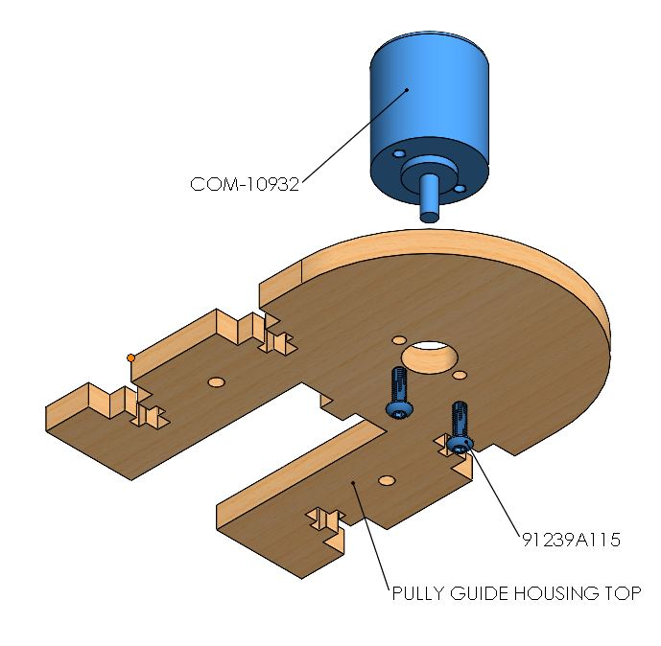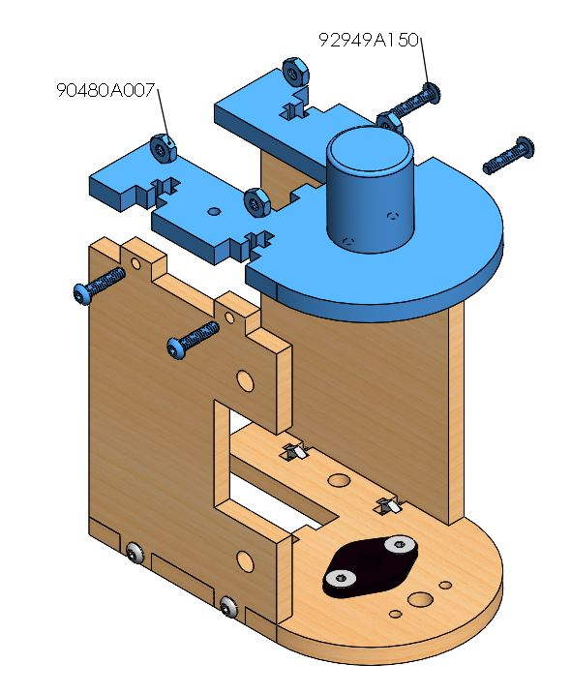

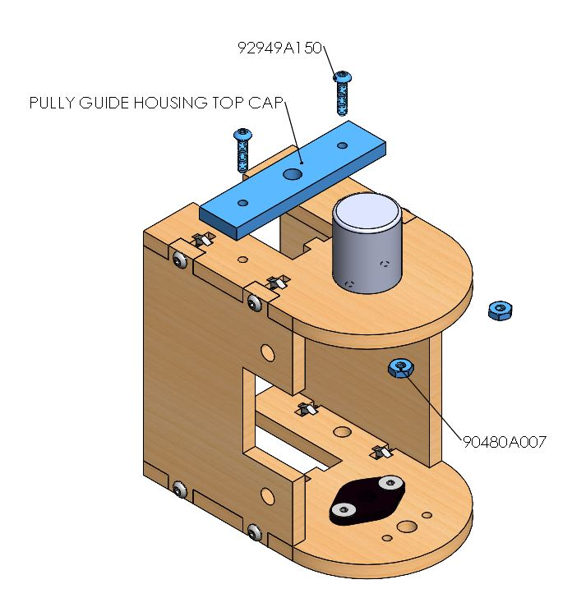 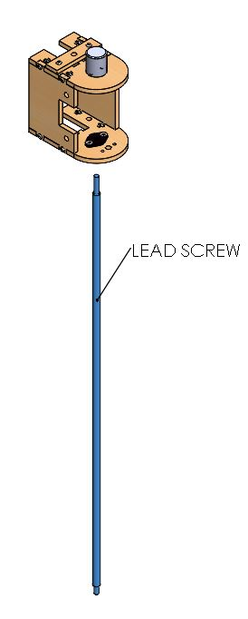

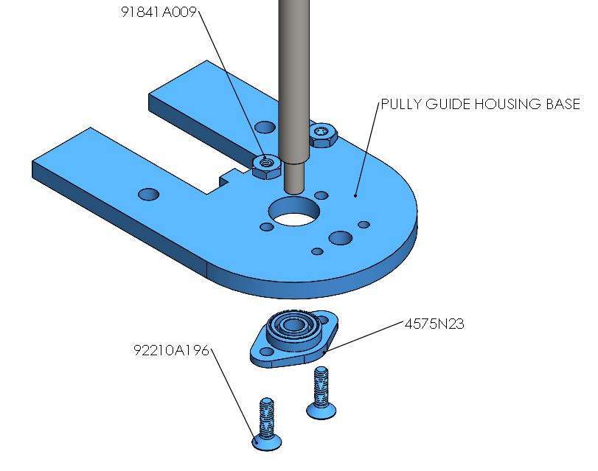

**Vertical Translation Housing Motor**

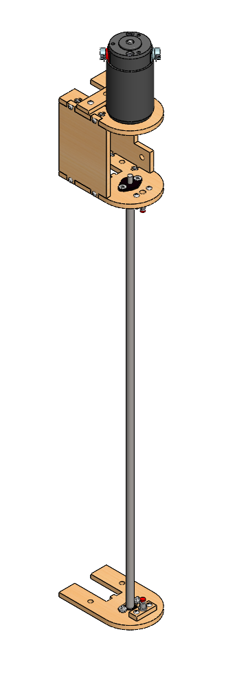

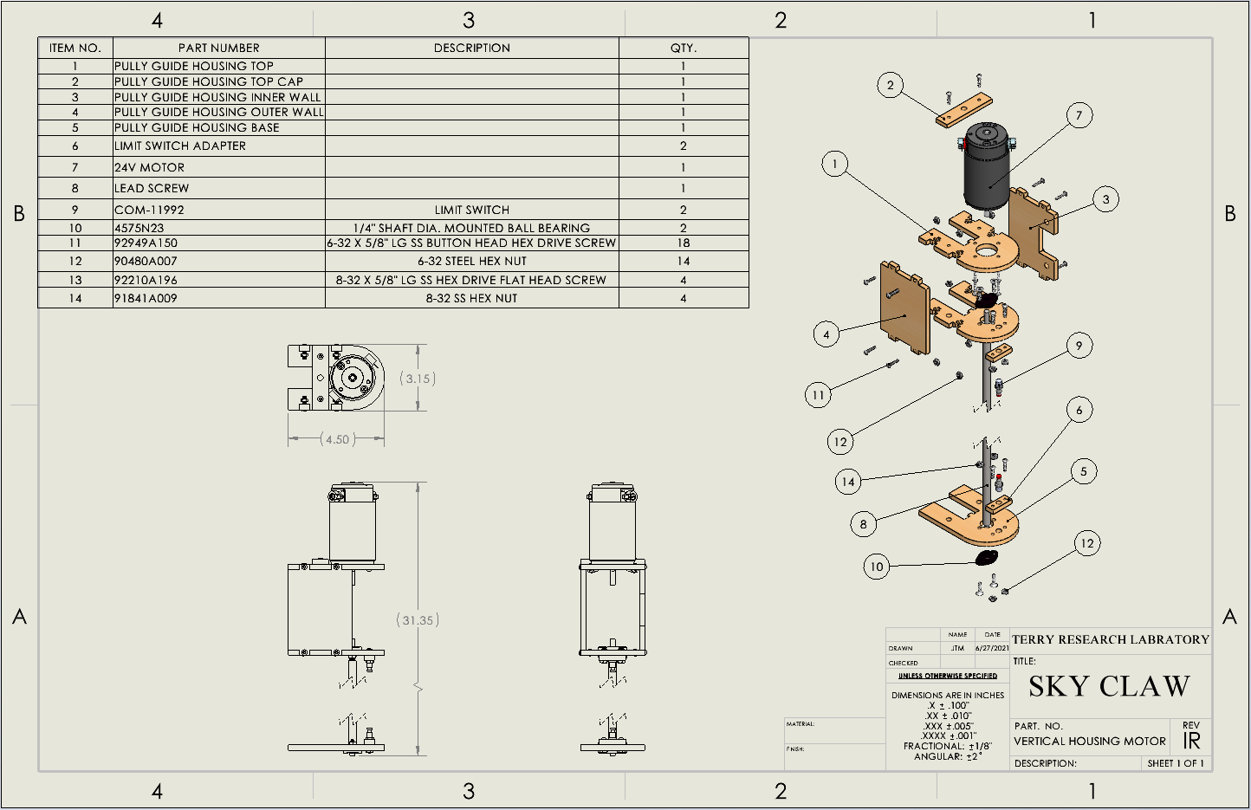

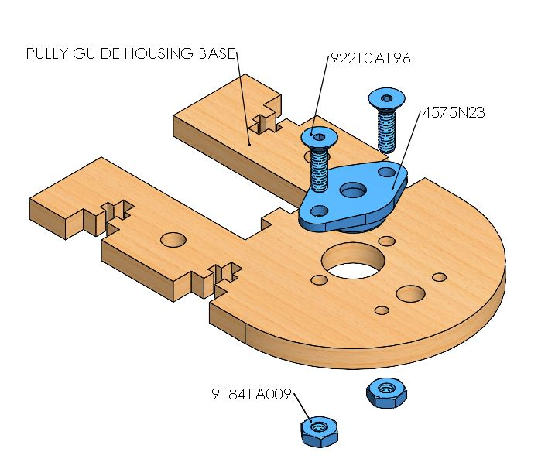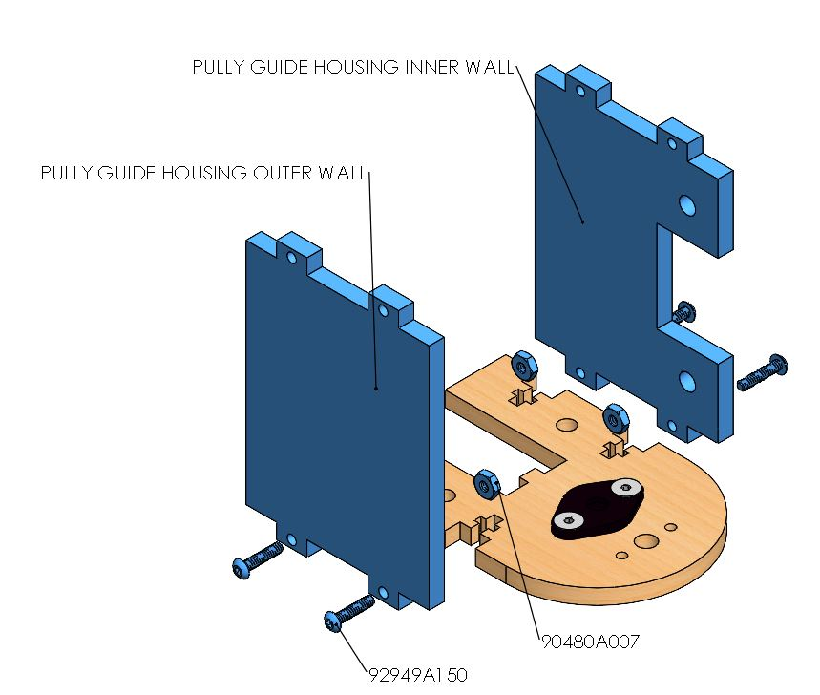

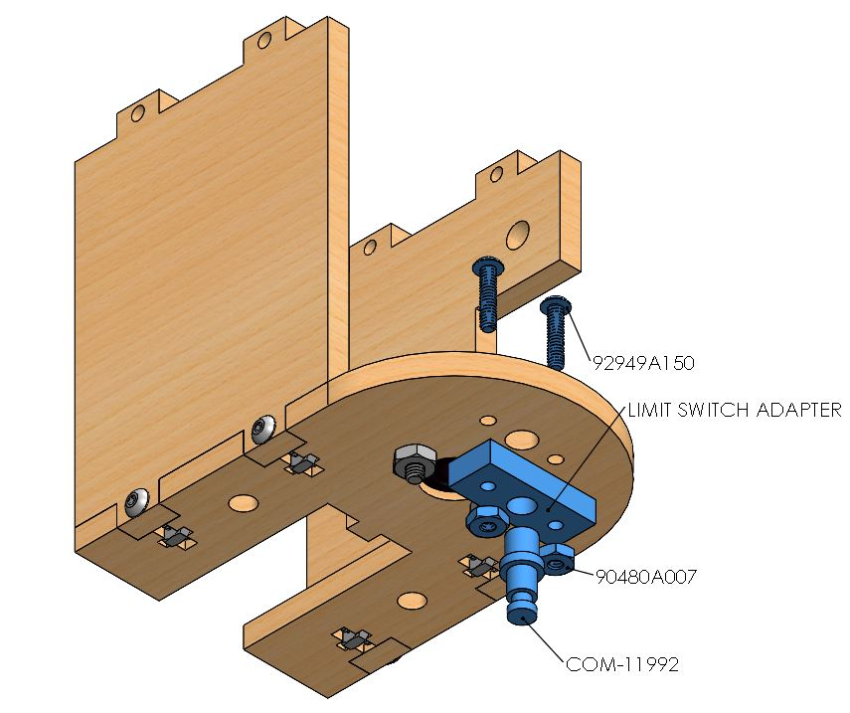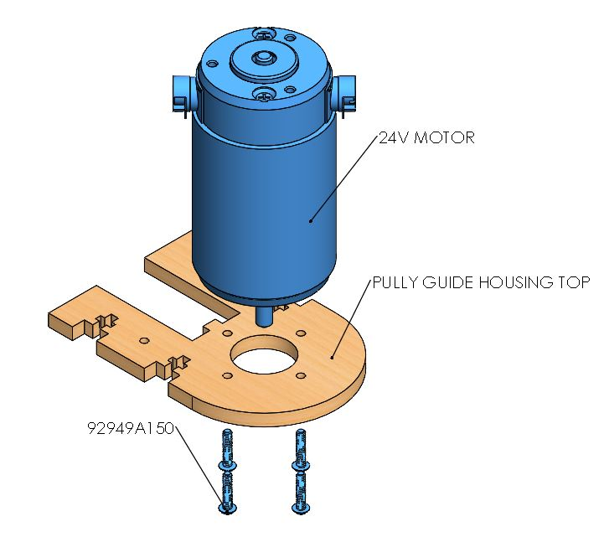

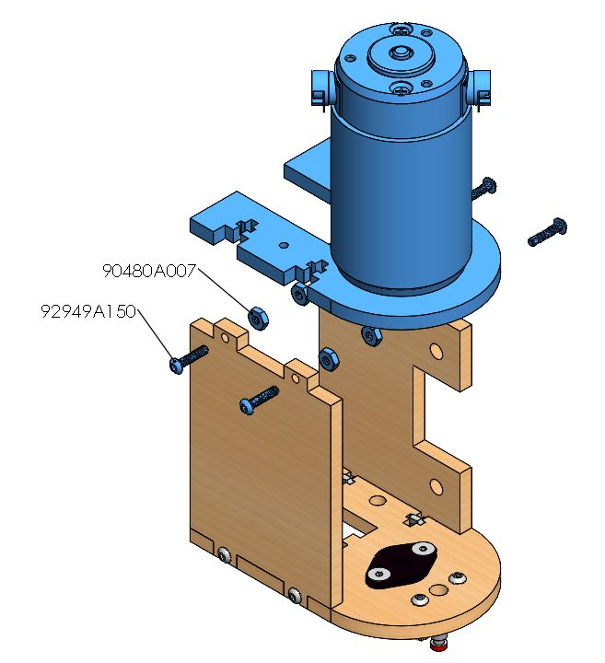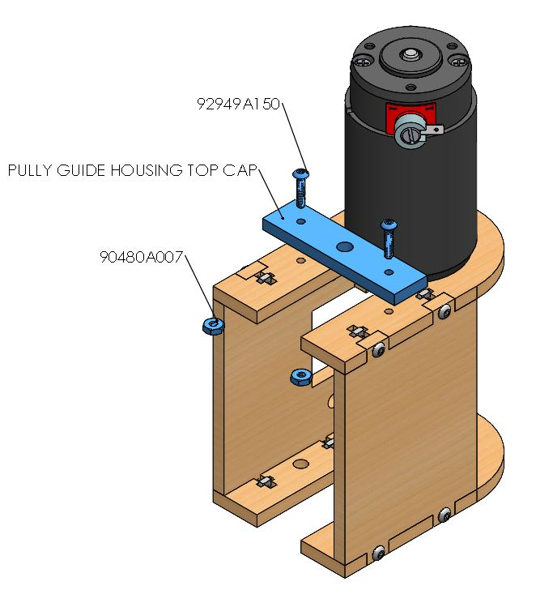

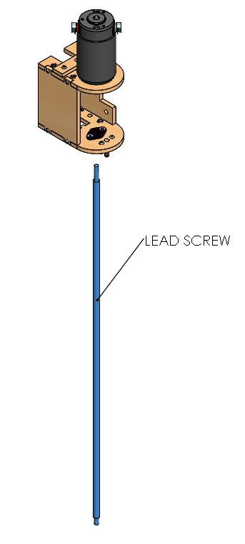 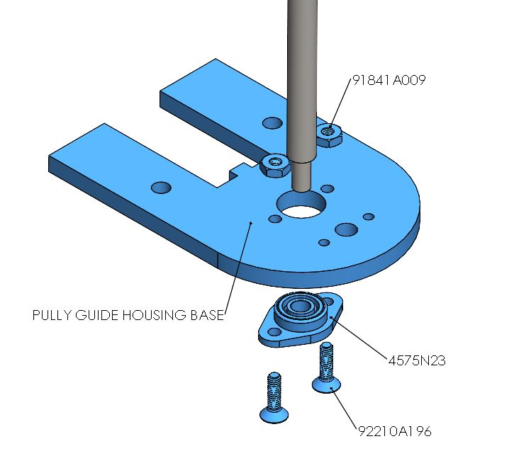

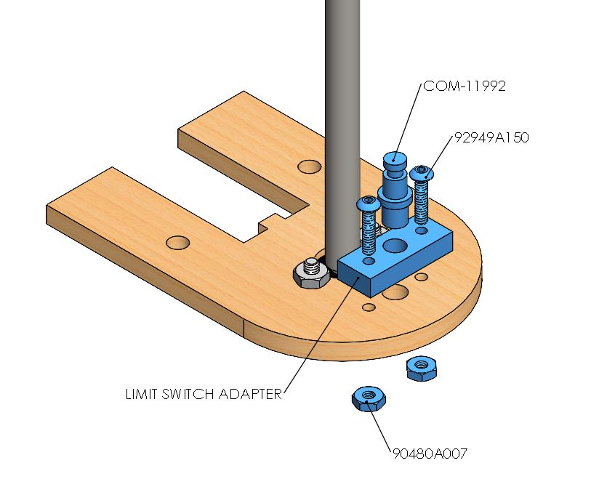

**Vertical Translation**

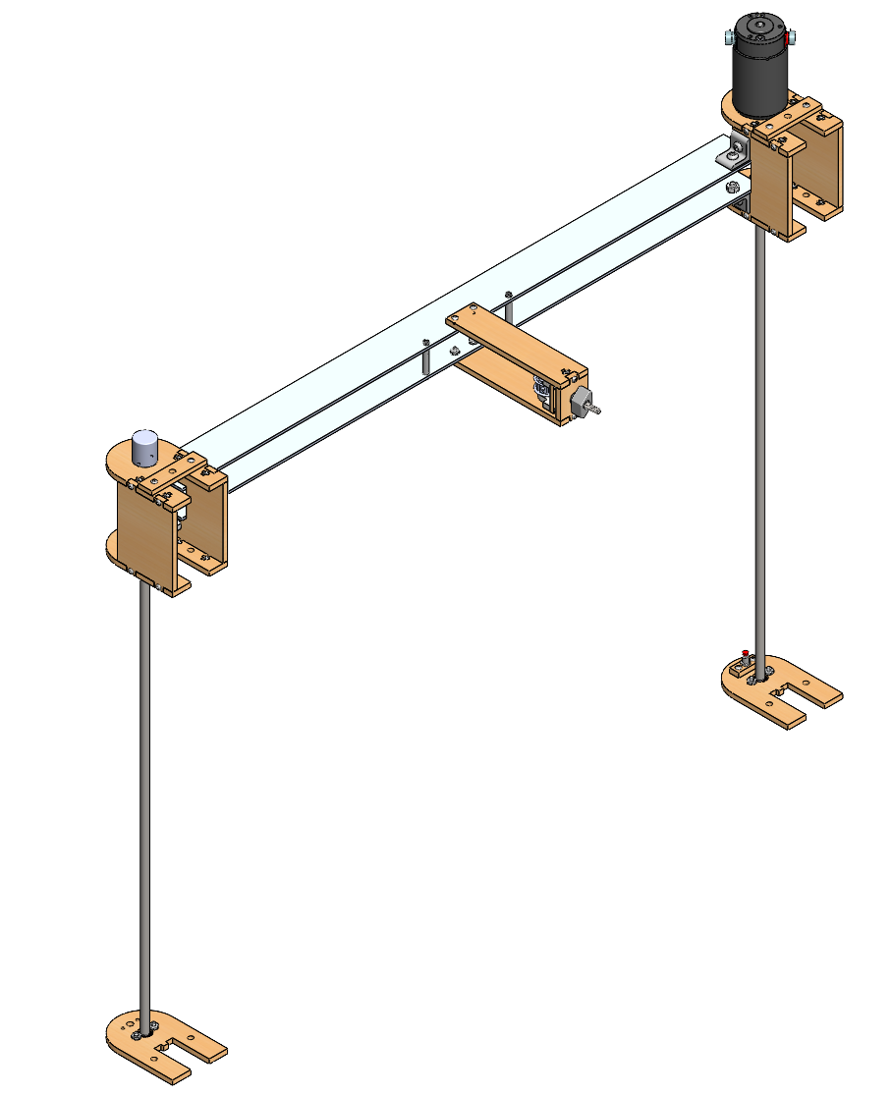

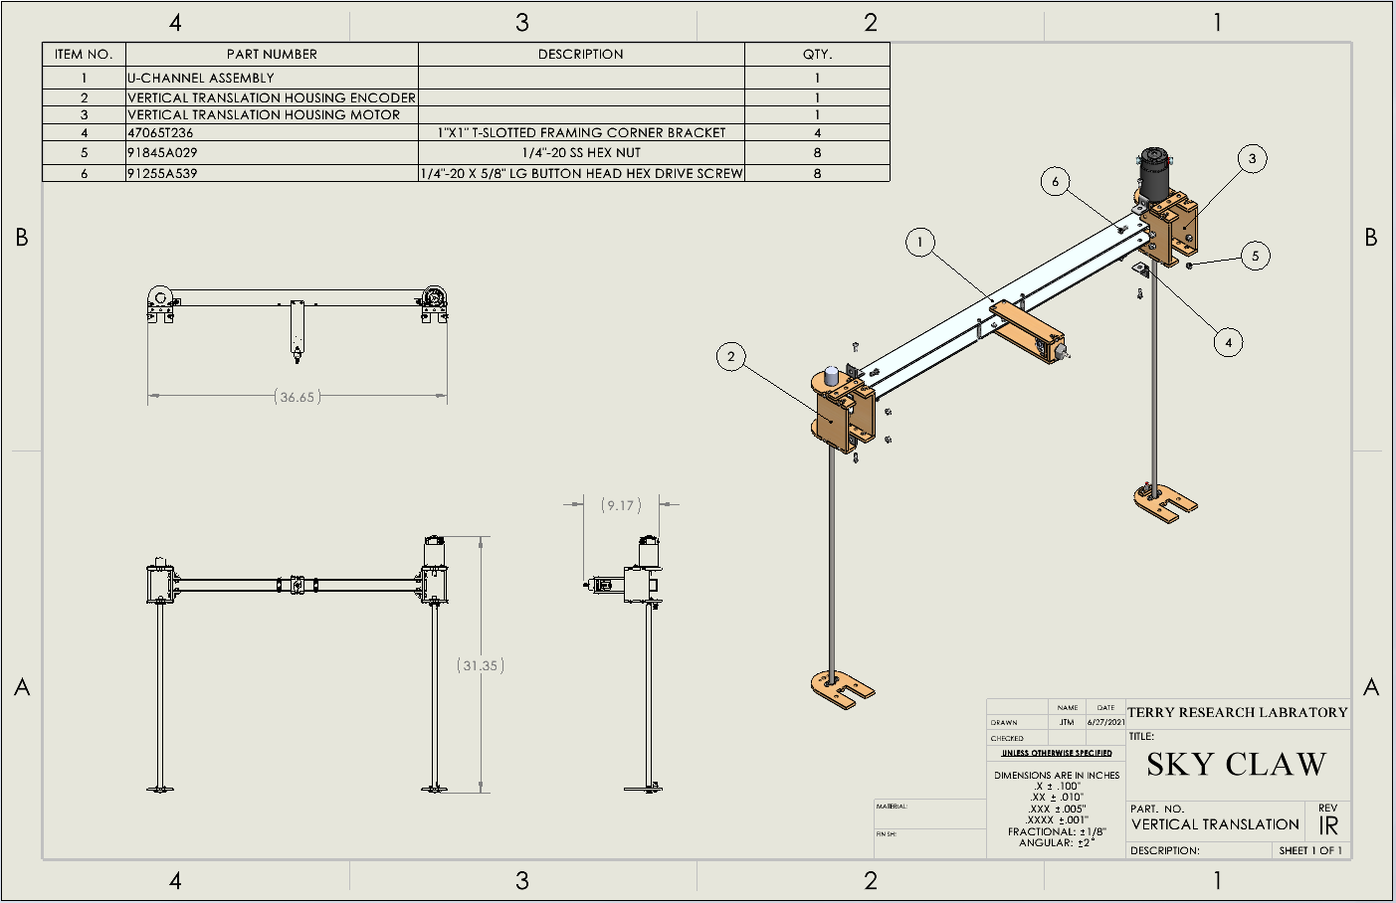

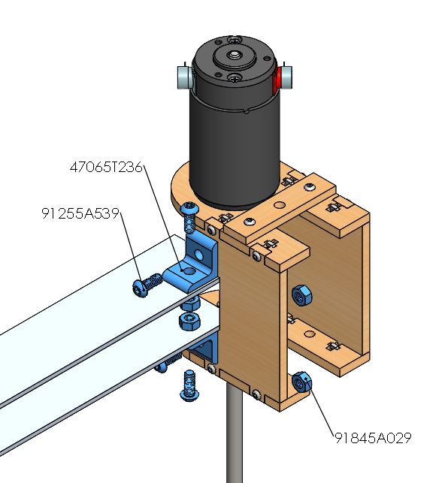 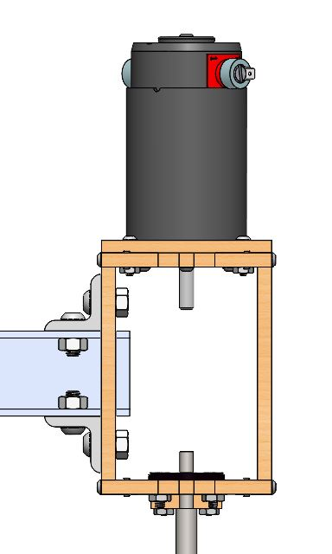

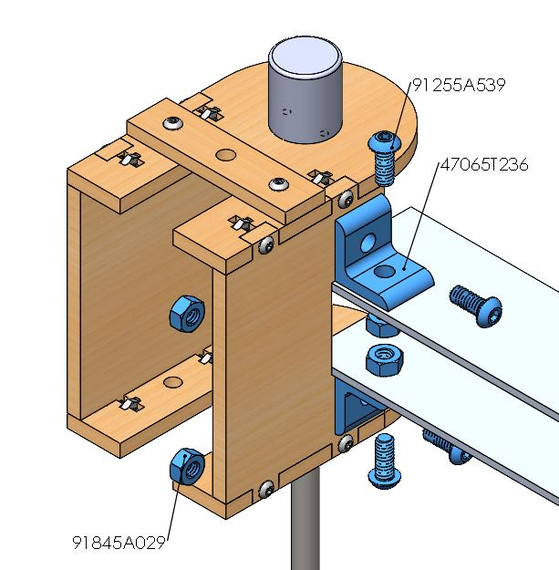 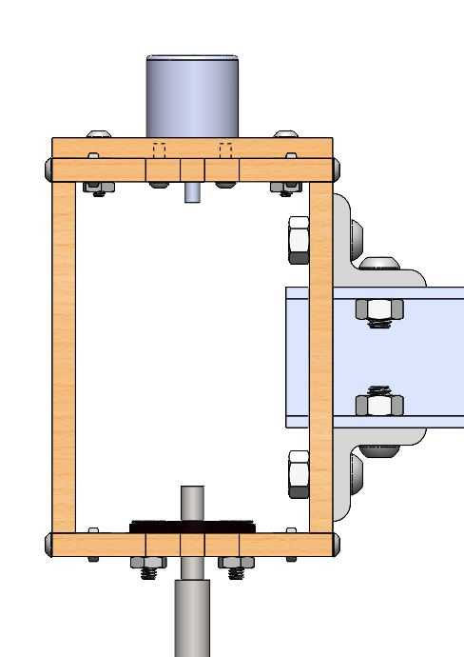

**Pully Bearing Guide**

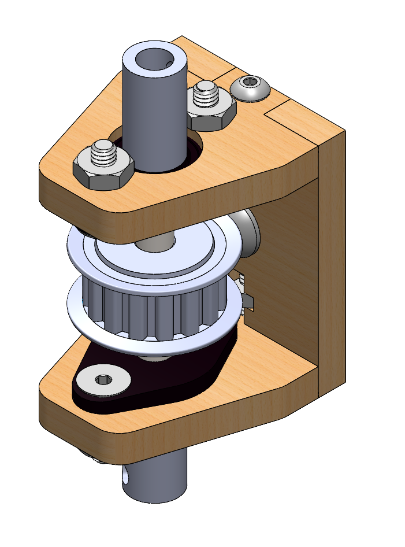

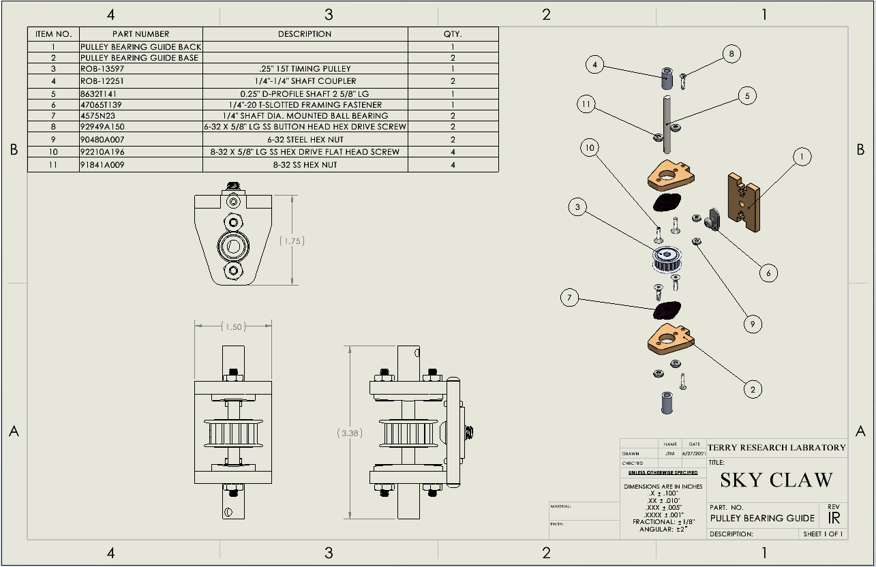

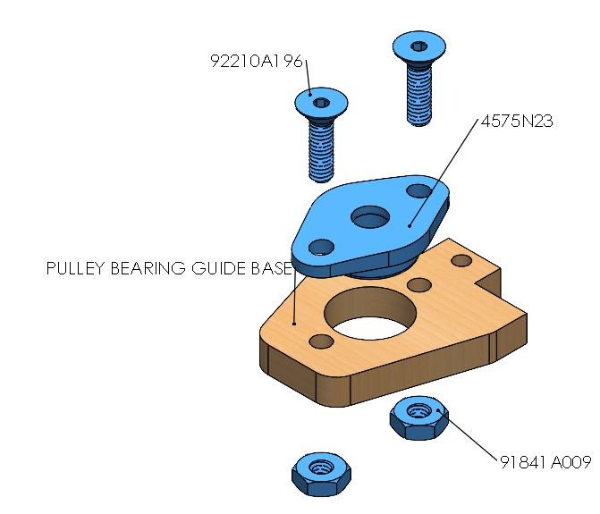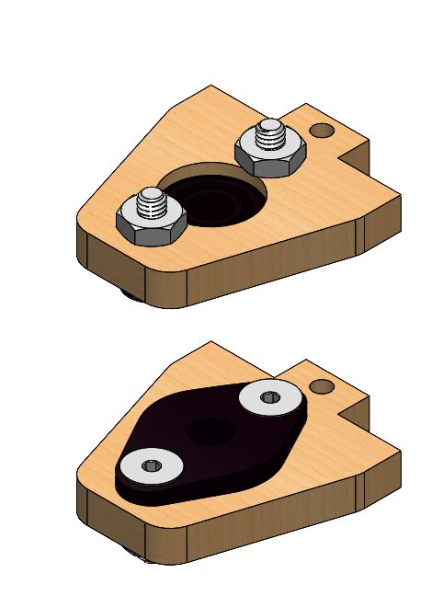

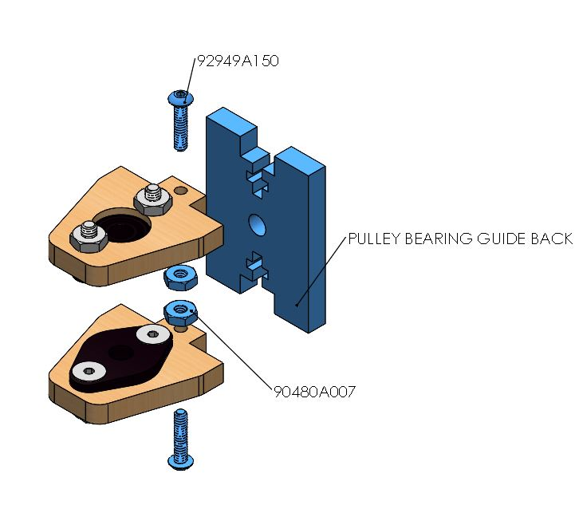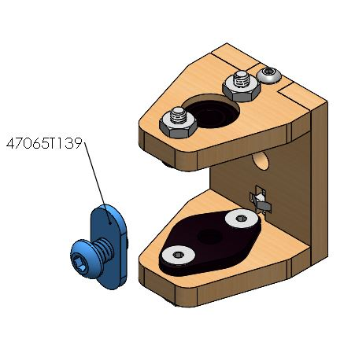

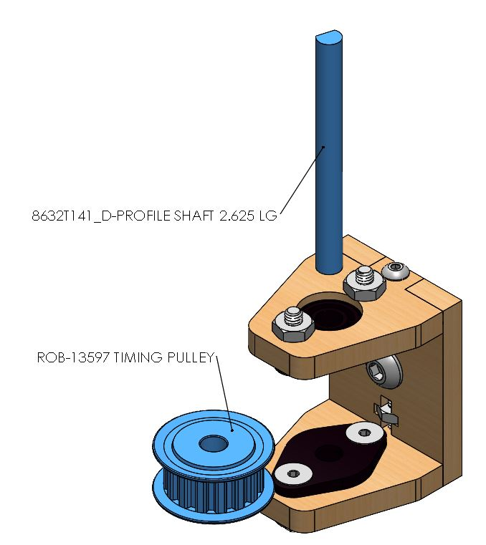 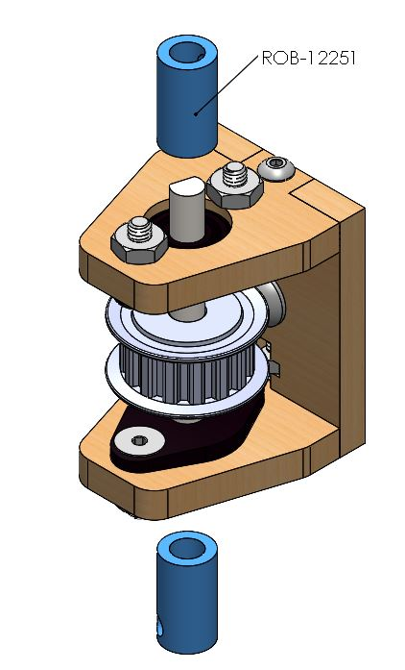

**Sky Claw Final Assembly**

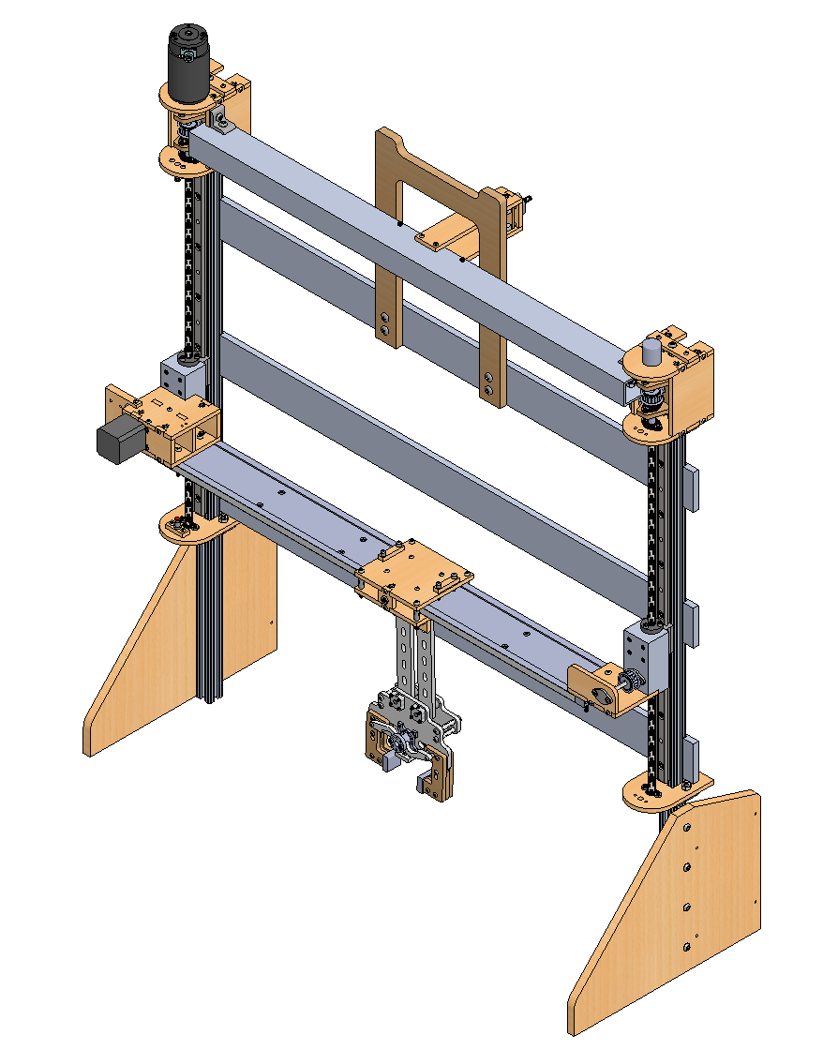

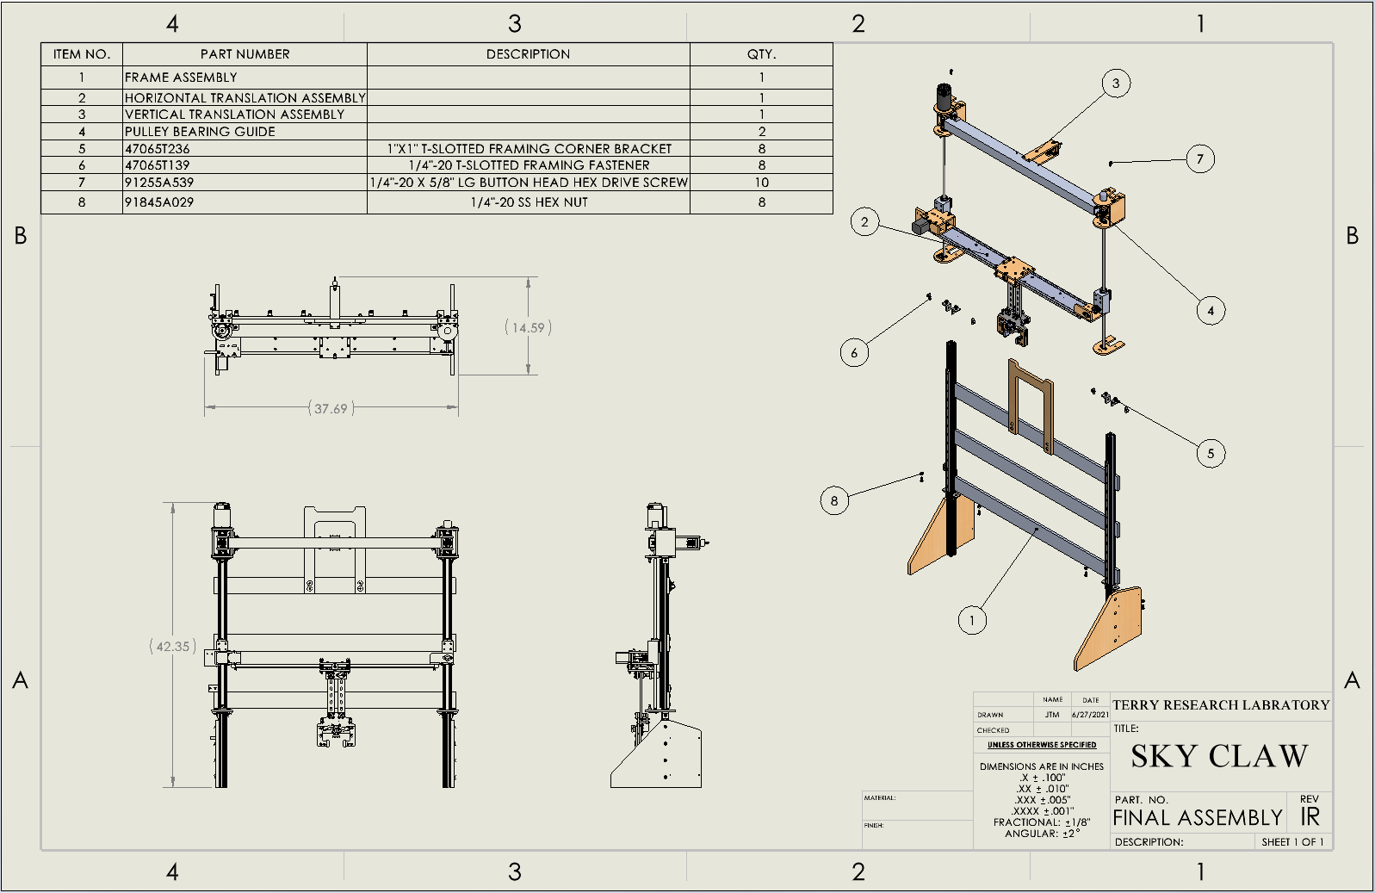

**[Proceed through this section with extreme caution]**

Solder and wire all electrical components according to the specification sheets provided in the folder “Schematics and Datasheets.” Below is a D-Sub connector guide.

Note: Wire colors may vary.

|  |  |  |
| --- | --- | --- |
| D-Sub Pin | Component | Component Pin |
| 1 | Proximity Sensor | Vin (Red) |
| 2 | Proximity Sensor | GND (Black) |
| 3 | Proximity Sensor | SCL (White) |
| 4 | Proximity Sensor | SDA (Blue) |
| 5 | Servo | GND (Black) |
| 6 | Servo | Positive (Yellow) |
| 7 | Servo | Signal (White) |
| 8 | Stepper Motor | Black (Coil 1) |
| 9 | Stepper Motor | Green (Coil) |
| 10 | Stepper Motor | Red (Coil 2) |
| 11 | Stepper Motor | Blue (Coil 2) |
| 12 | Pressure Sensor 1 | Power (White) |
| 12 | Pressure Sensor 2 | Power (White) |
| 13 | Pressure Sensor 1 | GND (Yellow) |
| 13 | Pressure Sensor 2 | GND (Yellow) |
| 13 | Vertical Translation Motor | GND (Black) |
| 14 | Top Button GND | GND (Blue) |
| 14 | Linear Resistor | GND (Black) |
| 15 | Bottom Button | White(Neutral) |
| 16 | Vertical Translation Motor | Positive (Red) |
| 17 | Top Button Neutral | White |
| 18 | Linear Resistor | Input(Red) |
| 19 | Linear Resistor | Output(White) |
| 20 | Rotary Encoder 2 (top) | Channel A (Black) |
| 21 | Rotary Encoder 1 (claw) | Channel A (Black) |
| 22 | Rotary Encoder 1 (claw) | Channel B (White) |
| 23 | Bottom Button GND | Green (GND) |
| 23 | Both Rotary Encoders | GND (Blue) |
| 24 | Both Rotary Encoders | Positive (Red) |
| 25 | Rotary Encoder 2 (top) | Channel B (White) |

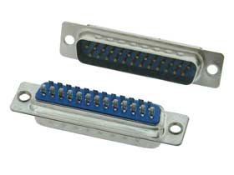

**Wire Management Recommendations**

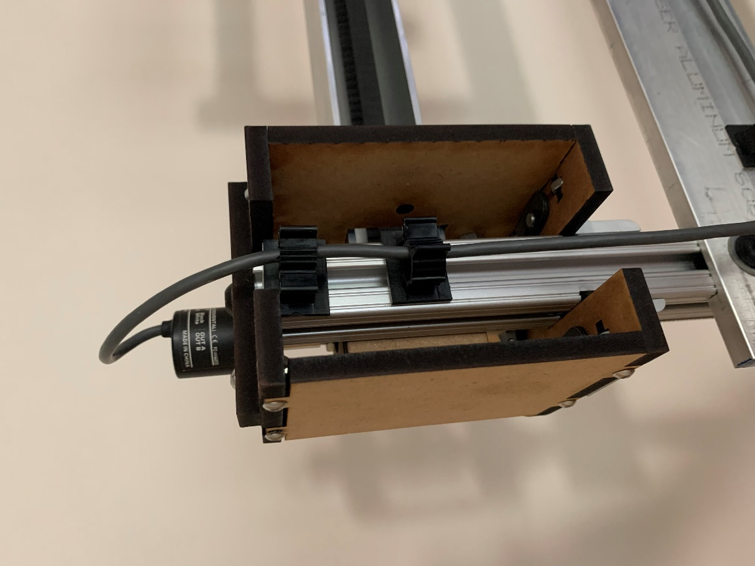

Attach two adhesive-back nylon cable holders to the aluminum t-slot framing extrusion between the vertical translation housing motor. Run the rotary encoder wires through the cable holders.

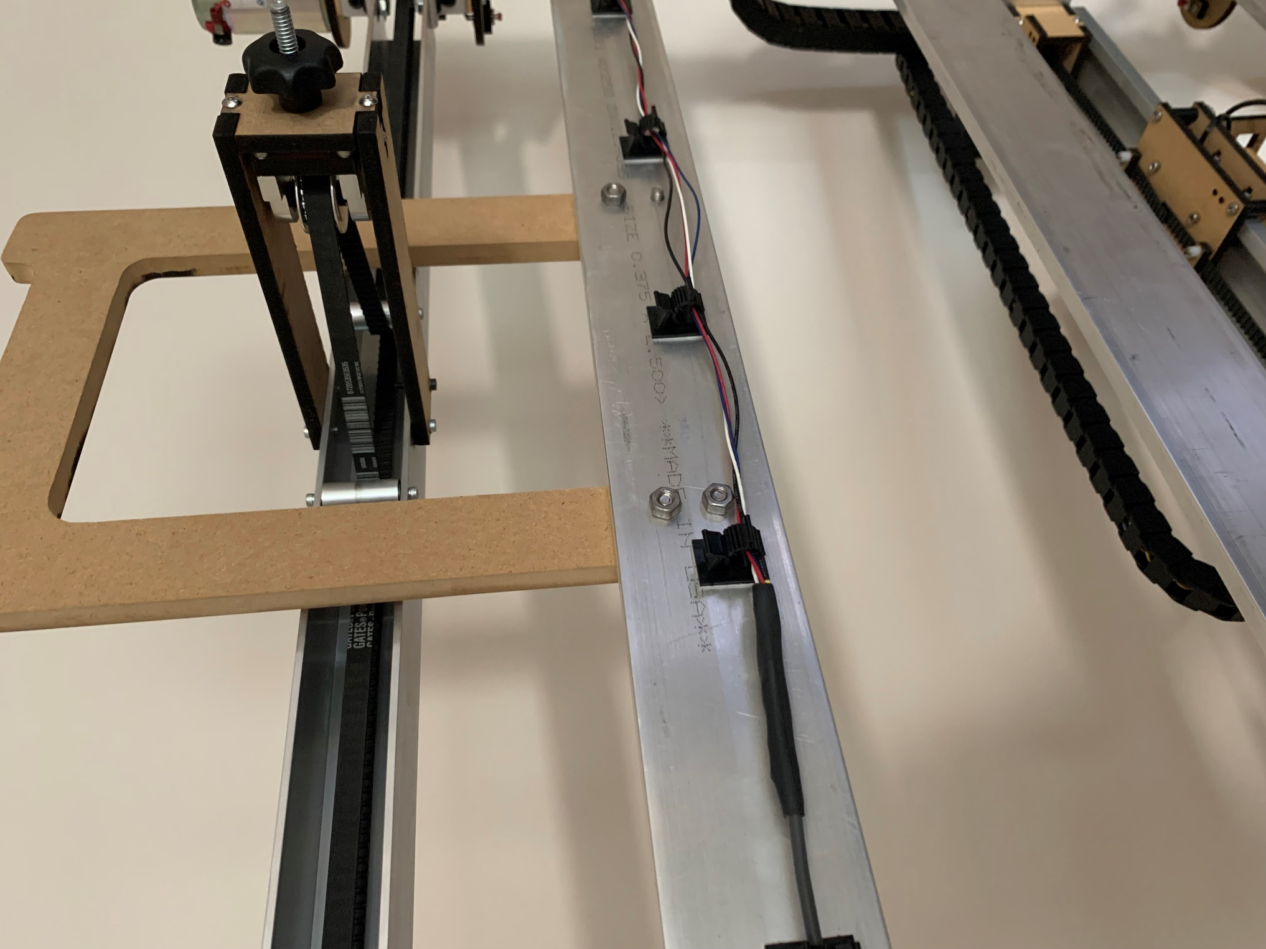

Attach the adhesive-back nylon cable holders to the FRAME BRACE TOP (use as many as needed). Run the wires from the rotary encoder through the cable holders to prevent sagging.

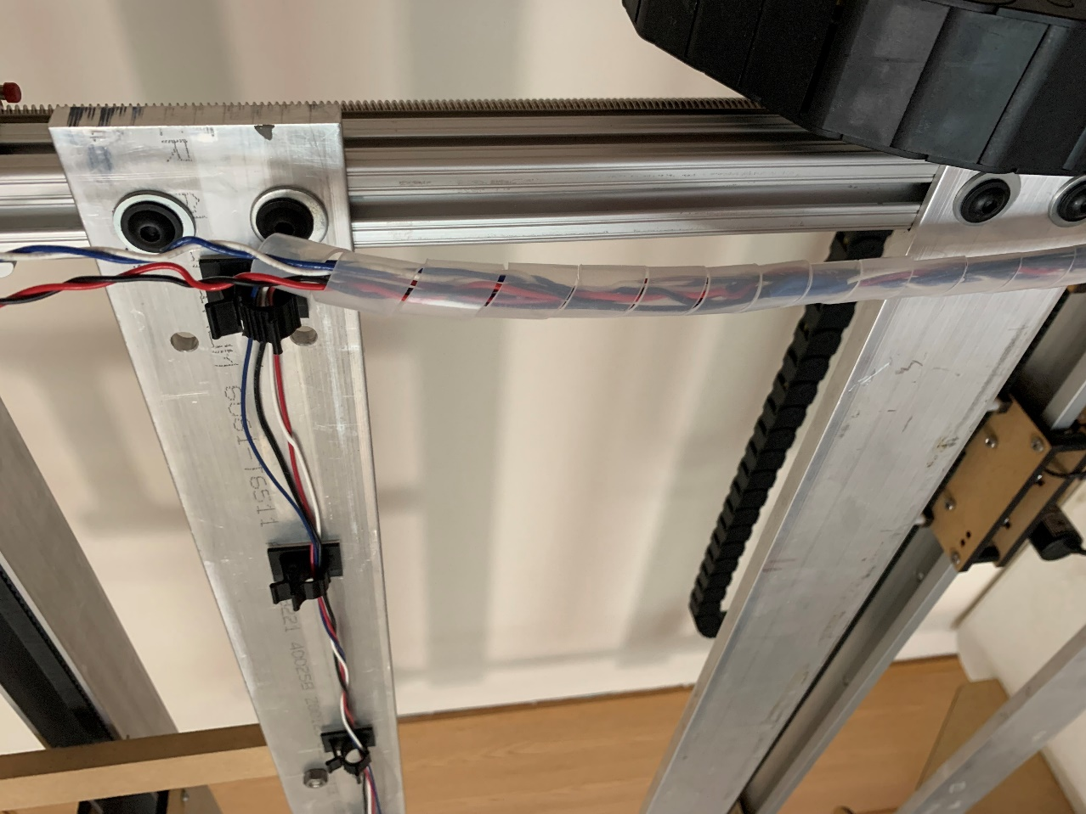

Enclose the wires from the rotary encoder and 24V DC motor in a plastic spiral cable wrap.

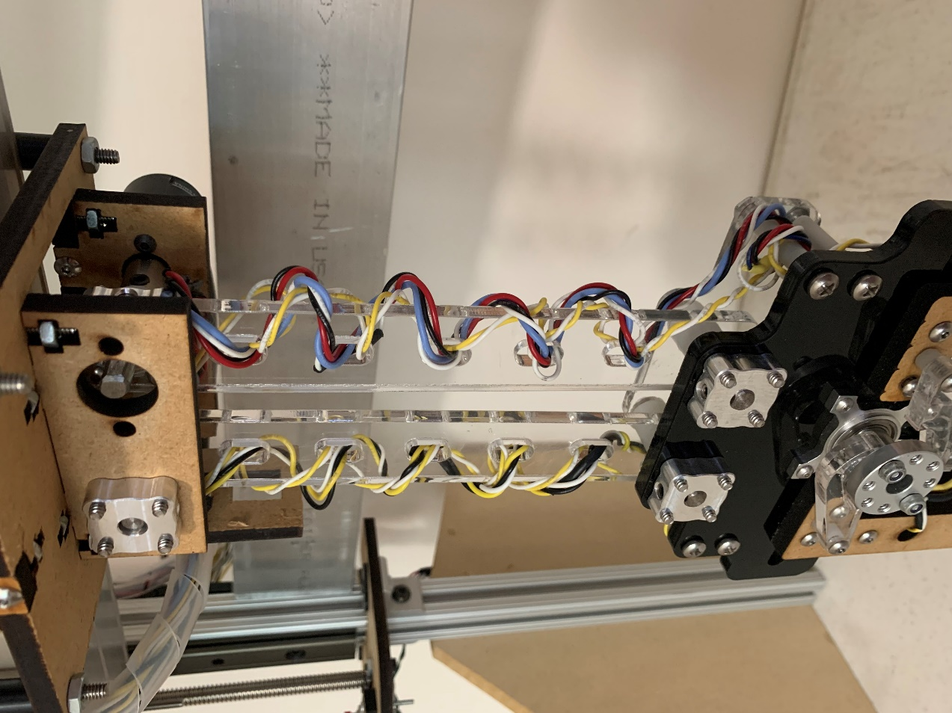

Coil the wires from the pressure sensors and proximity sensor through the provided slots in the CONNECTING ROD.

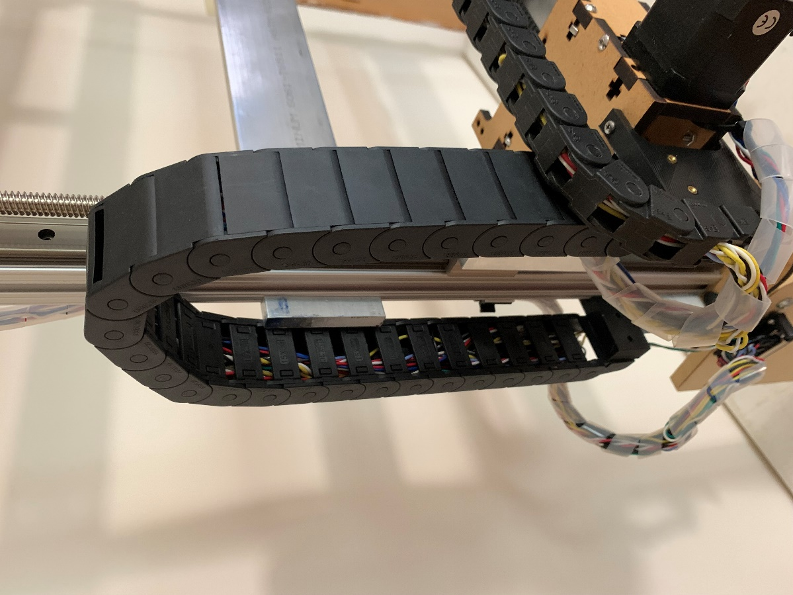 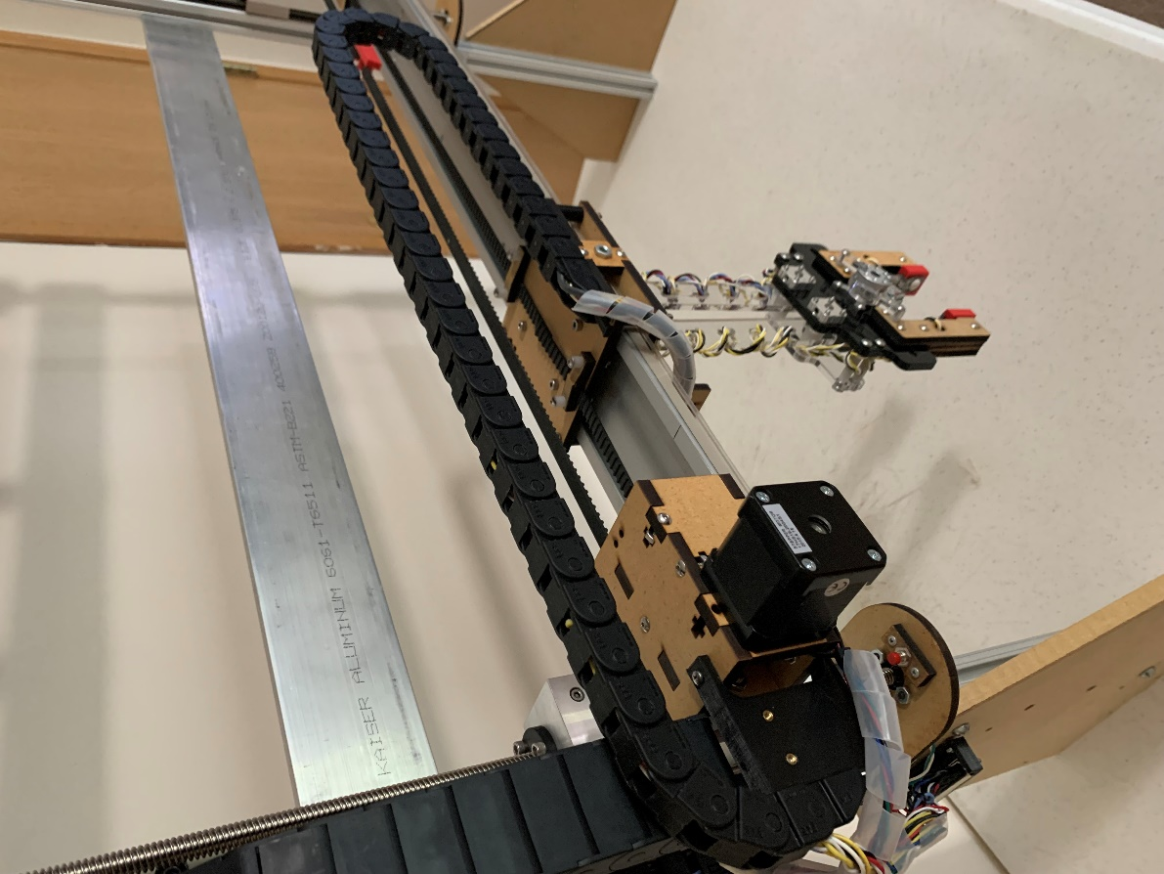

Run the cables through the drag chain cable carriers and connect it to the CABLE CARRIER CONNECTOR VERTICAL and HORIZONTAL CABLE CARRIER ADAPTER.

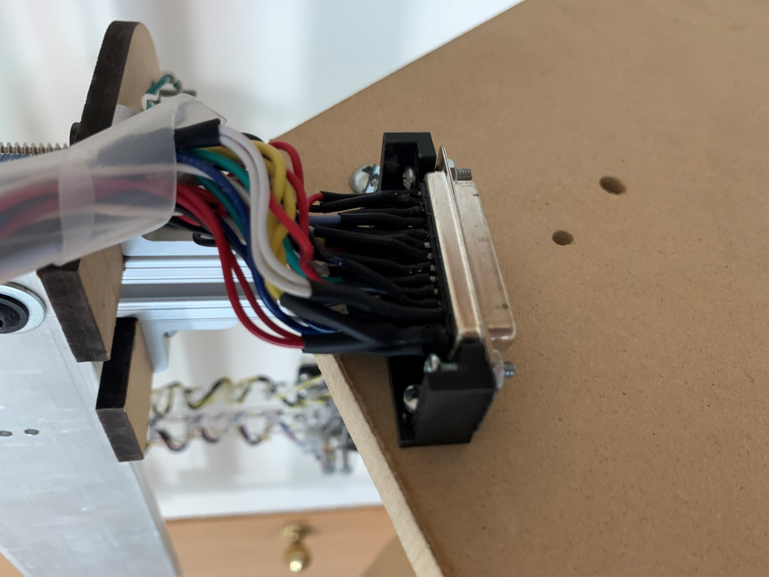

Solder all cables to the D-Sub connector and cover all exposed conductive surfaces with heat shrink tubes.